Portraiture as a Self-Therapeutic Artistic Process

By: Shannon Clauda

Submitted in partial fulfillment of the requirements of the Master of Fine Arts in Painting.

December 8, 2021

Introduction

This qualitative analysis intends to answer: how do I, as an artist, use paint for my development and healing? As a contemporary portrait artist, I seek to capture the character and essence of my subjects. My paintings encourage audiences to refer to their feelings and personal interpretations. I've always been a very imaginative individual, constantly looking to create things from what inspires me and looking for the fulfillment of overcoming challenges in the process of getting to my desired result. Through an abstract style, I address a wide variety of subjects in a multi-layer manner and engage the audience in a fashion that is often tactile; by exploring the complexity and origin of the subject through retakes and modifications. I attempt to enhance the viewer's interaction with the creator by reflecting on feelings and analyzing the duality that arises through the paintings' various interpretations. My work directly responds to a self-analyzing and therapeutic conversation between myself, the artist, and the canvas. I use this artistic process as a way to evaluate and rewrite the relationships I have with these individuals, all of whom have been a large part of my life and helped shape my identity. I use these portraits to analyze the changing dynamics of these relationships through my transition into sobriety.

Process

When possible, the process begins with a series of pictures of my subject, but due to difficulties related to Covid-19, social media images have also been utilized. Among the essential features of the images selected is how the eyes are engaged. The way the light falls on the face is just as critical because my art depends on the highlights and shadows on the face. The enhancement of this contrast can change the character and experience of the painting. After choosing the image, it is then transformed it into black and white using Procreate. Through heightening the contrast areas are established into regions of black, areas of medium tones, and speckles of highlights. Then begins the dissecting of the face into segments by creating a puzzle-like drawing on the surface of the image. These pieces refer to different planes and shadows of the figure, and I do this on an additional layer to make these changes.
This drawing is then projected onto a pre-prepared canvas where the image can be traced. These works are of a relatively large scale, about thirty-six by forty-eight inches or larger, on prepared canvases to help elevate my subjects. In some later pieces, like in Image 1, I transfer a charcoal image drawing. Finally, the painting is ready for the palette knives and oil paint. The impasto style creates a fleshiness on the canvas that forces the viewer to accept the portrait's humanity. The eyes are often the first area of the painting completed. The eyes are perhaps the most critical aspect to achieve accurately. They have the power to set the tone for the rest of the painting. The eye sections are often the regions that demand the most attention to detail. From there, I'll concentrate on the other areas, such as the mouth and bridge of the nose. When these areas feel right, I will then use large palette knives, and consequently, the strokes become broader and more spread out. By doing so, it encourages the aesthetic impact of the backdrop generated to become part of the final portrait. When it seems as though the artwork is done, it will be left for a day and then reassessed. Creating compositions that have not finished elements gives more interest to the painting and alludes to the ongoing process of rediscovering the complexities of human interactions and connections.

Portraiture

It always seemed apparent to me that feelings and emotions, even the abstract, maybe expressed visually. In this way, the image may be a form of language, using its symbolic nature to speak. The fragments of my portraits form a sort of puzzle, incomplete, damaged, and waiting to be solved. I relate this to the rebuilding of relationships that have been shattered or broken through the disease of addiction. The rehabilitation process involves rebuilding those relationships that were destroyed along the way and making amends. These puzzles are my metaphors for a consistently growing and evolving relationship with my subject. Visual poetry can embody an essence and engage the reader to differentiate.
The spark of life in an eye, the detectable tilt of a chin: we interpret sentiments in how features are arranged and what they reveal or conceal. The reader must discern the vocabulary of what they see. They must accept the signs and symbols and surmise the interpretation of what they see, even if it is a feeling, impression, or uncertainty. Occasionally, a correlation is realized that supersedes both the audience and the visual and brings them together. Perhaps this is beauty. American-French Artist Louse Bourgeois believed that "Beauty is the pursuit of 'the Other'" and implies that beauty is observed outside of ourselves. I am most fascinated and confronted by other individuals when I look beyond myself. "The greatest unknown is the challenge of another human ... of self-teaching beyond one's boundaries, and self-awareness in the process," writes Wendy Steiner. The concept of the other, found inside a portrait, appears to have an eternal essence that persists far outside of time. This concept of making a representation that forever contains the essence of the other can be seen from cave drawings, portraits of European Royalty, Street Art, and now even your cell phone. The very essence of image creation involves an outer scope that relies on more than just self, which allows one to find and define self.
The way I attempt to resolve the ambiguity of otherness of my portraits, or even to address the complexities of myself, is through poetry. Paint as a medium has the capacity to show emotional states and I was deprived of faces during lockdown and desperate to re-encounter them. By utilizing painting to re-create the essence of where ethics originates, which is according to Emmanuel Levinas, ‘The face is a living presence […] The Other faces me and puts me in question and obliges me.’. This visual poetry is a variety of symbols that function together in unity to create a vivid whole. Looking at another individual, I see a lot of signals. Every hue of the skin speaks volumes. I would argue that successful portraiture demands the empathic and emotional involvement of the spectator by making an image that has the sophistication and poetic depth of a real human. I have selected unique templates for my portraits, particular structural compositions, and a traditional way of showing my subject to make a visual that is physically, mentally, emotionally, and nuanced enough to be investigated.
I believe that exploring the human face is crucial at a period in time where we are constantly having to cover our faces due to the Covid-19 Pandemic. With the recent rise in hostility amongst political parties and with all of the heated racial tension from the summer of 2020, I can’t help but wonder how much of this rise in violence has to do with, essentially, dehumanizing ourselves behind our masks. The lack of face-to-face interaction from isolation and quarantine has left many feeling more alone than ever. I hope my paintings encourage my viewers to engage in more face-to-face interactions with those they cherish and love.

Influences

The contemporary artists I take influence from are Guy Denning, Ryan Hewett, Andrew Salgado, and Jenny Seville. I am currently interested in everything from design, color, composition, to the application of paint. Guy Denning is masterful at incorporating different and unorthodox media techniques together. He uses an array of tools such as paint, crayons, marker, pen, and conte pastels. Jenny Saville also works in both painting and charcoal figurative work. I am drawn to her thick impasto style of paint and the texture it creates on the canvas. Similarly, Ryan Hewett’s artwork has a structural feel to it from his thick use of paint. His figures extend beyond the picture plane and into our space, addressing the viewer with a captivating vitality and charm. Andrew Salgado is very playful with his color palettes and the way his subjects interact with their backgrounds. He allows areas of the background to show through the figure and it creates a visual tension that I am very drawn to. My work attempts to take the characteristics of these several artists and combine them to create a distinct style. All creative art is influenced by others, the trick is to take what you want from each artist and merge it into something unique. This is easier said than done. In reaction to society's obsessive documenting, narcissistic over-sharing, and unwavering interconnectivity, many artists investigate how to genuinely, truly capture identity, whether by reflecting on their perspectives or by encouraging others to recognize and meditate about their own.

Art: A Process of Healing

My artistic process serves as a therapeutic and restorative ritual through which I process many of life's difficulties. In conventional practices, the human race was seen as being primitive, and the tools used to restore health were typical chemical medicines. The knowledge of human conscious and unconscious minds has arisen in modern years when doctors and other medical professionals have accepted the need to consider patients' psychological well-being. According to the Gale Encyclopedia of Medicine, 2006, art therapy usually helps patients to gain more insight into their emotions and enable them to work constructively on these problems. Considerable focus is placed on the use of music and other means of art, such as painting to calm the minds of patients in order to improve their rehabilitation.
Today, schools promote the study of art as a subject to recognize it and its principles. Such learning is crucial as students gain insight into artistic creation and gain expertise, skills, and insight into the subject. Creative expression provides an important contribution to the process of healing and has now been recognized by culture. Throughout written history, people have used images, tales, dances, and songs as rituals of healing.
Various types of art therapy have been introduced in the health department. According to the American Art Therapy Association (AATA), the use of art as a rehabilitation technique has achieved groundbreaking outcomes. Children with autism use art as a medium of communication; children with deficit disabilities report increased attention and those with cancer that is soothed by it. Trauma can also be countered by newer types of art therapy. Faced with their Jungian shadows, those with trauma understand that anything they perceive as fears is no longer terrifying. Numerous case studies have validated the process, indicating that art as treatment helps people with both mental and physical disorders. Studies in adults have also demonstrated improvement from a general standpoint. All have been performed on people who have gone through the death of a loved one, addiction, and other medical complexes. Activities such as drawing emotions, meditative sculpture, compiling journals, and line art are also some of the enhanced approaches that psychotherapists use today. Many realms have incorporated these procedures, such as music and dance, to accomplish the goal of addressing emotional and behavioral disorders.

Conclusion

My artistic process is also my therapeutic process. I use my personal experiences to influence how I interpret my subjects and I attempt to show the viewer the multi-faceted layers to my subjects. All of humanity is built of these intricate and delicate pieces of our identities that are currently being molded and shaped by our interactions with others and the world around us. I have found a new appreciation for the loved ones I took for granted through my years of alcoholism and I renewed this appreciation through the isolation of quarantining due to the global pandemic. My work serves to remind us all to appreciate our complex identities and to value the humanness of our species.

Appendix

Image 1.

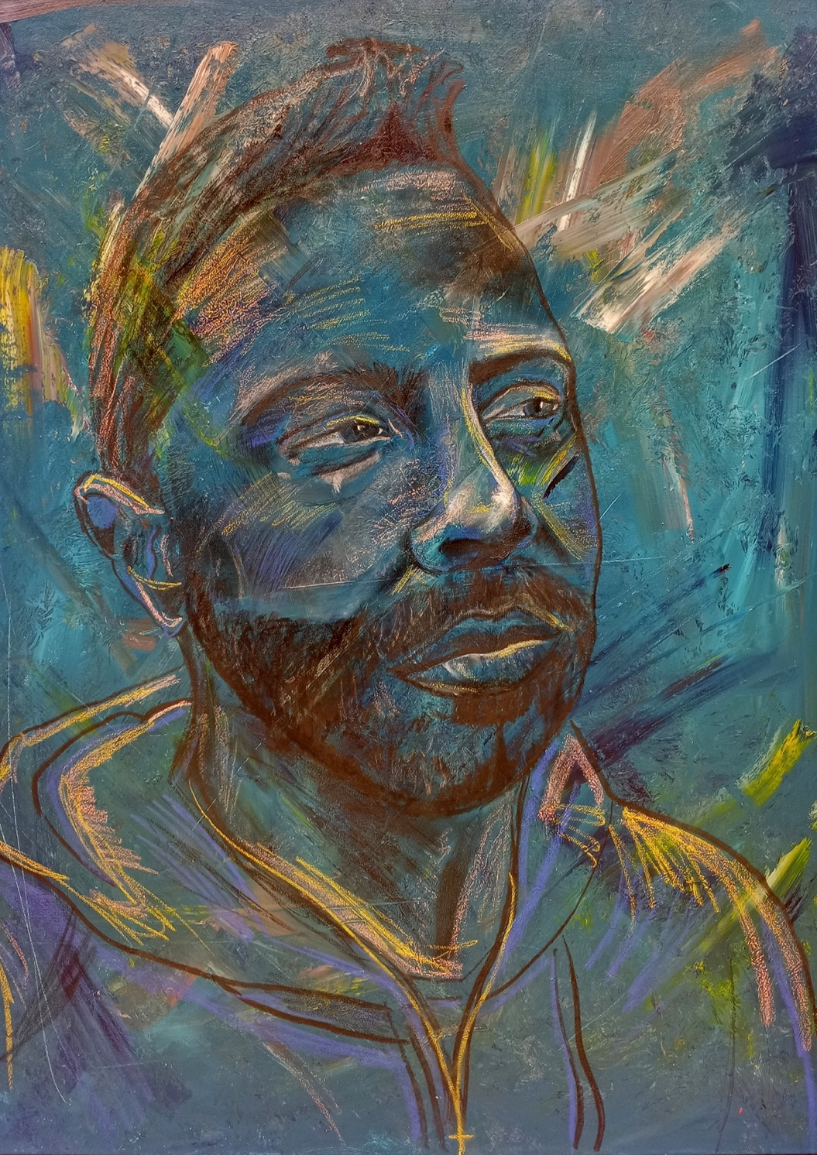
Portrait of Jason 1
Image 2.
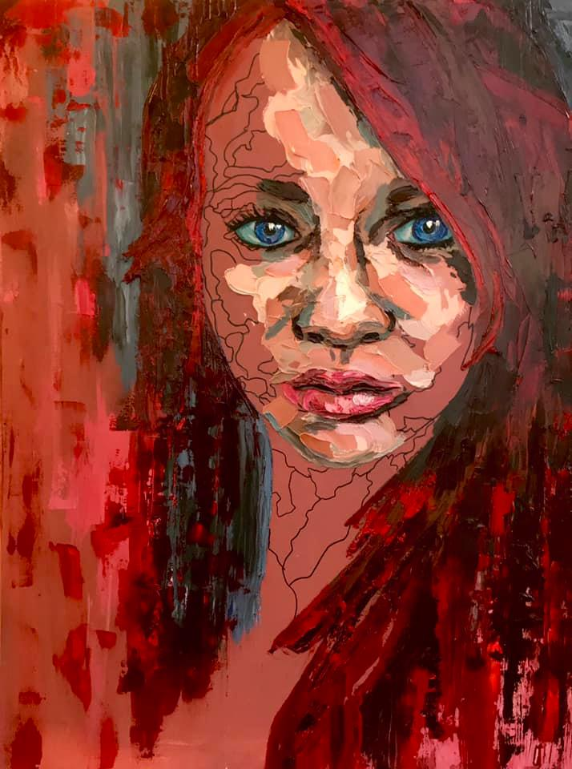
Portrait of Riane 1
Image 3.

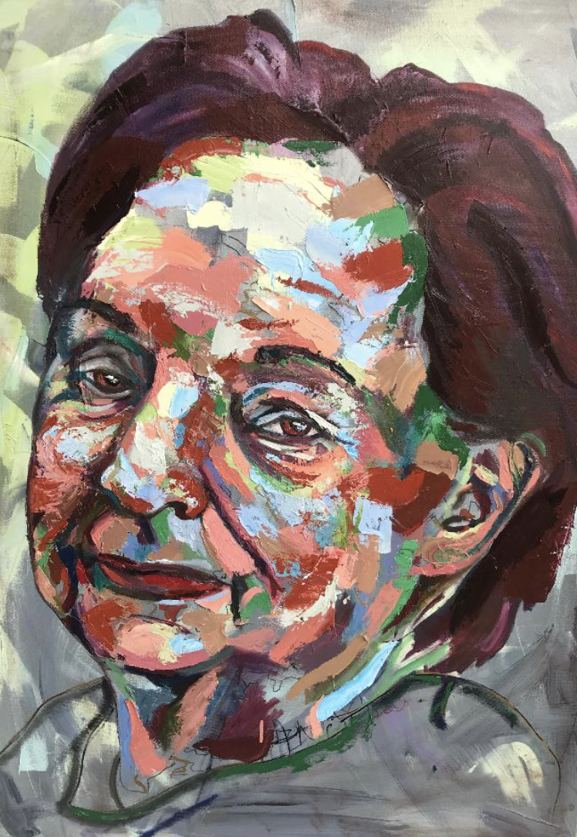
Portrait of Mother 1
Image 4.

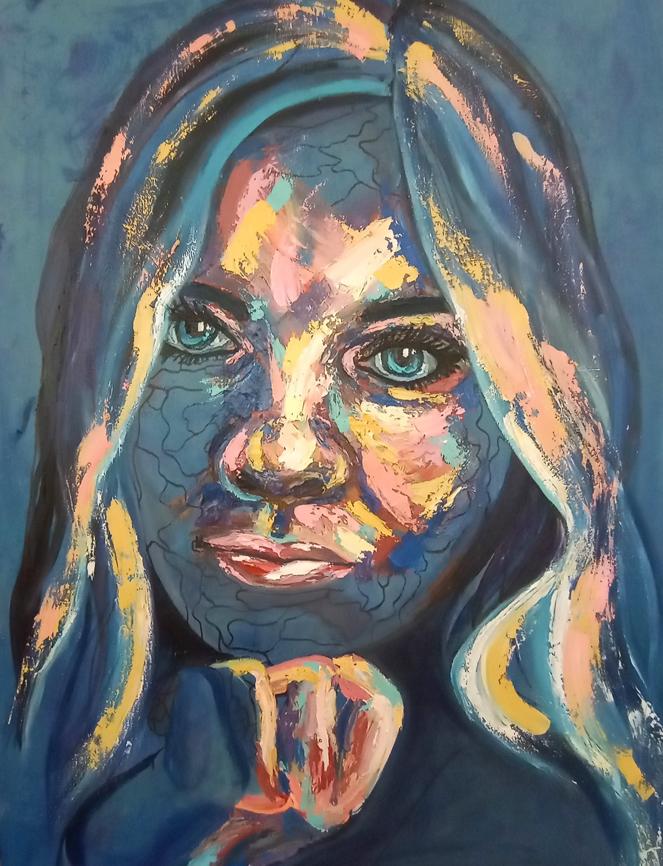
Portrait of Ryan 1
Image 5.

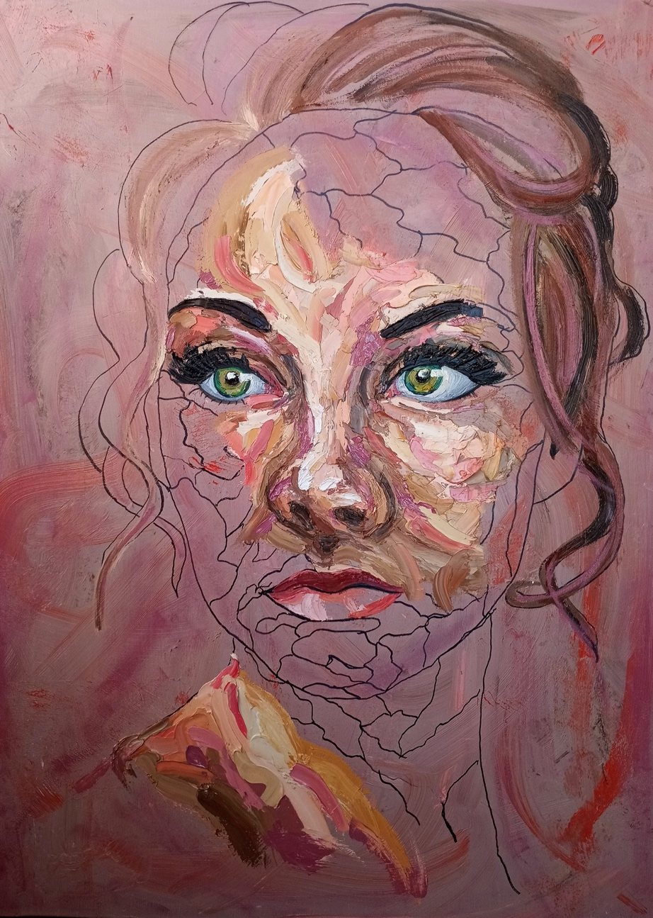
Self Portrait 1
Image 6.

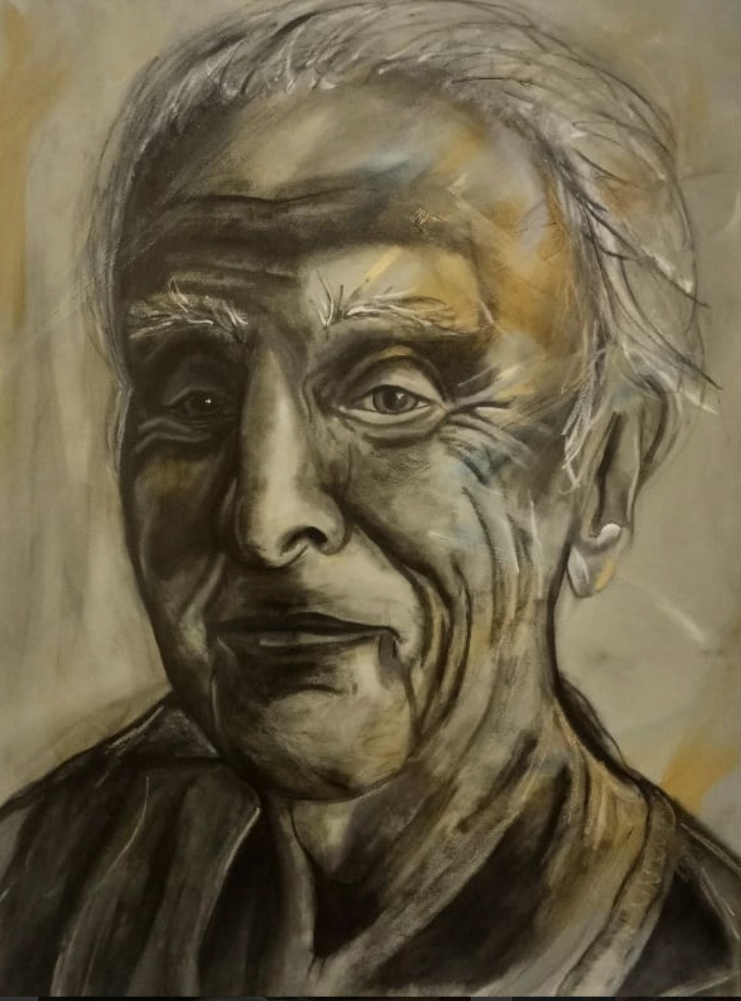
Portrait of My Father

Image 7.

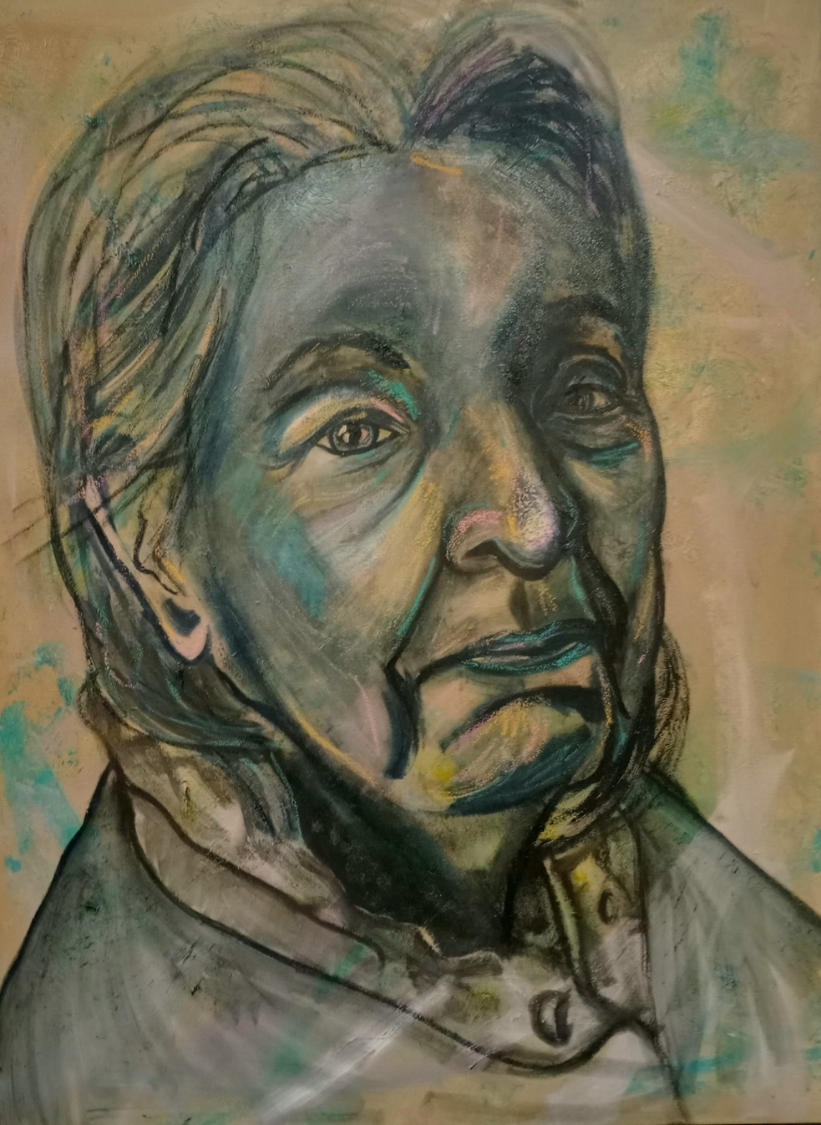
Portrait of Mother II

Bibliography

“Biography.” Guydenning.org, 21 Mar. 2019, https://guydenning.org/biography/.
“CV.” Ryan Hewett, https://ryanhewett.com/page-cv.
Cutler, David, Des Kelly, and Sylvie Silver. Creative Homes: How the Arts Can Contribute to Quality of Life in Residential Care. Baring Foundation, 2011.
Graham-Pole, John. Illness and the Art of Creative Self-Expression Stories and Exercises from the Arts for Those with Chronic Illness. Oakland, CA: New Harbinger Publ., 2000.
Image & Metaphor: the Practice & Profession of Art Therapy: the American Art Therapy Association, 22nd Annual Conference, November 13-17, 1991, Mariott City Center, Denver, Colorado. Mundelein, IL: The Association, 1991.
“Jenny Saville Paintings, Bio, Ideas.” The Art Story, https://www.theartstory.org/artist/saville-jenny/.
Jung, C. G., Herbert Read, Michael Fordham, and Gerhard Adler. The Collected Works of C.G. Jung. Princeton, NJ: Princeton Univ. Press, 1978.
Large, William. Levinas' 'Totality and Infinity'. Bloomsbury Academic, 2015.
Longe, Jacqueline L. The Gale Encyclopedia of Medicine. Detroit: Thomson Gale, 2006.
Luethje, Kathy. Healing with Art and Soul: Engaging One's Self through Art Modalities. Newcastle: Cambridge Scholars, 2009.
Steiner, Windy. Venus in Exile the Rejection of Beauty in 20th-Century Art. Chicago: University of Chicago Press, 2002.
Sutherland, Judy, Gwenn Waldman, and Carolyn Collins. “Art Therapy Connection: Encouraging Troubled Youth to Stay in School and Succeed.” Art Therapy 27, no. 2 (2010): 69–74. https://doi.org/10.1080/07421656.2010.10129720.
“Text.” ANDREW SALGADO, https://andrewsalgado.com/text/.

“Procreate® – Sketch, Paint, Create.” Procreate, https://www.procreate.art/.
Windy Steiner, Venus in Exile the Rejection of Beauty in 20th-Century Art (Chicago: University of Chicago Press, 2002).
Large, William. Levinas' 'Totality and Infinity'. Bloomsbury Academic, 2015.
Jacqueline L. Longe, The Gale Encyclopedia of Medicine (Detroit: Thomson Gale, 2006).
David Cutler, Des Kelly, and Sylvie Silver, Creative Homes: How the Arts Can Contribute to Quality of Life in Residential Care (Baring Foundation, 2011).
John Graham-Pole, Illness and the Art of Creative Self-Expression Stories and Exercises from the Arts for Those with Chronic Illness (Oakland, CA: New Harbinger Publ., 2000).
Image & Metaphor: the Practice & Profession of Art Therapy: the American Art Therapy Association, 22nd Annual Conference, November 13-17, 1991, Mariott City Center, Denver, Colorado (Mundelein, IL: The Association, 1991).

