Lil’ Birb’s Emporium
Rayne Karfonta

Introduction

I strive to marry the visual elements of whimsical narrative illustrations with underlying darker conceptual elements. Illustrations that contain stylized characters are often associated with childlike wonder. Therefore, characters such as these are almost always labeled as artwork designed for young viewers. Lil Birb’s Emporium challenges this stereotype by combining whimsical characters reminiscent of children’s book illustrations with narratives that portray discomfort, utilizing symbols based on alchemy that also reflect on issues of mental health.

Influence

Like most, the start of my influence began during childhood. As an only child to a single working mother, I spent much of my time alone. I enjoyed creating stories and characters to go along with them. In my younger years, I spent time at my great-grandfather's farmhouse where he enjoyed collecting vintage knickknacks like cookie jars and salt & pepper shakers. They had a certain peculiar charm to them that I still find appealing. His farm was surrounded by a large, wooded area and any chance I got, spent my time exploring those woods. Thus, resulting in my present love for natural science and elements.
I also had an appreciation for Studio Ghibli and Don Bluth films such as Secret of Nimh. I believe they had a direct influence on my work, primarily due to the fun character designs combined with more complex themes which were incredibly attractive to me. I have always been drawn to stories with darker elements or themes underneath a seemingly pleasant appearance.
Artists such as Hieronymus Bosch, Edward Gorey, and Beatrix Potter created artworks that directly influence my own pieces. All three focused on imagery that, at first glance, seem innocent and happy. However, upon a deeper analysis it becomes obvious that there are darker elements that shift the tone of the piece. Bosch was best known for his chaotic religious paintings. During the time Bosch was alive, people lived in fear of the church and the growing world around them. While there is not much known about Bosch himself, it is safe to say that the constant worry of sinning and the world coming to an end had a large impact on his work. Gorey was considered by many to be a children’s book illustrator/writer although he never enjoyed that claim and continued to do very gothic imagery that was uncomfortable to some. Many of his pieces had a traditional horror-like quality to them while still retaining a whimsical appeal. Potter is well known for her children’s books. Her style is extremely recognizable, and her stories are universally loved. However, many of her stories have adult themes to them. They are meant to be cautionary tales for the reader, thus sometimes having uncomfortable tones with friendly imagery.
Throughout all my works, there is an underlining theme of alchemy. While I am an atheist and do not believe in the spiritual aspect of alchemy, I have always found the history and science behind it incredibly interesting. I find that many misunderstand what alchemy, and more importantly alchemy art, is. It is assumed that alchemical art is scenes of potion making or herb grinding, when really, it is a broader term referring to spirituality and fantasy. It is important that the artwork has symbolic elements that can be broken down. The idea of alchemy art is to engage in what disturbs us and try to understand it. One of the biggest ideas of alchemy is to branch the harmony of opposites. It is believed in doing so, we can better understand the world around us. My concept and characters play on this opposite. I find a way to harmonize darker elements and characters with more playful styles.

Creation of Lil’ Birb

When I started to create character illustrations, my focus was on developing and enhancing my personal style. During this process, I began to blend realism with stylized, simplified character designs. I experimented with and researched a wide variety of character designs and world building that was heavily influenced by my passion for fantasy and narrative illustration. In 2016, I created a character based off the designs of Renaissance plague doctors. The concept was simple and graphic, so that it would always stand out in the illustrations. The piece was titled Lil’ Birb’s Emporium and “Lil’ Birb” was meant as a placeholder title and not an actual name as the term “birb” is internet slang for a small and cute bird. The title was more to let the viewer know that the “Emporium” belonged to this little bird character. An actual name never came, but I fell in love with the design and continued using him in illustrations. A year after making the original piece, I began creating a 20-piece series of illustrations under the same title. In those 20 pieces, I experimented with just using inks and small areas of digital coloring. These works are what I would say were the real start to my narrative illustrations. Prior to that, I never focused on an environment, let alone a character interacting with it.
As an undergraduate student, I created a series of illustrations titled Lil’ Birb and Friends. The goal of these illustrations was to expand the range and variety of fantasy elements, characters, and detailed scenes. While I designed quite a few characters, some of these characters were selected to accompany Lil’ Birb to enhance and provide variety to the narrative. The characters Newton the bat and Romeo the pug continued to show up in the paintings. Throughout the original and newer series, I used fantasy environments to portray a happier setting, while also incorporating darker meaning and tones to the work which allowed the audience to have a change in emotion upon viewing it. I was attracted to the irony that comes from childlike illustrations carrying a darker meaning. This attraction has continued throughout the series and my personal work.

Process

The specific mediums and size of my pieces are related to the concept. I use primarily watercolor and ink which allows my work to have a softness that most whimsical illustrations contain. There is something very appealing about the softness and fluidity of watercolor. In addition, the use of watercolor and ink/dip pens helps with visual clarity. Paring this with a smaller-sized piece creates an intimate composition. It also encourages the viewer to come close to see the subtle details. When viewing my paintings, the viewer should feel like they are only an observer of this world instead of being a part of it.
I use fantasy and nature as an escape from my depression. When it comes to someone’s mental health, a person can try and sympathize, understand, and relate to the one struggling. However, at the end of the day they will never fully understand how that individual is feeling. The best they can do is look in and hope to help from afar. The composition of my paintings reflects this feeling. The viewer is always looking in on the scene as if they are an outsider. Even as someone who deals with mental health issues, I sometimes feel like an outsider to myself.

Artwork

Vélemény (Figure 1)
Vélemény was the first painting that was completed for this series. The name Vélemény translates to point of view, opinion, or eye in Hungarian. I had been researching mutations and came across polycoria, which results in someone or something developing two or more pupils in one eye. I decided to play with that idea, and I placed Lil’ Birb in a cozy area being warmed by the soft glow of a lantern. The bottom of the picture seems comforting, but as the viewer notices the rest of the piece, they discover that it is primarily black with only a hint of trees and polycoria eyes. It seems menacing, all these eyes looking at the viewer and around the painting. This plays into that juxtapose of whimsical illustrations with an unsettling mood.
Sleep of Reason (Figure 2)
The title for Sleep of Reason was directly taken from Francisco Goya’s piece Sleep of Reason Produces Monsters. In this piece, Goya portrayed himself sleeping and being surrounded by nightmarish creatures. Since I was a child, I have been plagued with nightmares; they horrified me, and I feared sleeping. Now as an adult, I have become desensitized to it and no longer fear them. In fact, as time went on, I began to accept them. In my piece, like before, I placed Lil’ Birb in a comfortable environment. He is asleep at this desk, perhaps after a long night of reading. There is a warm yellow glow coming from out of frame, and a cup of a hot drink still steaming. However, on closer inspection, the shelf and desk are covered in things that make the viewer uneasy. The objects surrounding the characters are inspired by my own nightmares. For example, the shelf behind Lil’ Birb has a jar full of teeth representing my recurring nightmare of my teeth painfully falling out of my mouth.
Nyctophilia (Figure 3)
Nyctophilia was an experiment to see if I could successfully create an illustration where the biggest element was pure black. I am drawn to night-time environments since it allows for emphasized light source and different mood invoked by the chosen color schemes. Darkness and night-time can be associated with depression, and I utilize the relationships to my advantage. The piece contains about 80% pitch black ink. At the bottom are Lil’ Birb and Newton sitting at a campfire and at the top is a night sky. For me, when seeing a night sky full of stars, I get a sense of loneliness and feeling small. I wanted the blackness of the background to enhance that feeling. However, there is comfort at the bottom where Lil’ Birb and Newton are protected from the consuming black by the comfort of the fire.
Pick Your Poison (Figure 4)
Pick Your Poison features Lil’ Birb in the greenhouse of my new death moth character. Death Moths are large moths that resemble honeybees, and their most recognizable feature is the skull pattern on their back. Because of this, many associates them with death; however, these moths are completely harmless (Nozedar 2010, 184). I became interested in creating a greenhouse for this character because of this association and filling the greenhouse with poisonous flowers and plants. All the flowers are ones that have the ability to kill a human being while all the houseplants are ones that harm humans by touch or can kill an animal (Nozedar 2010, 224-225). The mandrake roots in the front have both the ability to kill or heal. When cooked, mandrake roots are used as a healing ingredient. However, if eaten raw, they are poisonous (Battistini 2004, 205). I wanted to play with the idea of something beautiful at first glance, but with a little knowledge the viewer will see how dangerous the environment is.
Perennial (Figure 5)
No matter how many times I see them, I will always find sunsets captivating. The way the colors radiate in the sky and wash everything in a warm glow elicits a calming feeling. It’s a sign that time is passing, and the day is ending, providing us with a sense of closure both in a literal and metaphorical sense. There is an inherent sadness and feeling of loneliness that follows as well. After the vibrant and beautiful act of nature comes the night and the darkness associated with it. This piece encapsulates my feelings on mental health. It is often perceived that someone suffering from a mental illness just lives a dark and depressing life. That is not the case, in fact there are many ups and downs that cause some days to be very bad, while other days can be calm and happy. I wanted to depict a serene scene where Lil’ Birb is shown looking up at a broad sky, providing the audience with the sense of feeling small in a big world. The colors and tone are visually soothing but still saturated, as most sunsets are. Symbols like the pine tree which represents longevity and peace, and the poppy which despite its beauty still can be a representation of death, provide the piece with a metaphorical example of how mental struggles can feel (Nozedar 2010, 238). In addition, poppies are perennials which means that even when they die, they will return the following year. I equate this to depression and that even when the bad days fade away, they never truly disappear. My final element in this piece is the choice to make Lil’ Birb alone. Sometimes friends can't be with you during both difficult or happy moments and that’s okay. Through time and coping mechanisms comes a sense of peace, at this point you have learned to live with it, and it is the first step to moving forward.
Wend Their Way (Figure 6)
To wend one's way means to move slowly and carefully in a direction. While the scene is dark, the characters are accompanied by a creature that carries them to a destination. Compositionally the piece is crowded and closed off, the very center being the exception. This creates a situation where the viewer feels as if they are a part of the piece, peering in on Lil’ Birb and Romeo. This feeling of unknowingly watching the characters leaves the viewer with a feeling of unease. Afterall, with the characters back-to-back watching their surroundings, what could they be looking out for?
Murky (Figure 7)
Unlike the previous paintings, this one changes perspective to put the viewer above the composition, allowing the viewer look down with Lil’ Birb. The top of the piece is hidden in shadow by a willow tree. The leaves of the tree create a curtain around the scene. Lil’ Birb peers into the water, watching as a creature swims under the water. As the viewer looks around the piece, they will notice two more smaller creatures hiding under lily pads in the forefront. Willow trees represent balance and harmony, which reflects the balance in alchemy (Hageneder 2005, 181). The unknown creatures slithering around in the water gives a feeling of unease and fear. With that fear though, comes curiosity. I find that with fear, curiosity soon follows. There is a balance of the two that Lil’ Birb is experiencing.
Tenebrous Shadows (Figure 8)
A recurring theme in the Lil’ Birb’s Emporium series is the feeling of looming darkness and being watched. For Tenebrous Shadows, the environment is the focus. The characters are kept small to emulate the feeling of being helpless. While everything but the center is dark, looking closer reveals small black creatures surrounding the characters. Whether these creatures are harmless or not is left up to the viewer to decide.
Bubble and Trouble (Figure 9)
A huge part of alchemy art is showing the actual place that alchemy is done. Laboratories are important in alchemy because they show the process of creation (Nozedar 2010, 345). Here we have Lil’ Birb’s house. Romeo and Lil’ Birb create a potion of some sort while Newton looks in panic at what is being created. We have this cartoonish skull coming out of the cauldron. I find a lot of anxiety in trying new things if I’m convinced that I could fail. We have Newton showing some of that anxiety, as Lil’ Birb and Romeo attempt to make something that they may or may not be messing up.
Deceptive Mortem (Figure 10)
The aim of I wanted to create a closer composition that was focused solely on the characters' interaction. We have Oleander showing Lil’ Birb a piece of Thyme. As mentioned previously, Oleander is a death head moth that represents bad omens. Also mentioned was Lil’ Birb’s design being inspired by plague doctors, which has its own negative representation. I have Oleander holding up a piece of thyme for Lil’ Birb to see. Thyme was used in alchemy in order to cleanse areas of dead souls. It was also believed that seeing thyme growing where no other plants were meant a murder had taken place there (Nozedar 2010, 242) All this being lit by seven candles, seven being a number used in alchemy to represent wisdom (Battistini 2004, 226) All of these negative symbols in a composition forms a cartoonish skull. As my original thesis stated, I enjoy playing on that duality of dark and whimsical. Alchemy also plays on this duality of negative and positive. While the symbols in the piece have negative connotations, their uses are positive. Plague doctors saved people during the Renaissance, death head moths help pollinate, and thyme extract is used as medicinal.
Fallen One (Figure 11)
One of my favorite video games is Shadow of the Colossus. I credit that game as a huge inspiration for my work. In the game, the main character is tasked with killing ancient creatures (Colossi) roaming around a sacred land. These colossi structurally are very organic and reflect the natural element around them. It is never outright stated if these creatures are good or evil. I wanted to pay homage to it. Lil’ Birb walks through a dilapidated temple. Whatever the creatures are, they have been consumed by nature. There is a welcoming light from an unknown source that has allowed greenery to grow in this dilapidated temple. The passage of time can be overwhelming but at the end of the day, we are all consumed back into the earth.
Astronomer’s Tower (Figure 12)
Astronomy is a huge part of Alchemy (Battistini 2004, 10). The first time I depicted Newton, I envisioned him as an astronomer. I had wanted to illustrate his observatory, yet never felt I had the capabilities to depict it the way I wanted to. It felt fitting to not only use the abilities I had gained working on the series to create the observatory, but to end the series on a peaceful note. What I've taken away from my research into alchemy is the importance of learning and discovery. So, Newton and Lil’ Birb have fallen asleep after a long day of research as Romeo plays his guitar. The night is coming as the sun begins to set, but not before beaming through the window of the observatory. There is a sense of peace and comfort that the others in the series do not have.
Lil Birb’s Book (Figure 13)
To accompany the Lil’ Birb’s Emporium series, I created a book that helps the viewer decipher the symbols used, since many of the paintings contain symbols that are not common knowledge. The inspiration for it was a traditional book of shadows, which were books created to hold information (spells, potion recipes, etc.) that were unique to the person. Along with symbolisms, I added notes personal to Lil’ Birb to help connect the book to his character more and add personality.

Conclusion

With the Lil’ Birb’s Emporium series, I have been able to explore more complex illustrations, as well as dive deeper into the narrative of the world and characters. Being able to express the potential of Lil’ Birb’s world has led to self-discovery and a better understanding of alchemical art. In doing so, the series has allowed me to show viewers that whimsical illustrations can be more complex than simple children’s illustrations.

Work Cited

Battistini, Matilde. Astrology, Magic, and Alchemy in Art. Los Angeles: J. Paul Getty Museum, 2007.
Hageneder, Fred. Essay. In The Meaning of Trees: Botany, History, Healing, Lore, 181. San Francisco, CA: Chronicle Books, 2005.
Nozedar, Adele. The Illustrated Signs & Symbols Sourcebook. London: HarperCollins Publishers, 2016.
Roob, Alexander, and Shaun Whiteside. Alchemy & Mysticism: The Hermetic Museum. Köln: Taschen, 2019.

Figure Index

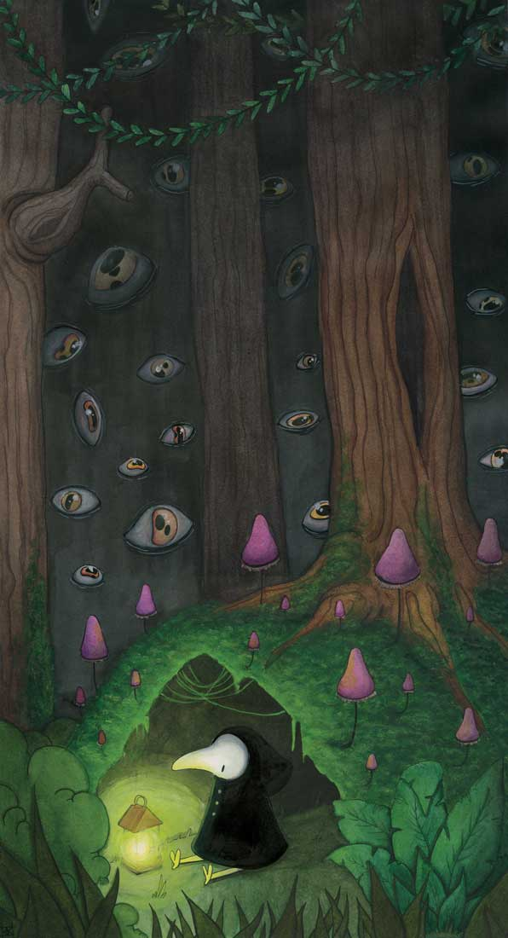
Figure 1

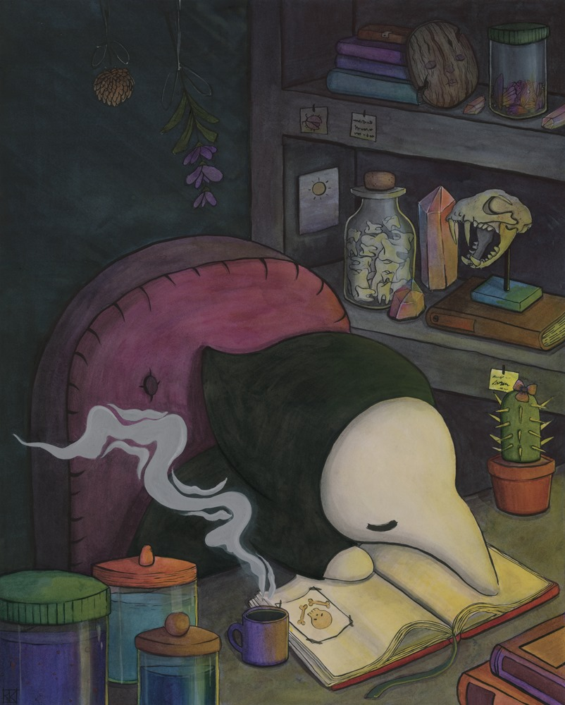
Figure 2

Figure 3
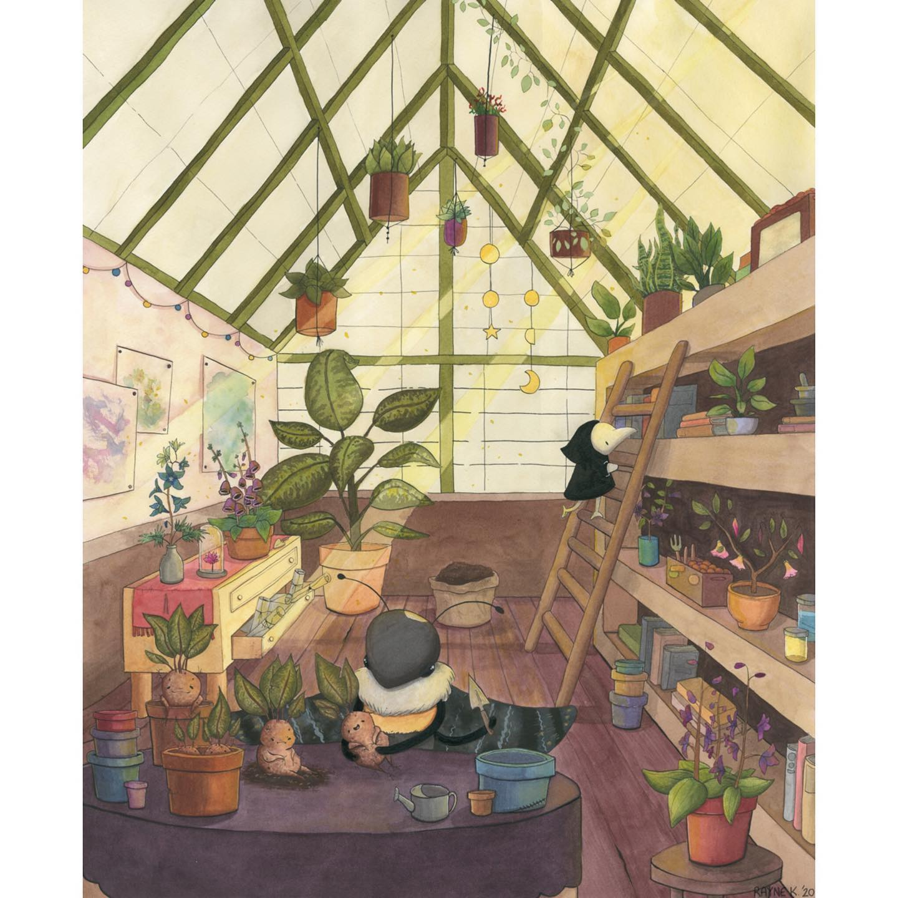
Figure 4

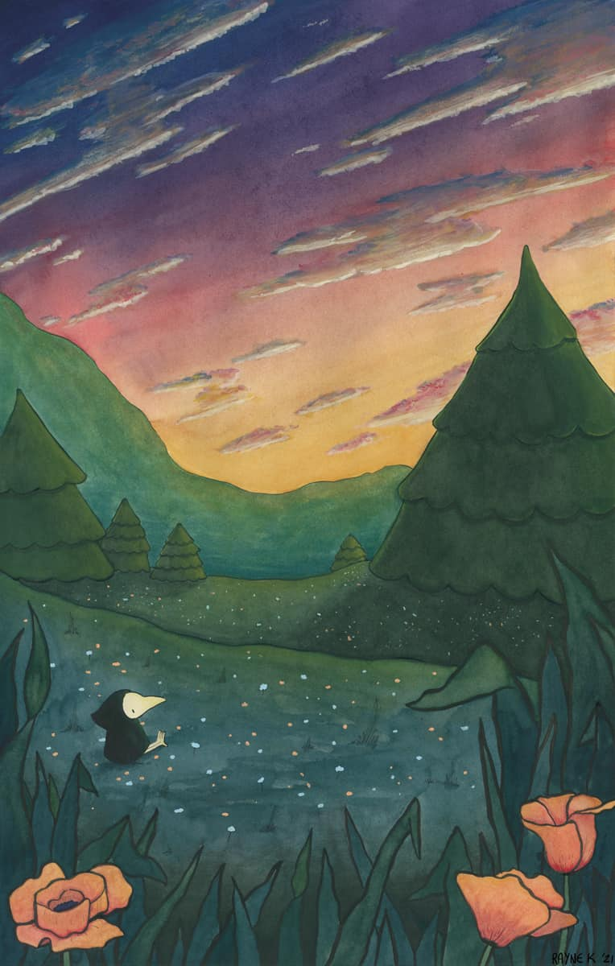
Figure 5
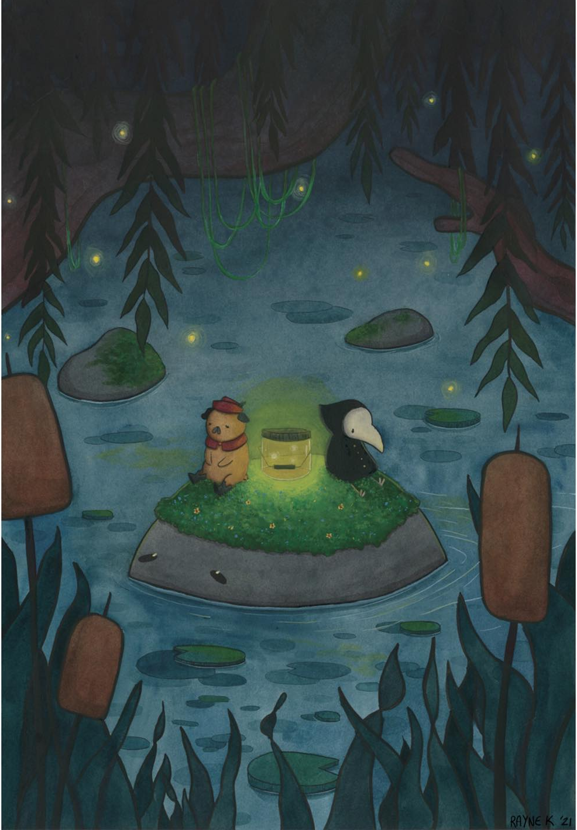
Figure 6

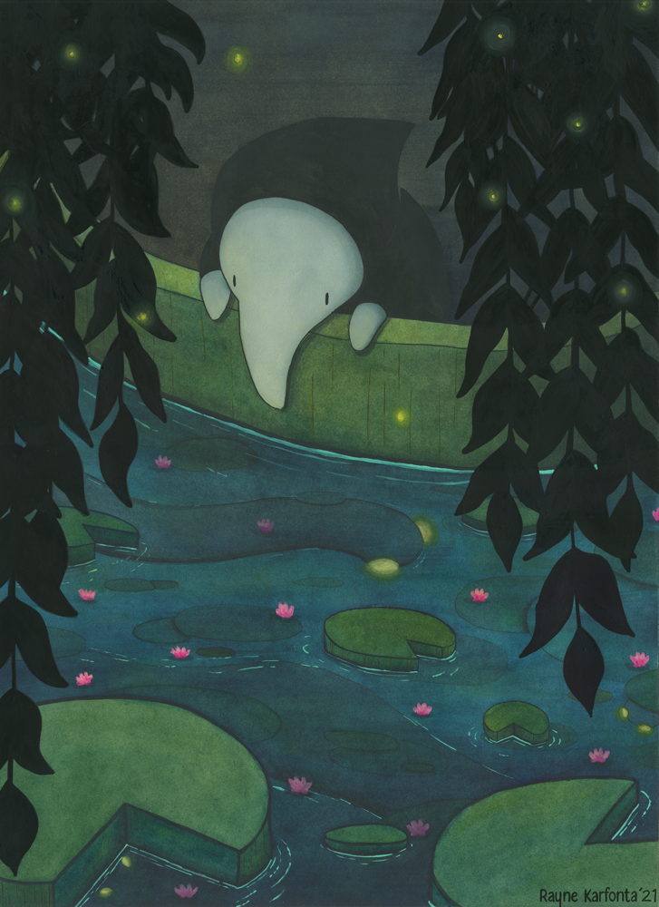
Figure 7
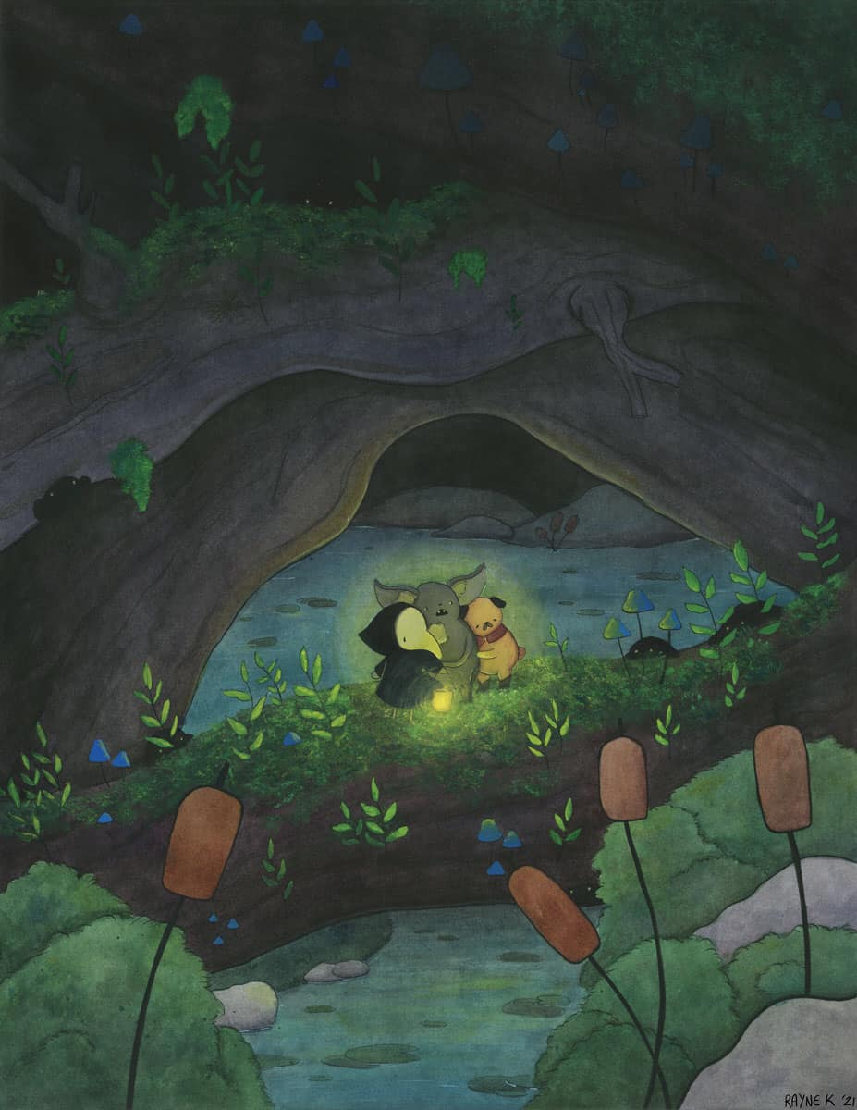
Figure 8

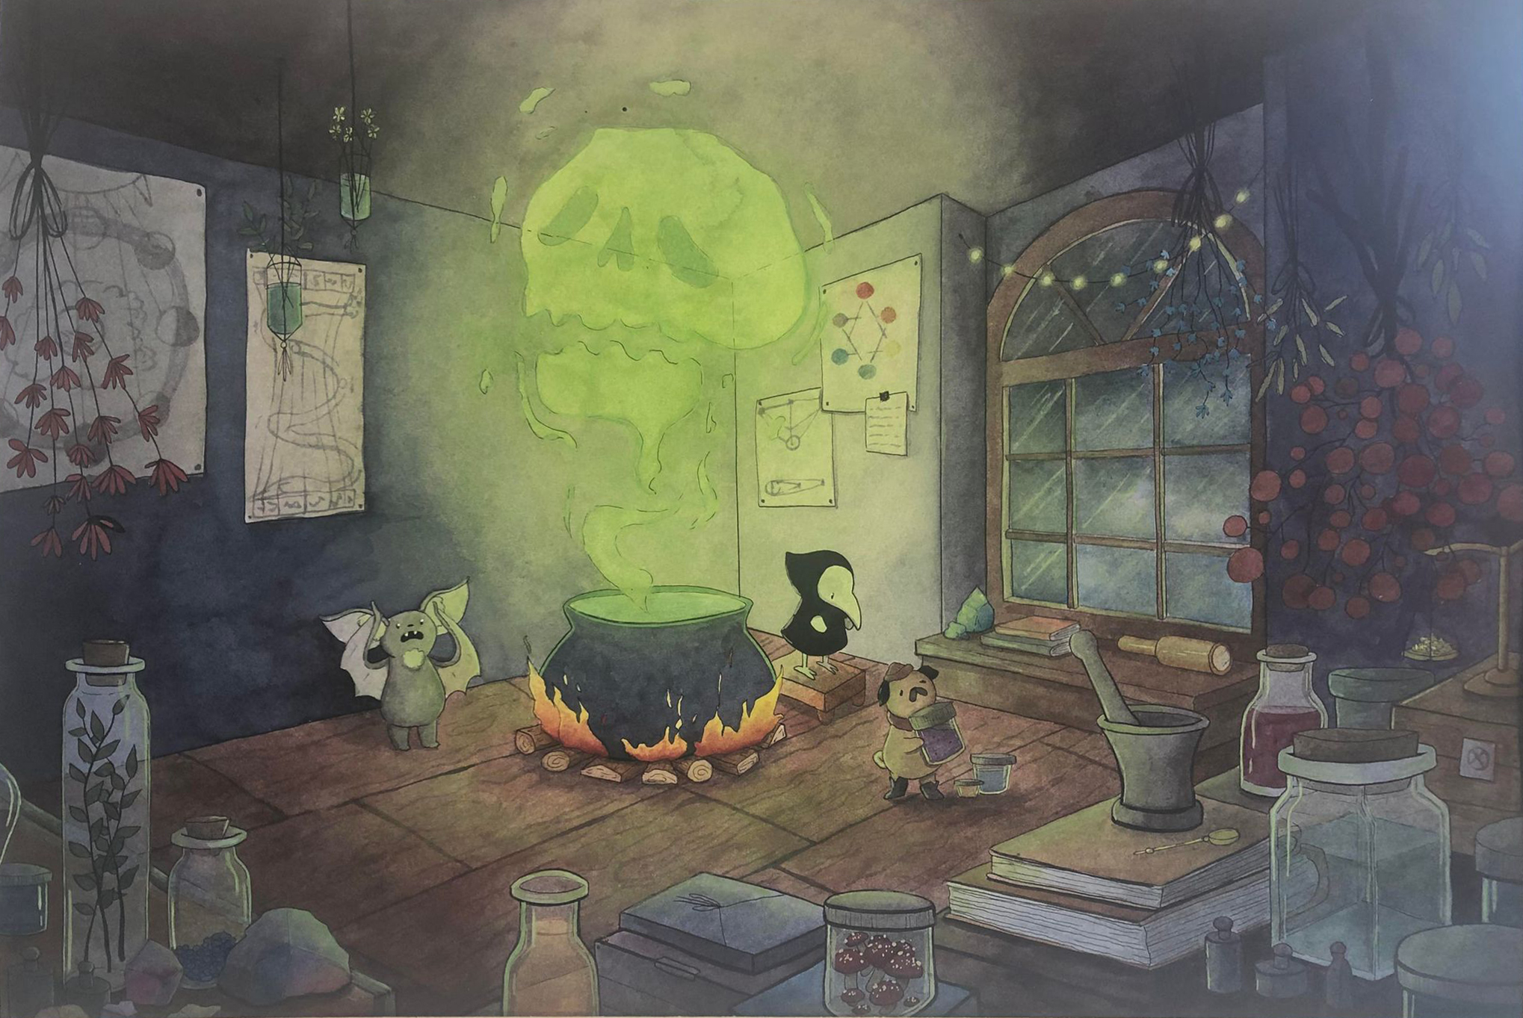
Figure 9
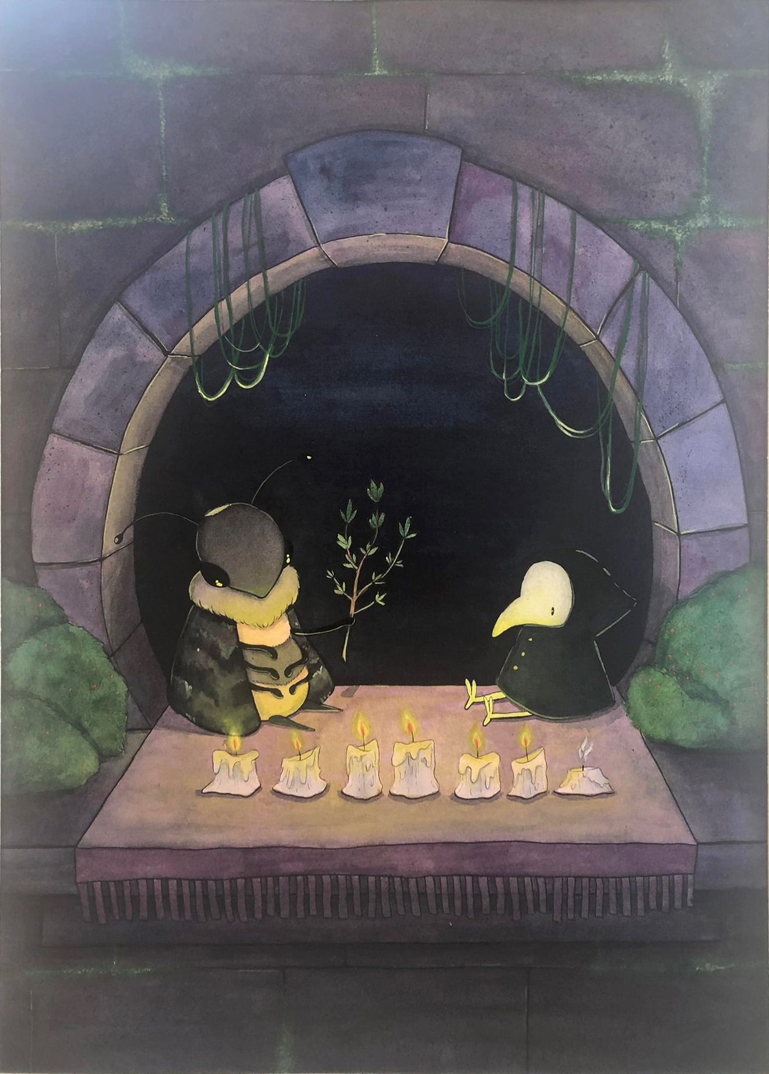
Figure 10
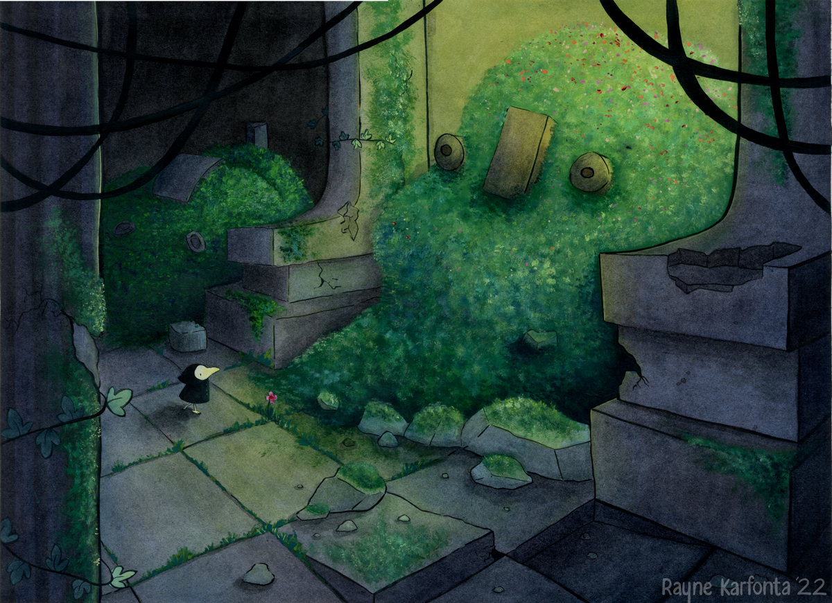
Figure 11
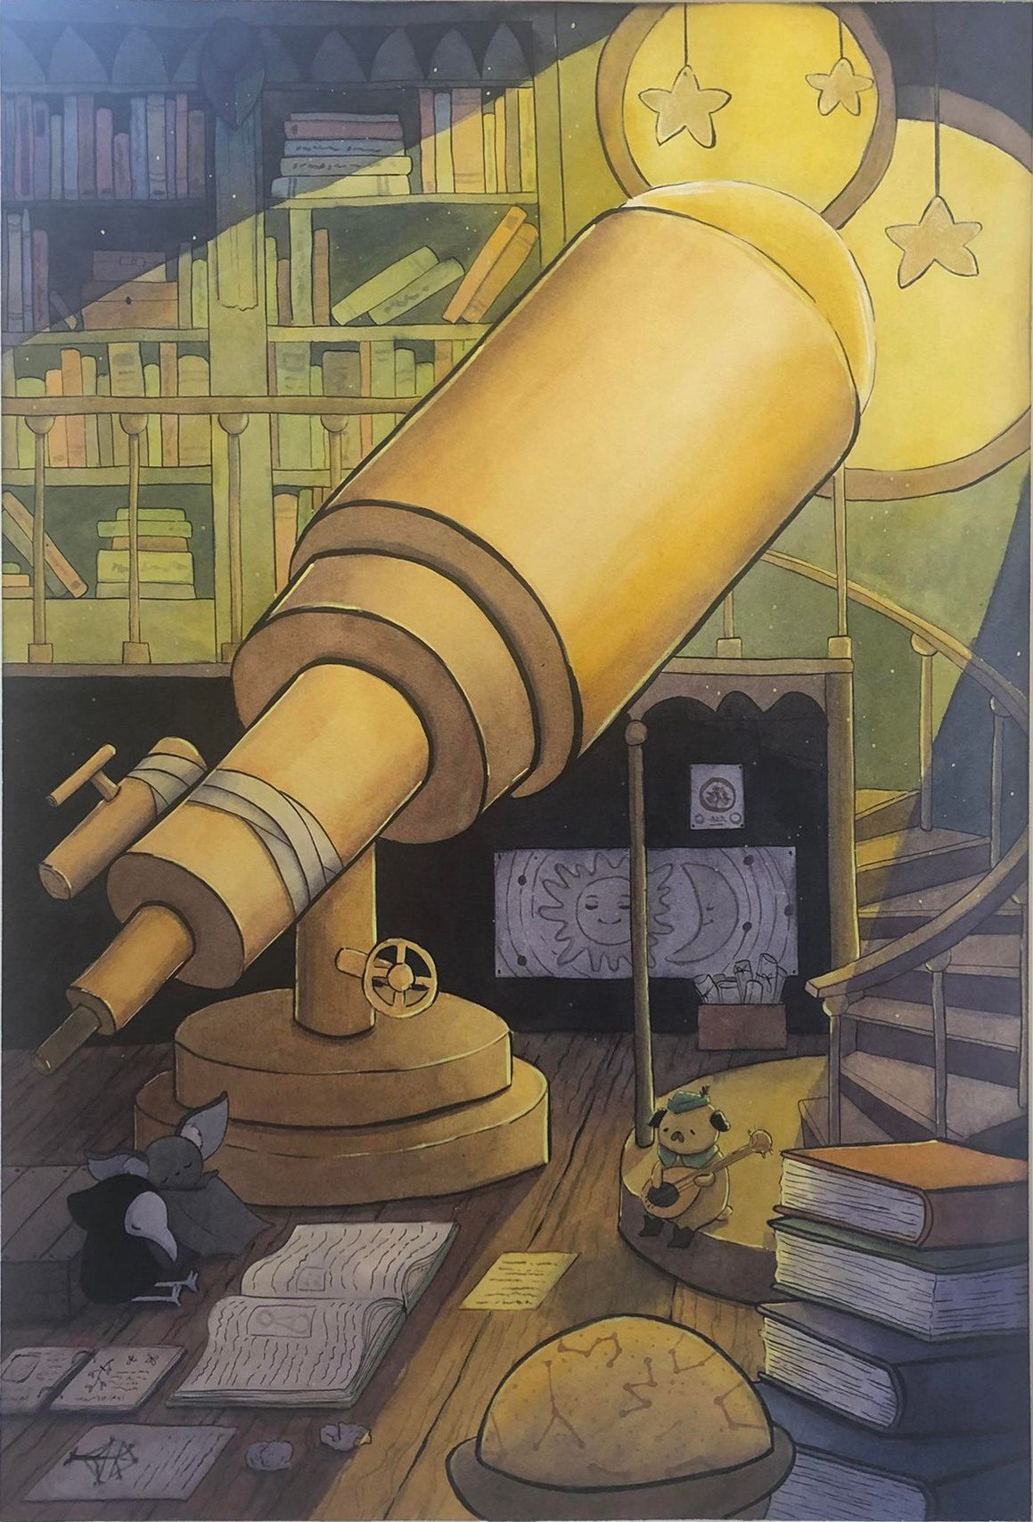
Figure 12
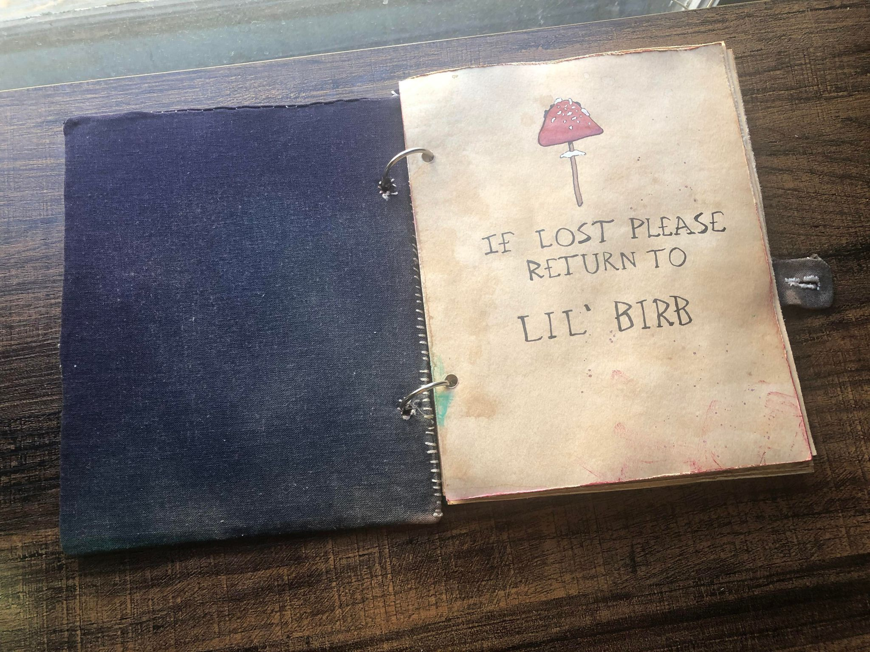
Figure 13

