Natural Beauty
Appreciating Women and Nature Through an Eco-Feminist Lens
Elizabeth K. Page
M.F.A Painting

Introduction

Throughout my artistic career, I have aimed to create paintings that address feminism in one form or another. I address various inequities or expectations within our society that force limitations on women, and even more specifically, the impact that these limitations can have on a woman’s mentality. Although I do not plug my own insecurities and inadequacies into these pieces, I strive to provide the confidence and pride to my viewer that I wish I had. As a woman I am constantly reminded of my imperfections and I am not the only one, which is why I focus on a natural beauty that breaks the bounds of what is typically perceived as beautiful in our media driven world. It is easy to lose sight of your own value when you are surrounded by images of something almost entirely unobtainable without the use of Photoshop. Paintings in this body of work address societal expectations placed on women inspired by eco-feminist philosophy and attempt to invoke dialogue through figurative compositions using symbols taken from nature, history, and mythology. All the while displaying an appreciation for the beauty of a woman's natural form as well as the organic world around us.

Reasoning / Research

I utilize natural elements in my work not only for my love of painting nature, but also because it emphasizes a “natural beauty” that isn’t appreciated enough. The stances that I take are ranged but have consistent elements such as painting women in their nude form, which includes all of the physical attributes that society may deem as imperfections. Elements such as excessive body hair, weight, stretch marks, low hanging breasts, wrinkles, and veins are just a few points of interest among the forms in my paintings that are typically not shown in today’s media.
My interest in these issues is, of course, not purely for academic purposes. As a woman I often feel inadequate based on media’s perception of what is deemed as beautiful, as well as feeling inferior or objectified by the male gaze. These feelings ultimately provide me with a drive to emphasize the beauty of other women and show an appreciation towards them along with natural and symbolic elements.
When I started with these paintings I immediately gravitated towards the concept of eco-feminism as it seemed like a perfect fit for what I was trying to accomplish. Eco-feminism, or ecological feminism, is often defined as a movement that sees connections between the domination of nature by the human race, and the exploitation of women. It is similar to basic feminism, as it shares the same beliefs of a gender-equal society, but it differs by implementing the environment into their belief system belief system with emphasis on the similarities between women and nature.
Within the eco-feminism umbrella are various types of ecofeminists; the most popular are radical and cultural. The cultural believe that women have a very intimate relationship with nature because of their biology and ability to create life. As a result of this, cultural ecofeminists also believe that women can be more concerned with the degradation of the environment.
The radical ecofeminist believes the similarities between women and nature is affected by patriarchal society that looks to degrade and dominate both parties. Radical eco-feminism developed in the late 1960’s and through the 1970’s and focused on how the relationship between women and nature evolved from prehistory, and how the mother goddesses were dethroned and replaced with male gods that had subservient female deities. Radical eco-feminism also praises the relationship between women and nature and brings back old traditions and rituals of worshipping goddesses, the moon, animals, and the female reproductive system. The focus on the reproductive system is also a common element in radical eco-feminism and they object to the idea that women are limited simply because of their ability to create life. These natural abilities only serve to power women, and that it provides us with a spiritual connection that men are incapable of having.
There is, however, another tangent to these beliefs that are centered around nature-based religion. In the mid 1970’s many radical and cultural feminists discovered through historic and archaeological resources of a religion that provided a lead female goddess, Gaia, who places value upon women and our earth. She is depicted to love the earth so much that Gaia’s anatomy is made up of different elements of nature. Charlene Spretnak touches base on this in her essay of Ecofeminism: Our Roots And Flowering where she states “What was intriguing was the sacred link between the Goddess in her many guises and the totemic animals and plants, sacred groves and womblike caves, in the moon rhythm blood of menses, the ecstatic dance - the experience of knowing Gaia, her voluptuous contours and fertile plains, her flowing waters that give life, her animal teachers.” This was the starting point for my conceptual sketches of Mother Nature and Father Metropolis where I began thinking of the figures as more god-like.
This broader idea was where my work started, where I depicted goddesses that were icons for this specific ideology. However, as I continued forward, I realized that I wanted to create work that could relate to an individual as well as gender as a whole. Although I enjoyed painting larger than life goddesses and will continue to do so going forward, I also wanted to create pieces that could be relatable towards females in today’s world, yet still acknowledging that we have those ties to mother earth. Feminist philosopher Susan Griffin challenges Western tradition’s assertations that humanity is separate from nature but ties it back into an individual standpoint. In the final chapters of her Woman and Nature book she reverses Plato by saying “I know I am made from this earth, as my mother’s hand were made from this earth, as her dreams were made from this earth, and this paper, these hands, this tongue speaking all that I know speaks to me through this earth and I long to tell you, you who are earth too, and listen as we speak to each other of what we know: the light is in us.” She defines in that passage as the line where collectively we belong to this planet while retaining and acknowledging her own individual self in the process. To reflect this idea, portraits were painted on smaller Aquaboards to provide individuality to the figures while using smaller natural elements to tie them to the much broader eco-feministic lens.
The initial association with women and nature isn't a stretch, as both create and sustain life. There is also a desire to anthropomorphize the earth into a motherly and nurturing figure for the same reasons. In fact, Carolyn Merchant, a philosopher and professor of environmental history, philosophy, and ethics, goes so far as to compare certain aspects of our world to the genitals and birth of women. She argues that even though we view our earth as a “mother” we do not treat her as we would our own mother, stating that “One does not readily slay a mother, dig into her entrails for gold or mutilate her body, although commercial mining would soon require that.” Though “Mother Nature” remains as a common and well-known icon, we tend to forget that if anything or anyone earns the title of “mother” then they should be treated as such.

Materials / Process:

I choose to work in watercolor for these paintings because I enjoy the fluidity and softness that watercolor can provide for the figure. The intense color and brightness caused by the light bouncing off the white paper and reflecting back up through the paint can give the figure certain tones that assist in allowing the figure to look more “flesh-like”. I also enjoy the actual process of how I paint the figure with watercolor; it takes numerous layers to create the form and each mark is an important decision. To prevent as many mistakes as possible, numerous sketches are done on paper to assess which compositions work best. Then I pick the top two that I enjoy the most and take photos of my model in said poses. I transfer the sketches into a digital drawing program and begin sketching out the composition further. I use digital sketching often as it allows me to quickly correct mistakes without having to re-draw over and over. Once I have settled upon a final sketch, I make a new file in Photoshop and do a quick color composition. I digitally paint in where I want certain tones, shadows, or highlights to be which is typically a very quick process as I am not focused on perfection in this initial stages. I transfer the image onto my surface using a grid system and mask off any highlights or areas I need to keep white.
The actual painting process is my favorite, I enjoy adding tones layer by layer while carving out the figure. Unlike other mediums watercolor has a mind of its own, and once a mark is put down, it is extremely difficult to remove. Every mark I make requires thought and consideration. By the end of the painting, feel as though a relationship has been built between myself and the painting. After spending weeks of layering up to carve out the form it becomes very precious to me. This is what causes the hardest part of my painting process, which is knowing when to stop. I often find myself wanting to work on something for forever because it has become precious to me. I have to walk away often to prevent myself from over-working the surface. Once a watercolor painting is complete, I feel that I have truly given it every ounce of myself with how much time I spend on each individual mark. It is a very satisfying yet tedious process that brings me pleasure by the end of it.

Artwork Breakdown:

“Mother Nature and Father Metropolis” (Fig. 1)

The Mother Nature and Father Metropolis piece is my take on the classical “Mother Nature” character while also creating her counterpart “Father Metropolis” who is a representation of large industrial cities, pollution, and other negative man-made footprints on earth. In addition to the environmental aspects of “Father Metropolis”, he is also ra representation of toxic masculinity in an almost literal form. By posing him in a dominating nature while quite literal toxic elements protruding from his city/body I was able to express an unhealthy appearance and implied personality. His eyes have a blank expression, one that looks empty of emotion and personality and is more representative of him being simply a product of the environment he is in. “Mother Nature” is a pretty standard depiction of the character, I wanted her to be almost entirely made from nature to me that seemed far more interesting than just a human. The pose for “Mother Nature” was carefully chosen to keep her from being completely vulnerable by having her legs remain closed and off to the side, not granting “Father Metropolis” access despite him looming over her. Her face shows concern but not completely distraught, she isn’t allowing herself to show fear. She is strong both in heart and mind, and like most mothers, she will carry herself with the same maturity and dignity she would want her child to have.

“Terra” (Fig. 2)

Terra references the Roman goddess of earth “Terra Mater” who is typically depicted reclining with either bunches of fruit or flowers. In this painting, Terra is depicted lounging in a indistinguishable place that contains grass while also having an abstracted background. This helps to emphasize her “otherworldliness” by placing her in an environment that is not easily identifiable as earth, creating ambiguity and intrigue to the setting. Her hair also adds to this emphasis, as it is an iridescent tone with metallic highlights within it, giving the hair its own magical properties. She reclines on a collection of flowers, each containing their own symbolic meaning. Peach roses are typically a symbol of appreciation, pink gladiolas symbolize strength of character, and heather represents admiration and protection. Each of these flowers ties into the relationship between females and nature, and the appreciation of the two. Unlike my other paintings, Terra is not massive in comparison to her environment. I felt that this was an unnecessary feature since the physical scale of the painting allows her to be confrontational already.

“Hey Honey” (Fig. 3)
For my Aquaboard pieces I chose an almost life-size scale, with the figure making direct eye contact with the viewer. The figure is accompanied by a symbolic piece of nature, such as tiger lilies, bees, etcetera; that continues to show that relationship between women and nature but with a deeper context by tapping into the symbolism of flowers and using metaphors for societal expectations using insects. All of these pieces have an abstracted background so that the figures themselves are not grounded in reality but rather an undefined place. This adds interest to the paintings while also allowing me to be make more expressive marks and creative decisions.
Hey Honey focuses on the societal change to gender equality, and if you aggravate or disrupt the patriarchal norm then there could be backlash. Granted we are no longer living in an age where menstruation is considered a threat to warfare, but even by today’s standards there are still societal expectations that are pushed onto women. The bees that are depicted in this painting are meant to be a representation of those societal expectations, they are even painted gold so that they are deemed as “precious” or “important”. Much like beauty standards or traditional expectations of women, they are held to a higher standard but can be detrimental on a woman’s self-image. I used Africanized honeybees as a reference as they are the most aggressive type of honeybee and has been knows to kill horses, cattle, and even humans. It made sense to use a bee that was held to a higher standard because of honey production yet was so harmful to its environment because of its aggressive behavior.
The woman in the painting makes eye contact with the audience, providing her with confidence and intimidation. Her body has multiple sting wounds to show that she had been stung by the bees before from agitating the patriarchal system and will most likely be stung again.

“Tiger Lily” (Fig. 4)

Tiger Lily is a piece that represents the positive mindset and confidence of being in your own body. The figure is in a slightly sexual but overall confident pose while making eye contact with the viewer. Tiger Lilies are the primary natural element in this piece as their history and symbolism fit well in my work. Lilies themselves are an extremely feminine oriented flower and carry multiple different meanings in a variety of different cultures. In Greek culture they represent rebirth and motherhood which is based on the lily being grown by the Goddess Hera’s breast milk. In Assyrian and Babylonian cultures, the Lily was typically associated with the Goddess Ishtar, who was the goddess of fertility, love and war. Lilies even have medicinal properties, and their bulbs can be boiled in water to make teas that help women in labor. In this painting we see orange tiger lilies used which adds an additional element to their symbolic meaning as they are viewed as a symbol for confidence and pride which is why I paired them with this painting.

“Fruit of the Womb” (Fig. 5)

Fruit of the Womb addresses the stigma in our society that aging is something to be ashamed of. There are thousands of creams, treatments, and surgeries to prevent your body from showing any signs of aging and you hardly see anyone over the age of forty in the media. I challenge the concept that we are trying so hard to hide something that is natural and out of our control. The primary element in this piece is the pomegranate, which is a common symbol for femininity, fertility, and abundance. It also is used commonly in art as a symbol for female reproductive organs, which is why I have it displayed to be perceived as a uterus with pomegranate blossoms being the ovaries. However, the pomegranate is not in pristine condition. Instead, it is beginning to change color and does not appear to be edible anymore. Though not completely rotted, the fruit starting to turn implies that early stages of menopause could be beginning and that the figure may reach a point where they are no longer able to have children. Ultimately, this piece addresses the objectification of women and how the perception change when the ability to create life is lost.

“A Girl’s Best Friend” (Fig. 6)

This piece plays with the classic phrase “diamonds are a girl’s best friend” the piece implies that the serpent is the girl’s companion instead. I present a positive depiction of a woman and serpent. Due to the story of Adam and Eve there are many depictions of the relationship between women and serpents that are negative, however in other cultures and mythology there are also positive depictions of this relationship. Egyptian goddesses that represented nature and beauty were typically portrayed with serpents in their hands and were also a symbol of divine sexuality. In Ancient Crete the Great Goddess was always depicted with serpents wrapped around her as a symbol of birth, regeneration, and overall protection. Pulling from both of these cultures I purposefully placed the serpent across the woman’s waist and depicted her with a confident demeanor. In addition, having her address the viewer with her gaze provides her with power and authority to counteract the typically perceived vulnerability that comes from the nude form.

“That Booty Tho” (Fig. 7)

A peach is just a peach unless given a sexual context. Emojis and modern culture have made the peach a symbol for a person’s behind and is often used when describing someone with a particularly large behind. I equate this to a nude woman, as a nude woman is just a woman unless given sexual context. The figure in this painting isn’t doing anything explicit, and the front of her body is hidden. We can only see her backside in this passive and relaxed pose. The viewer can make a conscious choice to sexualize her or not based on what they see, and there is criticism within that choice. I want my viewers to ask themselves why they are making something as natural as the body become so sexualized. Nudity does not equal erotic, and I aim to challenge that in this piece.

“Read My Lips” (Fig. 8)
Knowledge of your own anatomy always felt like it was a given. You were the best person to know your body, right? I had always assumed this until I met someone who didn’t know what their anatomy was and was even afraid of learning it. She didn’t know where the urethra was on the female body, and originally perceived it to be inside the clitoris much like how a penis functions. I was baffled by this and asked an empty room why she never took control of her own body and learned how it operates. It reminded me of when we were younger and still learning about what sexual interactions were. We were encouraged as girls to hand our virginity over to someone who would take care of us during the first time. Someone who would do it for us. Meanwhile I never heard of anyone teaching the boys how to make the first time less painful or what to do to help relax their partner. It all felt so one-sided and silly.
The term “pop your cherry” was used as a metaphor for losing your virginity, more specifically a woman losing her virginity. It was used in statements between teenage boys as they told their friends their sexual escapades, as if popping a woman’s cherry was a trophy to be obtained. However, if the hymen was torn accidentally or through self exploration, then her value was lessened.
The painting depicts a reclining nude holding a book. She is positioned with legs relaxed and open, her genitals shown but intentionally painted in loosely. Her gaze addresses the viewer as if we have interrupted her reading. There are cherries all over the composition including hanging from her ears to allude to that “pop your cherry” phrase. It is more blunt, maybe even more vulgar, than what I paint. However, I felt like it was necessary to branch outside of my comfort zone as it aided in enforcing my point.

“Clitoria” (Fig. 9), “Cliffside” (Fig. 10), “Moss” (Fig. 11), “Waterfall” (Fig.12), “Mushroom” (Fig. 13), “Evergreen” (Fig. 14), “Self Portrait” (Fig. 15)
For the latter half of this work I played with integrating natural elements within the figure itself. These pieces were more experimental and allowed me to focus less on symbolic elements, but more on technique and visual appeal. Using water, flowers, trees, and other various organic elements and combining them with nude figures allowed me to enforce the natural beauty that I wanted my audience to see.

Conclusion:

Society has placed many stereotypes and expectations on our world. Just about everything has some ideal image of what we expected it to look like or behave. Men are expected to be tall, muscular, and protective while women are shorter, thinner, and more passive. Breaking outside of the gender stereotypes can cause a change in perception, both in positive ways and negative ones. It is my philosophy that your appearance and self worth should stem from what you believe you should be. Your value shouldn’t be based on biology, and your image shouldn’t be based on another perception of perfect. My work addresses female specific stereotypes and stigmas while using eco-feminist theory as a tool to aid in my goal to enforce the importance of self love and value. Being authentic to ones self and remembering that we are all human can allow us to embrace that beauty that comes naturally.

Works Cited

Davis, Kenneth C. Don't Know Much about Mythology: Everything You Need to Know about the Greatest Stories in Human History but Never Learned. New York: Harper, 2006.
Dietz, S. Theresa. The Complete Language of Flowers: a Definitive and Illustrated History. New York, NY: Wellfleet Press, 2020.
Griffin, Susan. Woman and Nature. Counterpoint, 2016.
Merchant, Carolyn. Earthcare: Women and the Environmental Movement. S.l.: s.n., 1981.
Merchant, Carolyn. “Ecofeminism and Feminist Theory*.” Science and Nature, 2017, 250–60. https://doi.org/10.4324/9781315111988-20.
Merchant, Carolyn. The Death of Nature: Women, Ecology, and the Scientific Revolution. San Francisco: Harper & Row, 1989.
Ortner, Sherry B. “Is Female to Male as Nature Is to Culture?” Feminist Studies 1, no. 2 (1972): 5. https://doi.org/10.2307/3177638.
Spretnak, Charlene. The Politics of Women's Spirituality: Essays by Founding Mothers of the Movement. Garden City, NY: Doubleday, 1994.

Figure Sheet

Figure 1
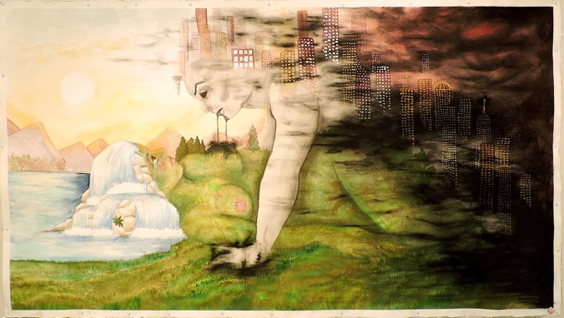

Mother Nature and Father Metropolis
42” x 84”
Watercolor and Gouache on Watercolor Paper
2019

Figure 2
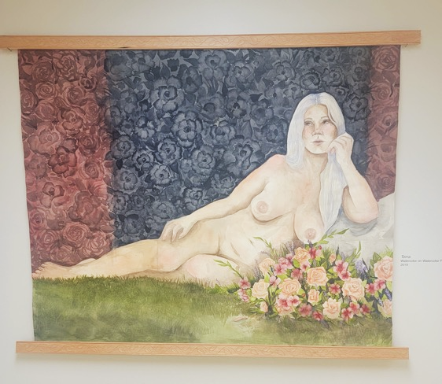

Terra
42” x 66”
Watercolor on Watercolor Paper
2019
Figure 3

Hey Honey
24” x 36”
Watercolor on Aquaboard
2020

Figure 3
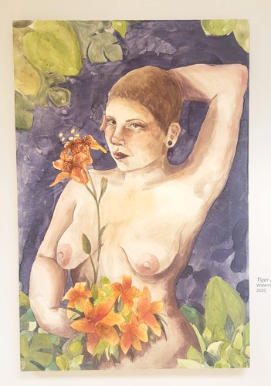
Tiger Lily
24” x 36”
Watercolor on Aquaboard
2020
Figure 5
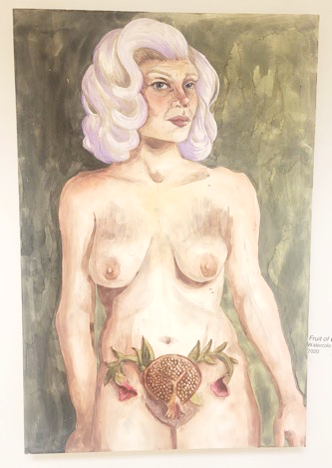
Fruit of The Womb
24” x 36”
Watercolor on Aquaboard
2020

Figure 6
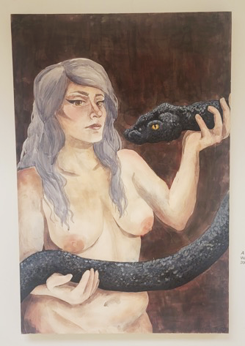
A Girl’s Best Friend
24” x 36”
Watercolor on Aquaboard
2020
Figure 7

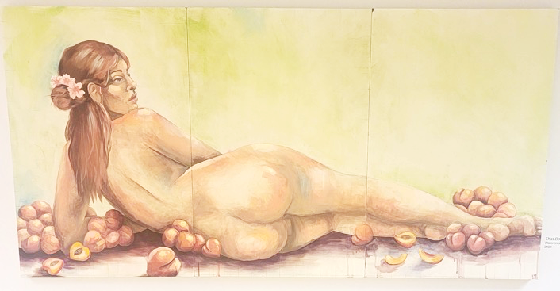

That Booty Tho
36” x 72”
Watercolor and Gouache on Aquaboard
2021

Figure 8
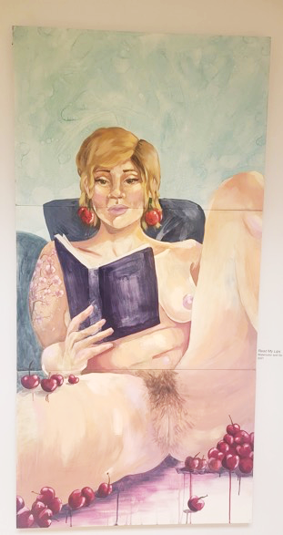
Read My Lips
72” x 36”
Watercolor and Gouache on Aquaboard
2021
Figure 9
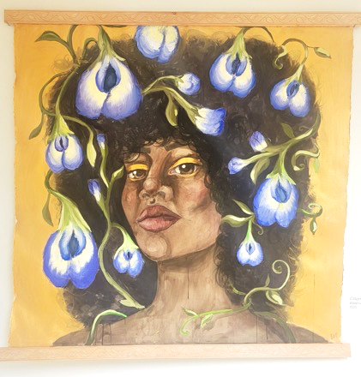
Clitoria
42” x 42”
Watercolor on Watercolor Paper
2021

Figure 10
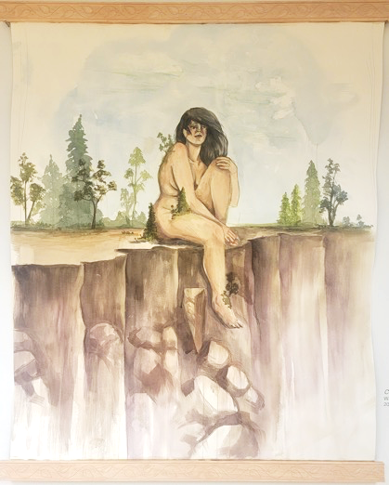
Cliffside
36” x 42”
Watercolor on Watercolor Paper
2021

Figure 11
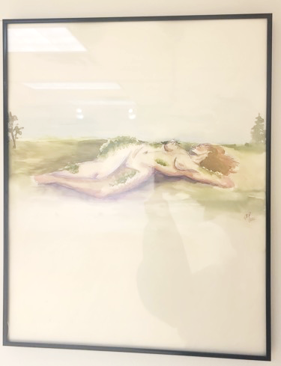
Moss
16” x 20”
Watercolor on Watercolor Paper
2022

Figure 12
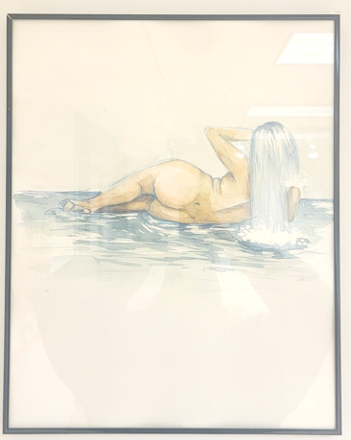
Waterfall
16” x 20”
Watercolor on Watercolor Paper
2022

Figure 13

Mushroom
16” x 20”
Watercolor on Watercolor Paper
2022

Figure 14
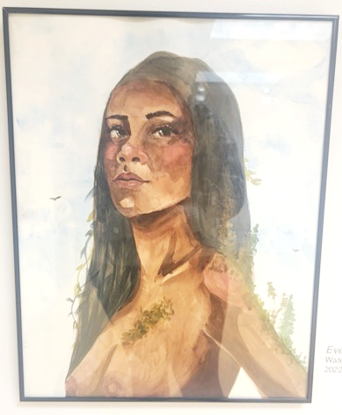
Evergreen
16” x 20”
Watercolor on Watercolor Paper
2022

Figure 15

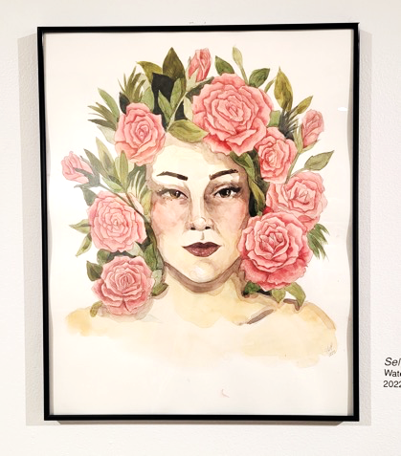
Self Portrait
16” x 20”
Watercolor on Watercolor Paper
2022

Merchant, Carolyn. Earthcare: Women and the Environmental Movement. S.l.: s.n., 1981.
Ibid
Ibid
Ibid
Ibid
Spretnak, Charlene. The Politics of Women's Spirituality: Essays by Founding Mothers of the Movement. Garden City, NY: Doubleday, 1994.
Spretnak, The Politics of Women's Spirituality: Essays by Founding Mothers of the Movement.
Griffin, Susan. Woman and Nature. Counterpoint, 2016.
Merchant, Carolyn. The Death of Nature: Women, Ecology, and the Scientific Revolution. San Francisco: Harper & Row, 1989.
Davis, Kenneth C. Don't Know Much about Mythology: Everything You Need to Know about the Greatest Stories in Human History but Never Learned. New York: Harper, 2006. Page 71
Dietz, S. Theresa. The Complete Language of Flowers: a Definitive and Illustrated History. New York, NY: Wellfleet Press, 2020.
Davis, Don't Know Much about Mythology: Everything You Need to Know about the Greatest Stories in Human History but Never Learned. (Page 71)
Dietz, The Complete Language of Flowers: a Definitive and Illustrated History.
Davis, Don't Know Much about Mythology: Everything You Need to Know about the Greatest Stories in Human History but Never Learned. (Page 51)
Davis, Don't Know Much about Mythology: Everything You Need to Know about the Greatest Stories in Human History but Never Learned. (Page 51)

