From Self-Portraits to Selfies
Gender Performance in Artemisia Gentileschi’s Self-Portrait as a Lute Player and
Amalia Ulman’s Excellences & Perfections

Final Thesis

Presented to the Visual and Critical Studies Program
Kendall College of Art and Design, Ferris State University

In Partial Fulfillment of the Requirements for the Degree
Master of Arts in Visual and Critical Studies

By Laurel Dugan

April 26, 2023
WE, THE UNDERSIGNED MEMBERS OF THE COMMITTEE,

HAVE APPROVED THIS THESIS
From Self-Portraits to Selfies:
Gender Performance in Artemisia Gentileschi’s Self-Portrait as a Lute Player and
Amalia Ulman’s Excellences & Perfections
By
Laurel Dugan

THESIS COMMITTEE MEMBERS

Susanna Kelly Engbers, Ph.D. (thesis supervisor)
General Education/MAVCS

Christine Haskill, Ph.D.
General Education/MAVCS

Diane Zeeuw, M.F.A. Painting/MAVCS

MASTER OF ARTS IN VISUAL AND CRITICAL STUDIES PROGRAM (MAVCS)
KENDALL COLLEGE OF ART AND DESIGN, FERRIS STATE UNIVERSITY
April 2023

Acknowledgments
I want to whole-heartedly thank Professors Susanna Engbers and Diane Zeeuw. Truly, without you, I would not be writing this. Thank you, Diane for shepherding me through two master’s programs and believing in me the whole time. Your kindness and intellectual rigor have pushed me beyond what I thought I was possible. Thank you, Susanna, for your tireless critical reading, insights, and enthusiasm for my project. Thank you also for all the intermittent deadlines and for making sure that I crossed the finish line on time. I have learned more about writing from you than I will ever be able to say. You both are—without a doubt—the two most generous teachers I have ever had. Your willingness to give your time, energy, and deep thinking has taught me much knowledge. It has also taught me how to be a good teacher. I hope I can show my future students some of the generosity you have given me.
Thank you to Christine Haskill, for being so willing to jump in on my committee and for the time and generosity you’ve given to my project. You have brought valuable insights and perspective that have made the project better. It has been such a pleasure to work with you.

Thank you to my classmates: Kimn, Hannah, and Amy. Finding your people is important, and when you love visual studies, your people don’t come along every day. I will remember our animated class discussions fondly. You are very special to me.

Thank you to my husband, Conor. You have shown true love and sacrifice in the last four years.
Last, to my children: Gianna, Michael, Seamus, and Finn. Thank you for walking this path with me. I love you.

Table of Contents

List of Figures………………………………………………………………………….....………4
Abstract…………………………………………………………………………………………...6
Chapter 1: Introduction…………………………………………………………………............7
Chapter 2: The (Neo-)Baroque………………………………………………………….........32
Chapter 3: Performance and Performativity…………….……………………….……............51
Chapter 4: The Mise en Abyme……………..............................................................................68
Chapter 5: Conclusion...................................................................................................................85

Appendix: Figures..........................................................................................................................90
Bibliography................................................................................................................................108

List of Figures
Figure 1. Artemisia Gentileschi, Self-Portrait as a Lute Player, 1614, Oil on canvas, Wadsworth Atheneum Museum of Art, Connecticut.

Figure 2. Amalia Ulman, “The Cute Girl,” Excellences & Perfections, 2014, Digital photography on Instagram, https://webenact.rhizome.org/excellences-andperfections/20141014150552/http://instagram.com/amaliaulman.

Figure 3. Amalia Ulman, “The Sugar Baby,” Excellences & Perfections, 2014, Digital photography on Instagram, https://webenact.rhizome.org/excellences-and-perfections/20141014150552/http://instagram.com/amaliaulman.

Figure 4. Amalia Ulman, “The Life Goddess,” Excellences & Perfections, 2014, Digital photography on Instagram, https://webenact.rhizome.org/excellences-and-perfections/20141014150552/http://instagram.com/amaliaulman.

Figure 5. Caterina Van Hemessen, Self-Portrait, 1548, Oil on board, Kunstmuseum, Basel.

Figure 6. Sofonisba Anguissola, Self-Portrait at the Clavichord, 1561, Oil on canvas, Kunsthistorisches Museum, Vienna

Figure 7. Lavinia Fontana, Self-Portrait at the Clavichord with Servant, 1577, Oil on canvas, Accademia di San Luca, Rome.

Figure 8. Michelangelo Merisi da Caravaggio, Deposition, c. 1603, Oil on canvas, Chiesa Nuova, Rome.

Figure 9. St. Teresa in Ecstasy, Gianlorenzo Bernini, c. 1650, White marble, Santa Maria della Vittoria, Rome.

Figure 10. Andrea Pozzo, Triumph of Saint Ignatius ceiling fresco, 1691-1694, Church of St. Ignatius, Rome.

Figure 11. Michelangelo Merisi da Caravaggio, Death of the Virgin, 1606, Oil on canvas, the Louevre, Paris.

Figure 12. Michelangelo Merisi da Caravaggio, Conversion on the Way to Damascus, Santa Maria del Popolo, Rome.

Figure 13. Cindy Sherman, Untitled Film Still #2, 1977, Silver gelatin photograph, Museum of Modern Art.

Figure 14. Frances Benjamin Johnston, Self-Portrait, Silver gelatin photograph, 1896, Library of Congress.

Figure 15. Claude Cahun, Self-Portrait, 1927, Silver gelatin photograph.

Figure 16. Claude Cahun, Self-Portrait, 1928, Silver gelatin photograph.

Figure 17. Frida Kahlo, Henry Ford Hospital, 1932, Oil on metal, Dolores Olmedo Museum, Xochimilco, Mexico City.

Figure 18. Frida Kahlo, My Birth, 1932, Oil on metal, Private Collection.

Figure 19. Louise Bourgeois, Self-Portrait, Kunsten Museum of Modern Art Aalborg

Figure 20. Alice Neel, Self-Portrait at Age Eighty, Oil on canvas, 1980, National Portrait Gallery

Figure 21. Example of “Korean girls whose Instagrams I check every morning,”

Figure 22. Amanda Bynes, 2013

Figures 23 and 24. Gwyneth Paltrow’s Goop’s Instagram feed

Figure 25. Gisele Bündchen,

Figure 26. Self-Portrait as St. Catherine -Uffizi

Figure 27. Self-Portrait as St. Catherine of Alexandria - NGA

Figure 28. Instagram post by Wadsworth Atheneum Museum of Art

Figure 29. Instagram post by Detroit Institute of Art (DIA)

Figure 30. Instagram grid for Excellences and Perfections

Figure 31. DIA Gift shop, showing Artemisia “merch”

Figure 32. Jan Van Eyck, Arnolfini Portrait, …

Figure 33. Johannes Gumpp, Self-Portrait

Abstract

This thesis analyzes two works of female self-portraiture: Artemisia Gentileschi’s Self-Portrait as a Lute Player, an oil painting made in 1614, and Amalia Ulman’s Excellences & Perfections, an Instagram performance—largely composed of selfies—made in 2014. Through the lenses of the (Neo-)Baroque, Judith Butler’s theory of performativity, and the concept of the mise en abyme, the analysis reveals similarities in the seemingly contrasting artifacts. By interpreting both texts as having baroque qualities, a foundation is laid on which to compare them. The analysis demonstrates how each text acts as a tool of manipulation for its maker in the network of power. Taking Judith Butler’s statement “[Woman] is a permanently available site of contested meanings,” the examination highlights the ways each artist constructs and projects the illusion of a stable self while participating in an endless abyss of meaning. Ultimately, the thesis demonstrates how both artifacts are current sites of meaning-making and reflect each other like an endless series of mirrors.

Chapter One: Introduction

Overview
This thesis analyzes two works of female self-portraiture: Artemisia Gentileschi’s Self-Portrait as a Lute Player, an oil painting from 1614, and Amalia Ulman’s 2014 Instagram performance, Excellences & Perfections. While created four hundred years apart, the works resemble each other in surprising and significant ways. Primarily through Judith Butler’s theories, I analyze how performativity shapes the projection of a self; in addition, however, I employ two other lenses to further unpack the analysis: namely, the concept of the neo-baroque and the concept of the mise en abyme.

Self-Portraiture, the Mirror, and Changing Concepts of Self
The history of self-portraiture is intertwined with the history of the mirror, which made self-portraits possible. The sixteenth-century poet Berénger de la Tour wrote that mirrors were “invented in order to know that which our gaze cannot see.” The mirror showed artists what he or she could not see unaided: his or her own face. Sabine Melchior-Bonnet expands this statement, claiming that by seeing his own eyes, an artist was able to see into his own soul.
Reflection in nature has always been possible, as the myth of Narcissus indicates. Until about 1500, however, “mirrors” were not the clear, flat glass objects we know them as today; they were very small—a few inches at most—and composed of polished metal or obsidian. These reflective tools gave a viewer some idea of what they looked like, but not with great clarity. Fourteenth century glass blowers created convex mirrors, which were also tiny and came with the distortion of spherical glass. Neither of these types of mirrors was available in abundance. Clear glass mirrors developed in Venice around 1500.
During the Middle Ages, when the Catholic Church dominated cultural norms, the mirror became an object of suspicion. As Stephen Greenblatt has argued, the general concept of a “self” shifted from a humanist perspective to a near-erasure of personal identity for religious reasons. “Hands off yourself,” Augustine of Hippo declared. “Try to build up yourself, and you build a ruin.” By the early-modern period, mirrors were caught in a cultural double-bind between the ancient dictum to “know thyself” and the suspicion of vanity, especially for women. In The Mirror and the Palette, Jennifer Higgie explains that “women rarely included mirrors in their self-portraits, perhaps because for centuries the sin of vanity was embodied, again and again, by a woman holding one. It’s possibly why so many women chose to portray themselves looking out at us: while the artist may have been looking at a mirror to make the painting, once it’s completed, we become the mirror’s substitute.” However, in the early Renaissance, with the rediscovery of ancient texts and renewed interest in a humanist worldview, attitudes began to shift. This coincided with the technological advances in production of clear-glass mirrors. Once again, the injunction “know thyself,” became popular and acceptable—this time as a Christian humanist perspective. Renaissance humanists believed that knowledge of oneself could lead to virtue and knowledge of God. Stephen Greenblatt observes that in the early modern period, attitudes toward intellectual, social, psychological, and aesthetic structures governing identity began to evolve toward an understanding of how one might construct and manipulate an identity to present to the world. In describing this new perspective Greenblatt explains the process as “forming a self” through “a consistent mode of perceiving and behaving”—which parallels Judith Butler’s understanding of how identity is formed. Both understandings emphasize the repetition of behaviors presented to the world—the public-facing parts of one’s life.
The relative availability of clear-glass mirrors offered possibilities to artists that had not existed before. On a cultural level, the availability of the mirror helped birth a new concept of “the self” as an individual with a unique, distinct identity from other individuals. For artists, this humanist perspective led to the belief that artists possessed a unique kind of virtú: a type of excellence encompassing virtuous living and virtue in one’s craft. A cultural fascination and mystique grew around artists, connected to the belief that their creative talents were a special gift from God and perhaps even a share in his powers of creation. This gain in social status (from lowly craftsman to divine geniuses) led to the belief that artists themselves were worthy of portrayal. Melchior Bonnet’s assertion that mirrors reveal to an artist their soul through their eyes implies that an artist—with the valuable ability to portray what they see might, aided by the mirror—could communicate their soul in a self-portrait. A glimpse into the being of divine genius—through the vehicle of a self-portrait—would have been attractive to many patrons.
Renaissance humanism helped fuel the popularity of self-portraiture. Albrecht Dürer’s series of self-portraits, from the end of the fifteenth century, is considered the starting point of self-portraiture as a genre. Artists attained a level of mystery and glamour thanks to Renaissance ideas; because of this, there were two main motivations to create a self-portrait: (1) as a way to advertise one’s skills—an artist would circulate the self-portrait to possible patrons as an example of what they could do—and (2) because it was commissioned—likely having to do with the new mystique surrounding artists.

The History of Female Self-Portraiture
Self-Portrait as a Lute Player and Excellences & Perfections roughly bookend female participation in the visual art genre of self-portraiture. Gentileschi was among the first female self-portraitists, and Ulman is among the most recent. There were—and are—many reasons an artist might make a self-portrait. Yet self-portraits made by women have, from the beginning, revealed different performative concerns from those made by men—for example, in Gentileschi’s time, the desire to be perceived according to the culturally proscribed qualities of a virtuous female. The visual language of sixteenth and seventeenth century Europe dictated certain pictorial conventions that a female artist used to communicate her character. Chief among these norms was modest dress and a domestic setting. These conventions were consciously deployed by the artist as selling points for her work, because artifacts made by a woman artist who was perceived as chaste and virtuous would hold greater cultural value than if her character was perceived otherwise. In Seeing Ourselves: Women’s Self-Portraits, Frances Borzello explains that “women artists’ position in the art world and the ideas of their day were causally related to the self-portraits they produced.”
Near-contemporaries of Gentileschi include: Catharina Van Hemessen (b. 1528, d. 1565; Flanders), Sofonisba Anguissola (b.1532, Duchy of Milan; d.1625, Sicily), and Lavinia Fontana (b.1552, Bologna; d. 1614, Rome). While these women were rebels in their own ways—most notably in their assertion of importance and seriousness as women painters—their self-portraits demonstrate the culturally proscribed performance of virtuous femininity. However, even within the bounds of cultural propriety, some women artists found ways to subvert the standard visual language. Van Hemessen’s Self-Portrait, 1548 (Figure 5), is the first extant example of an artist of any sex portraying themself at an easel. While Van Hemessen displays her feminine propriety through her modest dress and covered head, she pushes the boundaries of acceptability by presenting herself with the tools of her craft. The terms “lady” and “career” were considered contradictory concepts, but Van Hemessen makes a clear statement by portraying herself as a painter that she is a professional woman. Following on Van Hemessen’s heels, Sofonisba Anguissola produced the longest-running series of self-portraits between Durer and Rembrandt. She unfailingly portrayed herself in modest dress, but often her dress was black in color—a subtle push-back on gender norms, since black was more commonly worn by men. In Self-Portrait at the Clavichord (1561) (Figure 6), Anguissola portrays herself as having musical ability, a sixteenth century convention for a gentlewoman. While she wears black in this representation, the addition of an aged woman in the background underscores the artist’s feminine propriety and youthfulness.
Perhaps the most demonstrative projection of feminine virtue comes from Lavinia Fontana, whose 1577 Self-Portrait at the Clavichord with a Servant (Figure 7), shows the artist seated at the clavichord, ensconced in a domestic environment and attended by a female servant. Fontana was influenced in this work by Anguissola’s earlier self-portrait. Perhaps painted as a betrothal gift to her future husband’s parents, the image foregrounds Fontana as a virtuous, accomplished gentlewoman and identifies her in script in the upper left as “virgin.” As a testament to the accuracy of the depiction, the script also notes that she used a mirror to make this likeness. Her easel—curiously empty—occupies a background space. One might surmise that this subtle nod to her primary occupation before marriage meant that Fontana wished to emphasize the culturally laudable aspects of her nature—such as her fittingness as a wife, mother, and housekeeper—and downplay the fact of her artist occupation. Many texts of the time described the ideal woman as one who was a practical mother and wife and a gracious hostess. While Fontana’s painting literally foregrounds the symbols of these attributes, she leaves a clue to her intention to continue to paint by including an easel in the background of the composition.

Selfies as Self-Portraiture
Since the seventeenth century, female self-portraiture has evolved—as has the concept of “self.” The twenty-first-century sub-genre of self-portraiture called “selfies” describes a photograph that one has taken of oneself, especially one taken with a smartphone or webcam and shared via social media. Mary Warner Marion’s 100 Ideas that Changed Photography elaborates on the conditions that led to selfies and how they fit into the larger picture of photographic self-portraits:

The digital revolution of the late twentieth century energized the vernacular self-portrait on social-networking sites like Facebook. Indeed, the capacity to share photographs often and instantly on social-networking and photo-sharing websites encouraged the creation of incidental self-portraits and fostered a fusion of art and vernacular photography.
In 2014, Instagram was primed for a performance examining the performance of self. The culture at large experienced an explosion of “selfies” in 2010 for two reasons: in June, Apple introduced the iPhone 4, which featured a forward-facing camera; in October, Kevin Systrom and a small group of entrepreneurs in Silicon Valley released Instagram, a photo sharing app built specifically for iPhone interface. The term “selfie” existed before 2010. However, the massive proliferation of iPhone selfies taken and posted to social media—Instagram in particular—redefined the term to mean a photo one takes of oneself on one’s phone. This intersection of technological development and cultural use of it made Instagram ripe for an experimental performance dealing in selfies and the performance of identity. Materially, selfies are a far cry from the skillfully painted self-portraits of the past—while painted self-portraits generally take time, concentration, and specialized knowledge and materials; selfies are by nature quick, casual, and expressive. However, both forms present a “self,” and the maker has agency over how that self is constructed.

Self-Portrait as a Lute Player
Artemisia Gentileschi’s Self-Portrait as a Lute Player depicts the artist from the waist up, wearing an elegant cobalt gown and playing a lute. She wears a turban and seems to be turning toward the viewer as she plays. Purchased by the Wadsworth Atheneum Museum of Art in Hartford, Connecticut, the painting has been written about by art historians Mary Garrard, Francesco Solinas, and Sheila Barker. The first record of the painting’s existence is a 1638 inventory of Medici possessions, but it is believed to have been painted between 1614 and 1620. The painting fell into obscurity and was rediscovered in 1998—too late to be included in R. Ward Bissell’s 1999 catalogue raisonné of the artist’s work. For that reason, it is lesser known than many of Gentileschi’s paintings.

Excellences & Perfections
Amalia Ulman’s Excellences & Perfections is a work of performance art that took place on Instagram from April 19, 2014, to September 14, 2014. For nearly five months, Ulman posted ostensibly sincere images to her personal Instagram account that actually followed a fictional narrative. Using herself as a subject, she constructed a three-part story in which a young woman artist moves to a city, breaks up with her boyfriend and becomes an escort, has a breakdown, and then emerges after rehab a health-conscious, yoga-practicing woman. Ulman titled the three phases of her character “The Cute Girl,” “The Sugar Baby,” and “The Life Goddess.” She describes the narrative here:
Money, boredom, malaise, addiction, self-esteem, surgery, the provincial girl moves to the big city, wants to be a model, wants money, breaks up with her high school boyfriend and wants to change her lifestyle, enjoys singledom, runs out of money, maybe because she doesn’t have a job. Because she’s too self-absorbed in her narcissism, she starts going around, seeking arrangement dates, gets a sugar daddy, gets depressed, starts getting into more drugs, gets a boob job because her sugar daddy makes her feel secure [sic] about her own body and also pays for it. She goes through a breakdown, redemption takes place, the crazy bitch apologizes, the dumb blonde turns brunette and goes back home, probably goes to rehab, then she’s grounded at her family’s house.

Ulman says she was motivated by concern over the where gender performance intersected with commercial strategy as an artist. She reports observing and experiencing that as a woman artist, her performance of femininity was more important—to gallerists, patrons, and the general public—than the art she made. Recalling Butler’s statements about performativity taking place beneath the level of conscious thought, Ulman explains that she realized she had been “unintentionally playing the part of the stereotypical artsy brunette.” From that realization, one of her goals with Excellences & Perfections became “to prove that femininity is a construction, and not something biological or inherent to any woman.” She began asking herself the questions, “[What] is a female artist supposed to look like? How is she supposed to behave? How do we consume images and how do they consume us?” These questions guided the “self” she projected online during the performance.
Each of the categories draws on recognizable images—especially contemporary social media personalities and tropes—in an effort to appeal to viewers’ senses of familiarity. Ulman hypothesized that by using images viewers had seen before, viewers could fill in the unstated parts of the narrative. The resulting gestalt has a “damsel in distress” theme. For this analysis, I will focus on one image from each of the three narrative categories.

Purpose & Research Question
Since the inception of the self-portrait, women have portrayed themselves performing cultural scripts. This thesis analyzes the gender performativity in each artifact and asks how each artifact projects a self through gender performativity. Since within Butler’s theoretical framework, “gender is the cultural means by which “sexed nature” is established as prior to culture, a politically neutral surface on which culture acts,” the analysis examines how specific aspects of performativity are responses to cultural expectations put on women’s bodies and behavior. It asks how each artifact reifies Butler’s statement “[Woman] is a permanently available site of contested meanings.”
Additionally, I examine these three points: how each of the artists uses performativity in visual texts to her advantage, how traits of female performativity function as currency in the network of power, and how each artifact conveys a sense of instability and deferred meaning through performances of performativity. Seen through theoretical lenses and in comparison to each other, Self-Portrait as a Lute Player and Excellences & Perfections emerge as sites of current meaning-making—which is the work of performativity.

Literature Review
This paper positions itself within a growing body of scholarship that juxtaposes new media and earlier forms of representation and visuality, such as works by Umberto Eco, Gilles Deleuze, and Angela Ndalianis. The bibliography reflects the timespan covered—i.e., from the Renaissance to the twenty-first century.

Contextual Background: Artemisia Gentileschi
Artemisia Gentileschi’s work fell to the background of art history—but never totally out of it—until the late twentieth century. Mary Garrard published a biography of the artist in 1991, simply titled Artemisia Gentileschi, and R. Ward Bissel published Artemisia Gentileschi and the Authority of Art: Critical Reading and Catalogue Raisonné in 1999. Much of what is known about Gentileschi is due to their research. Artemisia Gentileschi and Feminism in Early Modern Europe, published in 2020, accounts for the scholarship since 1991. In it, Garrard situates Gentileschi’s life and work amidst budding feminist attitudes of seventeenth century Italy. Garrard makes very clear that these feminist writers were not “proto-feminists,” but fully formed in their conscious defense and assertion of feminine value. She suggests that Gentileschi’s attitudes were sympathetic to it and shaped by it. The chapter “The Fictive Self: Musicians and Magdalenes” analyzes Artemisia’s Self-Portrait as a Lute Player and the St. Catherine paintings, all three of which are believed to be based on the same cartoon. In her analysis, Garrard touches on themes of performativity and shows that Gentileschi’s work is relevant to discussions of feminism and performativity today. Garrard’s work is some of the only published analysis on Self-Portrait as a Lute Player.
Art historians Francesco Solinas and Sheila Barker have recently published scholarship on Gentileschi. In 2011, Solinas, an Italian, published a collection of Gentileschi’s letters, some very recently discovered. The book reproduces scans of Gentileschi’s handwritten letters and transcribes them verbatim. Given that Gentileschi’s seventeenth century Roman/Florentine conventions are different from modern Italian, a layer of uncertainty adds to the mystery surrounding Self-Portrait as a Lute Player, which Solinas asserts was made for her lover, Duke Francesco Maria Maringhi. Most letters in the book are to Maringhi, but there are also some to Galileo Galilei, Cosimo II de Medici, and other patrons. Garrard entertains Solinas’s theory about Self-Portrait as a Lute Player’s original provenance but does not definitively agree. Sheila Barker, in her 2022 biography of Gentileschi rejects Solinas’s theory and claims Self-Portrait as a Lute Player was made in 1614—before Gentileschi met Maringhi—as a way to ingratiate herself at the Medici court. Barker explains that in 1614, the court hosted a prince of Lebanon, and she claims that Gentileschi’s dress in the painting appears similar to illustrations of women in Ottoman dress available in Italy at the time and probably to the dress of women in the prince’s entourage. Barker believes both the Grand Duke and the prince would have appreciated Gentileschi’s performance in Eastern dress. Regardless of what the intention of the performance was, it is clear that Gentileschi performed a version of culturally conventional hyper-femininity.

Contextual Background: Amalia Ulman
As a contemporary artist, many interviews with Amalia Ulman reveal her upbringing and opinions on her own work. Born in Argentina in 1989, her family soon moved to Spain. As a young woman, she attended art school at Central St. Martins, in London, from 2008-2011. By 2013, she was already recognized as a “rising star” in the art world. On panels in London and Art Basel Miami Beach in late 2014, she openly discussed how she had conceived the project and her motivations for it. The transcript is very revealing of how she thinks about performativity and digital spaces. Subsequent interviews and articles analyze Excellences & Perfections and discuss her attitudes about class, pop culture, and performativity.

The Neo-Baroque
The concept of the Neo-Baroque is put forth by a number of recent and contemporary scholars. Among them are Umberto Eco, Gilles Deleuze, and Angela Ndalianis. They elaborate on what has been termed the transhistorical and transcultural nature of the baroque, meaning the way baroque qualities manifest in many times and places, but most prominently in seventeenth century Europe and the postmodern era. Henri Focillon’s The Life of Forms in Art explains how form in art is in a continuous state of becoming, so while certain forms can become concentrated in a specific time or place—and so associated with it—they are not limited to it. In other words, baroque forms, such as highly dramatized paintings, were prevalent in seventeenth century Western Europe, but they continue to exist, have influence—and even reinvent themselves—beyond that time and place. Eco, Deleuze, and Ndalianis apply Focillon’s concept of fluidity of form to the baroque, understanding it to be a set of characteristics—use of new media, dramatic presentation, and tendency toward excess—that moves through history, finding footholds in the seventeenth century and the late twentieth into the twenty-first centuries.
Umberto Eco’s The Open Work deals specifically with the Neo-Baroque, relating its artifacts to what he calls serial thought. Eco describes serial thought as at odds with structural thought—structural thought being the consonance of signs with culturally agreed upon meanings. Eco claims that Neo-Baroque artifacts are products of serial thought when he says, “messages disturb prior codes by replacing them with their own distinctive variations.” He describes serial thought as a process that produces new meaning by introducing new variations on existing signs. He goes on to state that “the theory of open work is none other than a poetics of serial thought.” By “open work,” Eco refers to the characteristic intertextuality of Neo-Baroque artifacts. Intertextuality is a strategy deployed by makers of artifacts to create new meaning. This “openness” to engagement with forms outside the subject is a multi-layered participation that includes the audience and results in what Eco terms “poetic meaning.”
Angela Ndalianis’ Neo-Baroque Aesthetics in Contemporary Entertainment offers justification for comparing postmodern cultural objects to those of the seventeenth century Baroque period. The two time periods—while not mirror images of each other—share many parallels. Both came after highly rationalist periods in history, when there was an emphasis on science and technological advancement; one might argue that the inventions of the Renaissance and the nineteenth and twentieth centuries gave birth to the extravagance of the periods following. In fact, Ndalianis suggests, “as a result of technological, industrial, and economic transformations, contemporary entertainment media reflect a dominant Neo-Baroque logic.” She calls the Baroque a “transhistorical state” with effects weaving in and out of culture and time. She asserts that Baroque sensibilities are not limited to the seventeenth, twentieth, and twenty-first centuries—and in fact did appear at other times—but that they found fertile ground in the cultures of what we commonly call the Baroque and postmodernism. Seventeenth century visual art and music were arts of extravagance, impetuousness and virtuosity, concerned with stirring the senses. New modes of discourse—such as digital photography and social media—belie their dependence on older forms. Jay Bolter and Richard Grusin argue that “all media, no matter how ‘new’ rely on media past.” Ndalianis expands on their argument, arguing that “contemporary media such as the cinema, computer games, and the internet ‘remediate’ or refashion prior media form…” Ndalianis’ analysis of Neo-Baroque expressions in contemporary media offers a framework through which to connect Ulman’s work to Gentileschi’s.
Ndalianis liberally deploys Gilles Deleuze’s articulation of “the fold” as an illustration to understand the concept of the baroque. The Fold: Leibniz and the Baroque reinterprets Baroque polymath Gottfried Leibniz’s concept of “monads”—units of matter—as “folds” that ground an understanding of Baroque art and philosophy. Deleuze imagines the folds as perpetually folding and unfolding, throughout space and time, creating new folds and infinitely enveloping smaller folds within larger.

Self-Portraiture and the Mirror
Several key works help to unfold the history of the self-portrait and specifically those made by females. The chapter “Self-Portraiture: 1400-1700” in Self-Portraiture: A Companion to Renaissance and Baroque Art provides significant context on self-portraiture as a genre. Seeing Ourselves, by Frances Borzello, is a historical survey of the female self-portrait. By interrogating her own interest in female self-portraiture, Borzello concluded that female self-portraits are “a radical departure from the norm”—the norm being art made by males and supported by cultural infrastructure. The book chronicles images from 1404 to the mid 1990s. Jennifer Higgie’s The Mirror and the Palette explicitly links female self-portraiture to the development of the mirror. Published in 2021, it contains more recent scholarship than Seeing Ourselves, and it approaches the history of the female self-portrait with a distinctly feminist point of view.
Among The Mirror and the Palette, The Mirror, and the chapter “Power Mirrors” in The Essence of Style, there is much overlap; but each approaches the topic of mirrors and viewing one’s own reflection differently. The Mirror and “Power Mirrors” both chronicle the surprisingly intriguing history of the mirror. The Mirror, by Sabine Mechior-Bonnet and originally in French, moves through the history quickly and emphasizes the abstract possibilities that the development of the clear glass mirror offered. Two of the book’s main themes are how mirrors have affected the concept of self and how mirrors relate to visual art. “Power Mirrors” foregrounds the story of how the clear glass mirror developed in Venice, but how—through Louis XIV’s court—its center of manufacture moved to France by the late seventeenth century.

Gender Theory and Theories of Self
Judith Butler’s work in gender performance provides a lens through which to examine the performances of femininity in Self-Portrait as a Lute Player and Excellences & Perfections. Butler has written extensively on the topic of sexual identity. For example, in Gender Trouble: Feminism and the Subversion of Identity, Butler examines the ways in which identity is only understood through social power structures. She draws on Foucault’s concept of genealogy, which he reformulated from Nietzsche, to create a critical inquiry of, or to “trouble,” the gender binary and call for a reconsideration of how society defines sex and gender. She states in the preface:
…genealogy investigates the political stakes in designating as an origin and cause those identity categories that are in fact the effects of institutions, practices, discourses with multiple and diffuse points of origin. The task of this inquiry is to center on—and decenter—such defining institutions: phallogocentrism and compulsory heterosexuality.

She is particularly concerned with the authority and slippage of language, which is evident in her statement, “The domains of political and linguistic ‘representation’ set out in advance the criterion by which subjects themselves are formed, with the result that representation is extended only to what can be acknowledged as a subject.” She emphasizes the social conditioning of behavior as a “gendered performance,” which is rewarded or punished by the culture.
“Performative Acts and Gender Constitution: An Essay in Phenomenology and Feminist Theory” covers many of the same themes found in Gender Trouble; however, the themes are distilled and focused on the subject of performativity. Butler emphasizes an ontology of becoming—that “the body is always an embodying of possibilities both conditioned and circumscribed by historical convention,” and that “the body becomes its gender” through learned cultural acts that are repeated until they seem intrinsic. Through phenomenology, she argues that actions produce reality. Butler criticizes the rigid binaries of man/woman and heterosexuality. She spends several paragraphs teasing out the similarities and differences of theater performance and real-life gender performance—which directly applies to the examination of Gentileschi and Ulman’s performances in their self-portraits. Butler articulates the finer points of human behavior and the subtle ways each of us is shaped by our own behavior and the larger culture.
Many theorists have written in response to Butler’s theory of performativity, ranging from those who vehemently disagree with her to those who want to help explicate her views. Many are sympathetic but have opinions that are a shade different from Butler. Butler Matters is a compilation of essays covering a wide variety of Butler’s thought. Frederick S. Roden’s essay “Becoming Butlerian: On the Discursive Limits (and Potentials) of Gender Trouble” addresses both sides of the claim that Butler emphasizes abstraction over material circumstances. Roden offers a thoughtful examination of the arguments and Butler’s responses. Also responding to Butler, Julia Serano offers an embodied perspective as a transexual woman in The Whipping Girl: A Transsexual Woman on Sexism and the Scapegoating of Femininity.
Embedded in Butler’s thinking is the idea of a “self.” The concept of a self has been different according to cultures, and it has evolved over time. Interestingly, Gentileschi lived at a time when the idea of constructing a palatable self was emerging as a cultural conversation. Stephen Greenblatt’s book Renaissance Self-Fashioning: From More to Shakespeare details how in the early modern period, people seemed to become more aware of the persona one projected in the world. They began to understand the possibility of crafting of this persona as more of a “manipulable, artful process.” While the concept of self-fashioning clearly indicates a constructed self, it was practiced in a way that was predicated on binary sex and essentialized men and women through ideal characteristics. For example, men were expected to show masculinity and authority. Women fashioned themselves as beautiful, by wearing fine clothing and expensive jewelry.
Much contemporary scholarship analyzing the construction of self focuses on women’s presentation of themselves on social media. Among these articles are several that focus on Ulman’s Excellences & Perfections. Emma Maguire’s “Constructing the ‘Instagirl,’ Deconstructing the Self-Brand: Amalia Ulman’s Instagram Hoax” examines how Ulman’s performance can be considered self-representation and performance to investigate female embodiment.
One of the most valuable sources to me as a tool of investigation of Excellences & Perfections is the transcript of a presentation Ulman gave at the Institute of Contemporary Art in London (ICA) on October 17, 2014. This presentation mentions her overall aims as an artist and gives her detailed thoughts on Excellences & Perfections. Ulman reveals her thinking on the project, which provides ample material to analyze through theory.
Following Excellences & Perfections and her appearance at Art Basel Miami Beach, Ulman gave many interviews. Most are similar to each other. One, however, published in Bon Magazine two years after Excellences & Perfections, reveals a shift in Ulman’s perspective and betrays the workings of what I have come to call the “performativity feedback loop.” After years of claiming that her online persona in Excellences & Perfections didn’t represent her, she said to Daniel Bjork, “Nothing was satire, I was always embodying my own insecurities and fears.” This statement directly relates to Butler’s statements about performativity and phenomenology. It also tears away the veil on some other—less obvious—statements Ulman made along the way that indicate she was playing herself in Excellences & Perfections. As I will discuss in greater detail in subsequent chapters, Ulman describes her “real” self as very similar to the character she plays in Excellences & Perfections, even though she claims that character is not her.

The Mise en Abyme
Diane Elam explicitly connects Butler’s theories to the concept of mise en abyme. In Feminism and Deconstruction: Ms. en Abyme, Elam takes Judith Butler’s statement, “Woman is a site of permanently contested meaning,” as a starting point to analyze aspects of feminism through the lens of deconstruction. She argues that while what women are will not be fully comprehended, that is not a reason not to try. She also elaborates on Derrida and Foucault’s contributions to the development of mise en abyme. In the explanation of why what women are will not be fully understood, she says, “Women both are determined and are yet to be determined,” and, “the attempt to represent them only makes us more aware of the failure of such attempts. Hence the infinite regression I call “ms. en abyme.” Elam finds great value in the applying the concept of mise en abyme to women and performativity because it expresses the both/and nature she believes is true of women: in existence, but undetermined.
Elam embraces the mystery implied by the mise en abyme. Her investigation leads her to plumb the reasons the mise en abyme is an appropriate lens for female performativity and to deconstruct the subject/object relationship, saying:

By questioning the subject/object relationship—by putting it “into abyme”—deconstruction challenges the phenomenological claims which have often served as the foundation of feminism. That is to say, deconstruction argues that we will not become conscious of the true essence of woman through an endless recourse to descriptions of experiences of or by women. Such descriptions will only function as yet another representation in the ms. en abyme.

She spends the last few pages of the essay discussing why and how feminism must consider the body and experience. She asserts that the body is not the “ground of thought,” but it is inescapable and must be affirmed. She concludes with the paradoxical statement, “the experience in question must be one for which there can be no account.” These statements relate to Butler’s statements in “Performance Acts and Gender Constitution…” that discuss a person as an integrated being. In describing her theory of performativity, Butler says that “the body is a set of possibilities,” and that “One does one’s body.” She calls the English grammar of how we express such things “clearly unfortunate.” She means that when a person says “I” do my body, the grammar suggests that there is an “I” that exists separately from the body it directs. She suggests that a more accurate way to express humans’ animated existence would be “to rely on an ontology of present participles. The ‘I’ that is its body is, of necessity, a mode of embodying, and the ‘what’ that it embodies is possibilities.” In other words, performativity and the body are one animated being. They are not two separate, Cartesian entities. This integrated being participates in a mise en abyme that Butler expresses: acts create meaning, and meaning is performed by action.

Methodology
This thesis analyzes gender performativity in each artifact. The lenses of the Neo-Baroque and the mise en abyme support and deepen the analysis. The three lenses together provide a multifocal theoretical framework that highlights points of comparison. Butler’s thought will be the primary theorical lens through which I analyze the artists’ self-presentations, but the combined lenses create a sharper tool of analysis than one of them alone.
Judith Butler developed the concept that gender is something constructed through repeated behaviors and stylizations of the body. She states, “…gender is not to culture as sex is to nature; gender is also the discursive/cultural means by which “sexed nature” or ‘a natural sex’ is established as “prediscursive,” prior to culture, a politically neutral surface on which culture acts.” From a conventional point-of-view, the works I am examining are highly “feminine.” But what does it mean to be feminine, and how does one achieve femininity? Butler provides a lens for analyzing gendered behavior in world—how it is constructed, how it can be manipulated, and how it functions in the network of power.
Excellences & Perfections was believable as reality because Ulman’s images and captions fit into a larger category of gendered self-representations on social media. Ulman discusses performing Excellences & Perfections as a typical “Instagram girl.” The existence of the term “Instagram girl” presupposes a set of recognizable traits and behaviors that identify it. In her article “Constructing the ‘Instagirl,’ Deconstructing the Self Brand: Amalia Ulman’s Instagram Hoax,” Emma Maguire defines the Instagirl as “an identity, or cluster of related identities, particularly reflective of the commodification of the self on social media.” Maguire’s definition is evocative of Greenblatt’s concept of “fashioning a palatable self,” but in this instance, Ulman took his concept a step further: she commodified the self. Through studying the appearance, poses, and gestures that attracted attention on Instagram, she affected the performance of a seeming-self that was attractive to contemporary tastes.
This analysis will examine how Self-Portrait as a Lute Player and Excellences & Perfections depict Butler’s assertion that there is not one monolithic expression of womanhood; it will always be multiplicitous and debated. The deferred meaning of “woman” is evident in mainstream contemporary life and recalls Butler’s statement “[Woman] is a permanently available site of contested meanings.” One recent example, from U.S. Supreme Court Justice Ketanji Brown’s 2022 confirmation hearings, is Brown’s answer to Senator Marsha Blackburn’s request for a definition of the word “woman.” Brown answered, “I can’t…not in this context.” Another example is filmmaker Matt Walsh’s 2022 documentary What is a Woman? The contemporary debates surrounding gender underscore the relevance of Butler’s work.
The combination of Butler’s statements about woman as an unstable signifier and the use of mirrors in the artifacts lend themselves to being viewed through the lens of the mise en abyme. The concept of mise en abyme provides a frame through which to articulate the deferred meaning in terms of woman, performativity, and art. Multiple theorists have contributed to the development of the concept, such as André Gide, Claude-Edmonde Magny, Michele Foucault, Jacques Derrida, and W.J.T. Mitchell. Their development of the concept expands and deepens Butler’s assertions of deferred meaning.

Chapter Overviews
Chapter Two: The Neo-Baroque
Chapter Two offers historical context of the seventeenth-century Baroque and explains the concept of the Neo-Baroque. Highlighting the ways that Self-Portrait as a Lute Player and Excellences & Perfections are each baroque establishes a historical basis for putting these artifacts in dialogue lays a foundation to unpack the performativity and projection of self that exists in each artifact.

Chapter Three: Gender Performativity
Chapter Three unpacks Judith Butler’s theory of performativity and how she views performativity in the network of power. It analyzes the artifacts through the lens of Butler’s theories and offers an assessment of how the artifacts operate in the network of power.

Chapter Four: Mise en Abyme
Chapter Four introduces the concept of mis en abyme to deepen the analysis of woman as an unstable signifier. It gives a history of the development of the term and integrates the history of the mirror with the concept. Using the concept of mise en abyme, it analyzes Self-Portrait as a Lute Player and Excellences & Perfections to demonstrate the infinite regress of deferred meaning based on Butler’s statement “[Woman] is a permanently available site of contested meanings.”
The work of performativity is an infinite work in progress. As representations of performativity, Self-Portrait as a Lute Player and Excellences & Perfections exist as sites of current meaning production. As Rózsa Farkas suggests, Excellences & Perfections did not finish making meaning as a work of performance art when Ulman finished making photos for it. Because of its presentation on a social media platform, the performance shifted away from the body of the artist and to the social media platform. It exists in perpetuity, preserved by Rhizome to continue as a site of meaning-making.

Chapter Two: Neo-Baroque

Using the lens of the Neo-Baroque illuminates how Self-Portrait as a Lute Player and Excellences & Perfections reflect each other like an endless series of mirrors.

The Baroque
The twenty-first century bears many similarities to the Baroque period of seventeenth century Europe, and both artifacts under inspection could be called Baroque: Self-Portrait as a Lute Player from the seventeenth century Baroque period, and Excellences & Perfections from 2014. Some scholars identify the late twentieth and early twenty-first centuries as “Neo-Baroque,” citing the presence of the same traits that characterized the seventeenth-century Baroque. These shared characteristics include the use of new media, intertextuality, commodification, and a tendency toward spectacle. The Baroque period was shaped by the Catholic Church’s response to the Reformation; following the Council of Trent (1545-1563), the Church reaffirmed its teachings through art and architecture. Prototypical examples of the period are Caravaggio’s paintings, such as his Deposition (Figure 8); Bernini’s sculpture St. Teresa in Ecstasy (Figure 9); and the Church of Sant’ Ignazio (Figure 10); all in Rome. The Council of Trent stated that the faithful should be presented with “the mysteries of our Redemption, portrayed by paintings,” in order to “adore and love God, and to cultivate piety.” Hallmarks of this style include an abundance of ornaments, exaggerated materiality, and an appeal to the senses—a physical translation of what the Church wanted to communicate about the superiority of Catholicism and about God’s super-abundant qualities—such as majesty, love, and mercy—as well as its superiority as a faith compared to Protestantism. However, the stylistic traits extended beyond religious art, becoming the dominant style across artforms of the period. When Gentileschi painted Self-Portrait as a Lute Player in 1614, the Baroque style was at its apex. As a style, the Baroque indulges in the material world of the senses through visual appeals to sight, touch, and sound—such as in Caravaggio’s Deposition: the gestural motions and draping fabrics create dynamism and drama. The different textures, such as flesh, fabric, and stone evoke a sense of the tactile. Finally, the figures’ facial expressions suggest vocal sounds, such as crying out in grief and grunting under the weight of a dead man’s body.
Caravaggio set the tone for Baroque painting. Using oil paint on canvas, he created spectacular theater through dramatic lighting and gesture. He scandalized patrons and viewers by portraying sacred subjects as ordinary, unsophisticated people—even using a prostitute as the model for the Virgin Mary in Death of the Virgin (Figure 11). His Conversion on the Way to Damascus (Figure 12) was installed at Santa Maria del Popolo—Gentileschi’s home parish—in 1606, when she was 13. Gentileschi studied Caravaggio’s painting techniques alongside her father, Orazio. Her paintings are characterized by the simultaneously elegant and earthy dramatic style that she learned from Caravaggio. However, while Caravaggio’s dramatically lit figures can seem static, Gentileschi’s have a moving, fluid, sometimes twisting quality that belies the artifact’s inanimate nature. She heightened this illusionism—a (Neo-)Baroque quality—with the sumptuous drapery that is another trademark of her paintings. In most of her paintings—including Self-Portrait as a Lute Player—Gentileschi wrapped her figures in excesses of flowing fabric. She masterfully rendered the fabric to enhance the dramatic narrative in progress.
Gentileschi was aided in her prodigious portrayals by using oil paint on canvas—the new media of its time. Oil painting had become increasingly popular since the early Renaissance, enabling artists to paint with higher degrees of realism and greater expression, due to oil paint’s versatility in color mixing, layering, and thickness of application. Additionally, paintings made with oil paint have more colorfastness and surface stability than those in tempera or fresco. Also unlike tempera or fresco, oil painting could be used on a flexible support—such as canvas. It was not until the sixteenth century that artists began to favor canvas supports over wooden panels. Canvas allowed for greater size variation in the artwork. Its lighter weight also allowed the painting to be more portable. Because of oil paint’s flexible surface, an oil painting on canvas could even be removed from its frame and rolled up for convenient travel. In the late 16th century, oil and canvas became the favored materials for portraiture. Coupled with the innovations in mirror-making coming out of Venice, the concept of self-portraiture solidified in Gentileschi’s lifetime. In Self-Portrait as a Lute Player, she unified the innovations of the Renaissance with Baroque sensibilities.
Self-Portrait as a Lute Player—as already mentioned—has murky origins. In it, Gentileschi portrays herself in a dramatic role; however, we do not know exactly which role she plays—is it a reenactment of her role as a gypsy that she had recently played in a theatrical presentation at the Medici court? Is it—as Sheila Barker asserts—an allusion to Ottoman dress and musical ability that would have ingratiated her to Cosimo II and his Lebanese guest, Prince Fakhr-al-Din? Or, as Francesco Solinas suggests, is the performance a private appeal to a lover? Regardless of the specifics, Gentileschi presents herself in a performance of femininity. Appealing to the cultural appetite that believed artists had a unique virtù and therefore were desired as subject matter in paintings, Gentileschi combines a Renaissance conception of an artist’s self with the Baroque penchant for drama, ornament, and sensory experience.

Theories of the Neo-Baroque
Now, in the twenty-first century, a similar expression of materiality has taken hold of cultural style. Akin to the way seventeenth century visual art and music were extravagant, sensual, and exaggerated, twenty-first century arts tend to be also. The idea of the Neo-Baroque is put forth by a number of recent and contemporary scholars. Among them are Umberto Eco, Gilles Deleuze, and Angela Ndalianis. Building on Henri Focillon’s concept of fluidity and stability in art, they elaborate on what has been termed the transhistorical and transcultural nature of the baroque, meaning the way baroque qualities manifest in many times and places, but most prominently in seventeenth century Europe and the postmodern era.

Key Ways Excellences & Perfections exemplifies the Neo-Baroque
Excellences & Perfections exemplifies this return of Baroque sensibilities—particularly its use of new media, labyrinthian structure, and commodification. Ulman presents herself—a young, female artist—as the subject of a dramatic narrative. Similar to the way seventeenth-century patrons were curious about artists and their supposed virtú, Ulman presents herself—a young, female artist—as an object of curiosity.

New Media
Excellences & Perfections’ most prominent innovation is its use of Instagram as a medium. It has been called “the first Instagram masterpiece.” Intrinsic to its inception, smartphone photography and social media had to develop in order for Ulman to utilize them as tools of creation. In 2014, the iPhone was seven years old—so mainstream constant internet connectivity was arguably also seven years old—and its front-facing camera was four years old. The explosion of selfies on social media occurred at the exact intersection of the addition of a forward-facing camera to the iPhone and the advent of Instagram, in 2010.
The technological trifecta of the iPhone, Instagram and constant internet connectivity has produced a new generation of visual tropes on which Excellences & Perfections draws. Until 2021, one could only post to Instagram from the mobile app. The logic this builds into the app lends itself to seriality, such as casual, life-in-progress narratives. Even though Excellences & Perfections is a distinctly new mode of artistic discourse, such new media belie their dependence on older forms. Jay Bolter and Richard Grusin argue that “all media, no matter how ‘new’ rely on media past.” Ndalianis expands on their point, stating:
New media always retains a connection to past forms. Like painting, architecture, and sculpture, which have a longer history of traditions to draw upon, contemporary media such as the cinema, computer games, and the internet ‘remediate’ or refashion prior media forms, adapting them to their media-specific, formal, and cultural needs.”

Ndalianis cites Jim Collins’ neologism “techno-textuality” to describe new texts that rely on old media. In addition to traditional self-portraiture in paint and photography, Excellences & Perfections relies on narrative tropes from literature and film, such as the traditional fairy tale: sweet girl encounters problem, has existential crisis, her problems are resolved by Prince Charming. Instagram, as a primarily visual platform, is a fitting medium for a narrative that relies on storytelling through pictures. Like self-portraits of earlier photography and painting, the selfies in Excellences & Perfections seek to communicate an essence that is more intuitive than verbalized. Ulman capitalizes on the intuitive nature of performativity—present in self-portraiture throughout history—to compose a seemingly casual, life-in-progress narrative that actually hijacks viewers’ perception of reality. Knowing that each viewer brings their own unconscious lens to an image—shaped by a lifetime of exposure to images and experiences preserved in a mental archive—Ulman shapes her character with intertextual references. However, the images Ulman uses ultimately accord with her own intuition. Ironically, she cannot help but act performatively in creating a work of performance. Even the titles of her character’s phases—Cute Girl, Sugar Baby, and Life Goddess—say something about Ulman’s unconsciously held opinions about the personalities her character references.

The Labyrinthine Structure of Excellences & Perfections
Gilles Deleuze, drawing on the work of Gottfried Leibniz, presents the baroque form as a metaphor: he visualizes the baroque as a series of endless folds—each connected to another, folding over and inside one another infinitely. Borrowing from Leibniz, Deleuze speaks of monads as the most basic unit of a fold. A group of monads creates a “multiplicity,” in Deleuze’s terms. A multiplicity unifies to create a fold and then folds into other folds in a series of intertextual connections. Deleuze terms this series of connected folds a labyrinth. Recalling Focillon, the labyrinth is infinitely in a process of becoming.
Eco’s description of open work fleshes out the metaphorical process by which the monads and folds reference each other and endlessly connect, diverge, and reconnect in the labyrinth. In Excellences & Perfections, the intertextual references reveal the “open work” Eco speaks of by presenting new variations on existing signs. Eco suggests that poetic meaning is found by engaging the infinitely in-progress works. Excellences & Perfections actively engages spectators the production meaning, such as interpreting posts and commenting. Monica Francioso writes:
Eco’s aesthetics…sees the work of art more as a product of the artist’s poetics to which the reader, listener, or viewer responds through an act of interpretation. Indeed, the work of art generates multicoded messages whose actualization largely depends on the receivers’ activity of interpretation. The receivers therefore lose their passive role as simple recipients.

Ulman makes “meaning reliant upon an audience that [is] capable of traversing multiple ‘texts’ to give coherence to a specific work riddled with intertextual references and allusions.” Ndalianis adds, “each addition to the serial whole is reliant on an intertextual awareness of serial predecessors.”
The labyrinthine structure of Excellences & Perfections is made up of Instagram posts—which contain intertextual references, infinitely referencing, connecting and diverging. In Deleuzian terms, each post in Excellences & Perfections is a monad, and each of the three sections is a fold. The posts congeal into unified groups, with each post self-reflexively building on and folding into previous posts. This self-reflexive intertextuality is underscored by the use of mirrors and selfies, situating Excellences & Perfections in a greater cultural labyrinth.
Ndalianis asserts “The boundaries of films, computer games, and entertainment media are expanding ever outward as they intersect with diverse media.” I would add social media to that list. Excellences & Perfections references far more influences than the few Ulman names. In the larger labyrinth, Excellences & Perfections folds into Cindy’s Sherman’s work. Like Ulman, Sherman uses her body as a canvas with which to “try on” identities (Figure 13). Both artists claim their work is not autobiographical, yet those claims appear suspect. Ulman names several pop culture personalities that shaped the three phases of her character. Among them are “the Korean girls whose Instagram I check every morning” (Figure 21), actress Amanda Bynes (Figure 22), and Gwyneth Paltrow’s lifestyle company, Goop (Figures 23 and 24). Ulman said at the ICA and Art Basel Miami Beach, “My strategy was to rely on the narratives seen online before, so people could map the photographs with ease.” With her references to pop culture and cultural narratives, Ulman invites the audience into a game of renegotiating the visual and literary tropes they have experienced before. Rósza Farkas says in her foreword to the book version of Excellences & Perfections, “the narrative [is] driven just as much by mise-en-scene shots and images ripped from her online searches as it is by her selfies. By assembling a gestalt of intertextual references, Ulman manipulates viewers into thinking they know what reality is.

Intertextual References in Excellences & Perfections
Ulman’s manipulation of her audience begins with the Cute Girl. Ulman said she shaped the Cute Girl in reference to the “Korean girls whose Instagram I check every morning,” and also:
cute, pink, grunge, blonde, LA tumblr girl, the indie girl who has only read JD Salinger, the American Apparel model, pastel colors, pink nipples, and rabbits. Cats, pale models, kawaii, violence, flowers, bondage, bruises.

Kawaii references Japanese “cute culture” and similar Korean styles. In the labyrinth of references, kawaii culture appropriates the Hello Kitty character for its cuteness, which in turn is based on the character “Kitty” in Lewis Carroll’s Through the Looking Glass. Like kawaii personas—a Japanese style of women wearing clothing and makeup that connotes female children—the Cute Girl epitomizes the trope of the virgin/whore, who is simultaneously innocent and sexy.
The trope of the virgin/whore exists across cultures. American culture has many euphemisms for it, such as the “all-American girl” and the “girl next-door.” These phrases evoke images of a young white woman who is pretty, thin, blond or light brunette, and sexy in a fresh, youthful way. Additionally, the terms imply wholesomeness, which, along with youth, symbolizes innocence. American Apparel, a clothing company whose target market is young adults, strives to evoke these connotations in its aesthetic. Ulman implies a darker, less innocent side to the aesthetic by her mention of violence, bondage, and bruises.
The Cute Girl photograph analyzed here could be described as a sexy baby. The contradictory messages present in the visual cues set up the virgin/whore trope Ulman seeks to emulate. Her pale skin, rosy cheeks and lips, “bed head” ponytail, and pose with the back of her hand over her eye—as if stretching and yawning—bring to mind a small child waking from a nap. Her clothing is white, and her skirt is edged in lace, evoking both innocent girlhood and lingerie. However, her shirt hugs her bust and exposes her midriff, while the skirt is shorter than mid-thigh. She appears to be alone in a hotel room while taking a mirror selfie.
After the Cute Girl breaks up with her boyfriend, Ulman’s character enters the Sugar Baby phase. The cuteness abruptly ends in favor of a high-contrast palette—mostly black and white. This is the most dramatically lit phase of Excellences & Perfections. The Sugar Baby is overt in her sexuality, suggesting she is working as an escort and posting pictures of herself in lingerie. She posts many text images in this phase that have what Ulman calls a “faux feminist empowerment” tone. Some of them were lifted directly from working escorts’ social media feeds. The Sugar Baby artifact shows Ulman’s reflection in a mirror wearing only a black lace bodysuit, historically indicative of mid-century pin-ups and Madonna. She stands in three-quarter view, pushing her scantily-clad hips and rear toward the mirror. This type of sexually suggestive image is so common on social media that it has its own term: “thirst trap.”
The Sugar Baby phase draws on actress Amanda Bynes’ descent from child star on Nickelodeon to bizarre, often illegal behavior between 2012 and 2014. During this period, Ulman’s attitude and dress take on a darker, harder-edged mood. She is overtly suggestive and evokes a femme fatale. Like Bynes, after a public meltdown, the Sugar Baby goes to rehab. When she returns to social media, the Sugar Baby (like Bynes) apologizes to her followers for her behavior and thanks them for their support, which apparently consists of their role as witnesses.
The Sugar Baby emerges from rehab a health-conscious, travel-loving yogi who loves her family and cherishes inner peace. Ulman cites Gwyneth Paltrow’s Goop brand and Gisele Bündchen’s yoga selfies (Figure 25) as major influences for this phase. Goop, which calls itself a “modern lifestyle brand,” epitomizes the aesthetic of an American, wealthy, stylish, educated woman. The brand presents itself as accessible and democratic—as if for the “everywoman”—but the least expensive t-shirt on the website costs $88. Besides selling high-end apparel, the website deals in wellness, food, home, and travel. It presents a vision of a lifestyle that for almost everyone is merely aspirational. Like Paltrow and Bündchen, Ulman presents an exclusive lifestyle on a totally democratic platform. Ulman’s days seem to consist of traveling, retail shopping, looking at interior design magazines, and eating “perfectly plated brunches.”

Commodification
At the ICA in London on October 17, 2014—where Ulman first spoke in a live public forum after revealing that her posts on Instagram had been a purposeful performance—she introduced Excellences & Perfections as “a project about our flesh as object, your body as an investment. How do we market this flesh? How do we price this meat? How long will it stay fresh for? Meet me at the butcher’s.” The images in Excellences & Perfections are examples of understanding oneself as an image to be marketed to the world and consumed by it. This commodification of self directly relates to Jacques Lacan’s “mirror stage,” which denotes the process by which observing oneself in a mirror produces a self. In other words, to witness oneself in a mirror for the first time not only enables one to understand oneself as separate from one’s mother, but to experience oneself as an image. This moment is part of a larger cultural force that shapes a person to understand oneself as an image to be consumed in a larger culture of images. Another way to say this is by observing one’s own reflected image, one understands oneself (1) as an object, and (2) as an object for social consumption. David Guignion offers the following summary: “By associating oneself with an image, we are entered into a removal of ourselves from ourselves.” Ulman’s presentation of her image as a reflection in a mirror underscores this understanding of herself as a commodifiable image. When asked if we run the “risk of creating a culture where everything becomes an exercise in branding or something to consume,” Ulman answered, “I think this already happened a long time ago. We are now born into it.” Ulman approaches Instagram as a site where goods are praised, rejected, bought and sold—like a butcher’s shop. She manipulates what Maguire terms “the Instagaze”:—the audience, the technology, the app, and the broader capitalist logic that produces commodified performances of the self. She highlights the role of the Instagaze in:
constructing gendered, classed, and raced subjects. By using an arena in which life narrative is the mode de riguer to instead present an autobiographical fiction, (and
one that reproduces generic tropes of Instagram identity performance) Excellences & Perfections undermines claims of authenticity that support Instagram’s economy. This implicates everyday users who “like,” “follow” and post, influencers that use the platform to market their self-brand for financial gain, and the corporation that owns Instagram (which is Facebook, as of 2012).

Consciously deploying the functionality of Instagram to objectify and commodify femininity, she transforms the site into a metaphorical bloodbath—where her image is available for consumption and the commentary that accompanies it, but also, she is behind the scenes pulling the strings.
In the process of emulating social media influencers, Ulman herself becomes an influencer. Over the five months of her performance, Ulman amassed over 89,000 followers. As a result of her performance, she gains money, status, and influence within the art world. Because of the level of celebrity she achieves, more people want to work with her—which leads to greater celebrity. She gains power from her Instagram performance and its public nature.
Ulman’s serial production of images of herself performing different selves parallels Gentileschi’s serial production of images of self from the same cartoon. Both artists present images of themselves in theatrical roles performing different characters. Research by conservators at the Opificio delle Pietre Dure in Florence shows that Gentileschi used the same cartoon to produce Self-Portrait as a Lute Player and two self-portraits as St. Catherine of Alexandria, called Self-Portrait as St. Catherine of Alexandria and St. Catherine of Alexandria, respectively (Figures 27 and 28). Gentileschi’s pose in the British National Gallery’s Self-Portrait as St. Catherine is nearly identical to Self-Portrait as a Lute Player, and this version of St. Catherine wears a turban very similar to the Lute Player. The Uffizi’s St. Catherine of Alexandria, believed to be the earliest made of the three, differs: the figure’s head looks up—perhaps symbolizing a focus on Heaven—and the facial structure is flatter than the other two. However, through infrared, ultraviolet, and x-ray studies this version has revealed that Gentileschi began the composition as one that aligns more with Self-Portrait as a Lute Player and the National Gallery’s St. Catherine; however, in the middle of painting it, she changed the composition to fit the character of St. Catherine. In addition to adjusting the figure’s head to look up, Gentileschi added symbols of martyrdom: a blood-red dress, gold trim, and a palm frond. One theory for this is that Gentileschi began the composition to be the Self-Portrait as a Lute Player that we know but received a commission for St. Catherine while painting it.
After its rediscovery in 1998, Self-Portrait as a Lute Player has reincarnated as a Neo-Baroque artifact. Because the painting was made in a way that promoted its survival (an oil painting on canvas—portable and resilient), it has survived to the digital age and now lives as a serially reproduced digital image. Like other Neo-Baroque artifacts, Self-Portrait as a Lute Player has been commodified through reproduction and seriality. The Wadsworth Atheneum (which owns Self-Portrait as a Lute Player) and the Detroit Institute of Art have posted the digital images of Self-Portrait as a Lute Player and both St. Catherines to their Instagram accounts as marketing for their 2021-2022 exhibition, By Her Hand: Artemisia Gentileschi and Women Artists in Italy, 1500-1800 (Figures 30 and 31). The museums hung the three paintings side by side in the exhibition (Figure 26) to highlight their similarities. The three paintings—all within centimeters of the same dimensions—line up neatly, the way Instagram displays a grid of past posts in thumbnail images. This record of performances, viewable simultaneously, projects the appearance of a stable identity through seriality. (I’ll discuss the concept of a stable identity more in Chapter Three.) The museums use the image to drive consumerism—in a way that as institutions of power, they package Gentileschi and her work to be attractive to the contemporary mainstream public. They project a palatable self for Gentileschi —for their gain. In other words, Gentileschi commodified herself in her paintings, but now institutions commodify her.
Gentileschi’s persona has been commodified as a strong feminist who can be a role model for our time. Marketing departments for the museums combine her perceived motives with contemporary understandings of what it means to be a strong woman and use it as a selling point to attract visitors and to sell merchandise with Self-Portrait as a Lute Player digitally printed on it (Figure 31).

Drama, Excess, and Spectacle
(Neo-)Baroque artifacts tend toward spectacular narrative. seventeenth century visual art and music were arts of extravagance, impetuousness and virtuosity, concerned with stirring the senses. Returning to the idea that new media depends on older media, Excellences & Perfections is a dramatic narrative in the vein of a theatrical production, such as the one Gentileschi had participated in at the Medici court and perhaps commemorated in Self-Portrait as a Lute Player. Ndalianis elaborates, “The Neo-Baroque combines the visual, the auditory, and the textual in ways that parallel the dynamism of seventeenth century Baroque form, but that dynamism is expressed in the late twentieth and early twenty-first centuries in technologically and culturally different ways.” Both artifacts under investigation in this thesis present a self within a theatrical setting, and like actors in a play, the artists perform roles. Through exaggeration, materiality, and shock value, they produce spectacle. As in theater, both Gentileschi and Ulman use carefully considered lighting to manipulate mood and present dramatic content.
The Sugar Baby artifact is a good example of using lighting for theatrical effect. The dramatic value contrasts Ulman uses in this phase underscore the dramatic meltdown her character performs at the end of the stage. While a full-color photo, the palette is of such highly contrasting values that it is nearly black and white. Like the other images in this phase, this image creates drama through its extreme contrast. The mirror in which Ulman’s reflection hovers is situated in the top central half of the composition, above a hotel bathroom sink. The area surrounding the mirror is of very light value, but the mirror itself reflects a nearly-black void. Ulman’s light-skinned figure and platinum blond hair appear as a vertical punctuation in the darkness. Even the iPhone she holds to take the selfie is white. The translucence of the black lace allows some of Ulman’s light flesh to show through. This is the only site of mixing high and low values—to produce the effect of a middle value—in the artifact. On a technical level, the intertwining of values acts as a binder for the otherwise hard-edged areas of value in the composition. It integrates areas of black and white so as to weave the picture plane together, creating a more harmonious composition. The anomalous area also calls attention to Ulman’s breasts, waist, and rear. The lingerie turns Ulman’s body into an object of both display and female performativity. Conceptually, the mixed-value area—that simultaneously shows and doesn’t show her body—creates a tantalizing mystery. While the photo clearly invites viewers to imagine what is underneath the lingerie, the situation of the artifact’s consumption—as a photograph online—means that will remain out of reach. The Sugar Baby artifact shows possibilities for drama and manipulation of an audience. Ndalianis talks about “virtuoso skill” as a quality of the Neo-Baroque. This level of ability with her craft allows Ulman to create a virtual reality within the matrices of her work that reaches beyond the boundaries of the media.
Self-Portrait as a Lute Player presents the viewer with an experience of sight, touch, and sound. Gentileschi masterfully portrays the rich Florentine fabrics, used liberally to make her dress, turban, and belt. As I mentioned at the beginning of this chapter, Gentileschi’s technique for painting fabric gives a Self-Portrait as a Lute Player an animated quality. The twisting fabric echoes the twist of her torso as she turns to face the viewer. The directional light casts a sheen on the blue fabric and suggests its tactile, velvety nature. By the contrast in the ranges of tonality, one can observe that the gold detailing appears to be of a different fiber—perhaps metallic—and a smoother texture than the velvet. Her skin is supple and matte, evocative of youth and health. Her hands positioned on the lute indicate she is playing as she regards the viewer. The figure is painted to be life-sized. The experience of standing in front of the painting, meeting Gentileschi’s gaze at eye level, enhances the feeling of illusionism embedded in this artifact. This bold eye contact is underscored by Gentileschi’s shocking self-presentation. Her rosy cheeks and lips, exposed breasts, and the symbolism of the lute would have been a shocking display for a young woman artist in 1614.
Ulman’s question “What is a young female artist supposed to look like?” was as timely in 1614 as 2014. The shock value of the Sugar Baby artifact—Ulman in very revealing lingerie, posing suggestively—is along the lines of how Self-Portrait as a Lute Player could have been received in 1614. According to seventeenth century standards, Gentileschi portrays herself lasciviously. Even though she knows she is playing a role, she also knows this kind of self-portrayal could be perceived as deviant and could turn away patrons. Gentileschi knows she is bucking conventions, but she seems to enjoy it. Perhaps the corners of her mouth are beginning to turn up in a wry grin. This tongue-in-cheek performance brings elements of mirth and perhaps parody to the artifact.
Similar to the way Gentileschi gives an exaggerated performance as an exotic other—whether gypsy or Turk—Ulman displays excess in Excellences & Perfections with an “overwhelming abundance of self” and by “oversharing.” She also makes exaggerated appeals through displays of materiality, such as colors, textures, food, flowers, and the indication of spoken works through type. She indicates material wealth and caricatures the tropes and personas she emulates.

Conclusion
The concept of the Neo-Baroque gives an unexpected but firm rationale to compare Excellences & Perfections to Self-Portrait as a Lute Player. Separated by four hundred years, these artifacts bear more in common than a first glance might indicate. Beginning with their uses of new media to project dramatic presentations of female self-portraiture, the artifacts find common ground. Further research reveals that their creators were both young women, intellectually engaged in contemporary issues and unapologetic about making art that probed conventions of gender performance. Rather than being examples of gender performance, Self-Portrait as a Lute Player and Excellences & Perfections are performances of gender performance. In order to produce the artifact, each artist had to reiterate a set of actions, such as wearing certain clothing or posing in a certain “feminine” way. In doing so, the artist also produced the appearance of a self. In the words of Judith Butler, a self emerges from “repeating the norms by which one is constituted.” The following chapter will address how the artifacts create the appearances of self through repetition and interrogate the construction of feminine identity.

Chapter Three: Performance and Performativity

Judith Butler argues that femininity, or any gender, is a social construction, not an inherent way of being. Their theory of performativity offers a lens through which to analyze Self-Portrait as a Lute Player and Excellences & Perfections (1) as expressions of a learned way to behave and (2) to interrogate the construction of feminine identity. Butler defines performativity as “a matter of reiterating or repeating the norms by which one is constituted” and explains that “[performativity] consists in a reiteration of norms which precede, constrain, and exceed the performer and in that sense cannot be taken as the fabrication of the performer’s ‘will’ or ‘choice.’” In this way, Butler explains that we have no access to a body that is not already gendered. In other words, she asserts that long before conscious memory remembers, humans are subjected to the enculturation of behavioral gender norms and threatened with negative consequences if they do not adhere to them. Based on the gender their physical bodies were assigned at birth, they grow up understanding that there are correct and incorrect ways to behave. These “gender scripts” coalesce through repetition to produce a self. Over time and through repetition, people internalize the scripts so completely that the learned behaviors feel inborn. Butler states in a 1993 interview:

Gender is performative insofar as it is the effect of a regulatory regime of gender
differences in which genders are divided and hierarchized under constraint. Social
constraints, taboos, prohibitions, threats of punishment operate in the ritualized
repetition of norms, and this repetition constitutes the temporalized scene of gender
construction and destabilization. There is no subject who precedes or enacts this
repetition of norms.

In other words, Butler believes that none of us remembers a time when we were not subjected to cultural forces of gender performativity. She explains that gender and performativity are caught in a circular logic; that by assuming an essential gendered nature, gender is assumed into being. She states “the anticipation conjures its object.” Butler goes on to say about the construction of gender:

it operates as an interior essence that might be disclosed, an expectation that ends up producing the very phenomenon that it anticipates. In the first instance, then, the performativity of gender revolves around this metalepsis, the way in which the anticipation of a gendered essence produces that which it posits as outside itself. Secondly, performativity is not a singular act, but a repetition and a ritual, which achieves its effects through its naturalization in the context of a body, understood, in part, as a culturally sustained temporal duration.

So, when gender is assumed to exist as an essential trait, it becomes a self-fulfilling prophesy. This process forms a cycle that I call the “performativity feedback loop,” in which a person behaves in ways defined by forces outside them, but through repetition of these behaviors, the behaviors become traits that seem essential to the individual’s identity. (I’ll discuss the performativity feedback loop more extensively in Chapter Four.) Over time, new behaviors are added to the loop and some are discarded, which can be conscious or unconscious choices. Good examples include “picking up” the slang of one’s friends or a child growing out of a lisp.
The cultural forces that do this shaping—parents, doctors, retailers, media, etc.—are all agents in the network of power that Butler speaks of. Butler, like Michel Foucault before her, believes that everything exists in a complex network of power wherein people and entities exercise authority over and across one another. In Butler’s conception, exit from this network is impossible. The only possibility to mitigate manipulation by the network is for one to understand it in order to navigate it. Butler is clear that performativity is not something that a person can throw off at will, but they theorize that awareness of performativity and its construction can be raised. Their major example of this is through drag, which consciously parodies gender norms to undermine the idea that gender is essential. In this thesis, I assert that performativity can be performed—such as in the example of drag—and leveraged as a tool in the network of power.
While Butler argues that performativity takes place below the level of conscious thought, critics of Butler have argued that people can consciously choose identities. “Identity” in this case means the appearance of self that is projected to the world. For example, in Language and Sexuality, Deborah Cameron and Don Kulick present identity as something a person actively and consciously affiliates to. In The Whipping Girl, Julia Serano also touches on identity. Speaking of the body in which one “does gender,” she contends that social gender is produced and propagated by physical appearance (in particular secondary-sex characteristics) and the way others perceive them, rather than a result of action-based performativity.
Other criticisms of Butler’s theories include an assertion of a gap between theory and praxis, specifically in the way Butler is perceived to over-emphasize the power of language and de-emphasize “the material conditions of real women.” In a 1999 New Republic article, Martha Nussbaum spoke for many feminists in arguing for more recognition of “corporeal reality.” Beatrice Hanssen later attempted to reconcile the different camps within American feminism, writing, “We need to see the different feminisms as standing side-by-side…so that a so-called cultural feminism that demands the recognition of identity claims can cohabit with other branches—for example, those concerned more specifically with economic redistribution.”

Analysis of the Artifacts
Self-Portrait as a Lute Player
Recalling the self-portraiture of Lavinia Fontana and others, a chaste and virtuous self-presentation was important to female performativity of the time. By contrast, Gentileschi presents herself in Self-Portrait as a Lute Player as a nubile, sensual young woman. While the painting displays hyper-feminine features, it bears none of the markers that would indicate Gentileschi’s chastity and virtue and thus signal the conventional performance of gender for a seventh-century Italian female of her class and status. Dramatic chiaroscuro envelopes her figure as she holds a lute—certainly an indication of musical ability, but not the kind a “virtuous” woman would advertise herself as possessing. At the time, the lute was a symbol of eroticism. She holds it near her full, highlighted breasts. By all accounts, Gentileschi did not play the lute, so its allusion here is symbolic rather than autobiographical. Her cheeks and lips blush red, and her hair, shining in the dramatic, diagonal light falls down her back, reinforcing her youth. Her plump, supple skin emerges from the folds of her expensive blue gown. A turban circles her crown and a small, gold hoop earring hangs from the one exposed ear. Clearly provocative, this image could have been scandalous if seen in public.
Why would a young woman painter trying to make inroads with wealthy, powerful patrons—new to the Florentine community and starting from a cultural disadvantage as a woman—create a self-representation that scandalously broke the cultural norms? The answer lies in examining Self-Portrait as a Lute Player as part of Gentileschi’s larger series of similar compositions from the period. First, a self-portrait served as a promotional piece for her skills as an artist. She was able to capitalize on the popular notion of virtú and her culturally-recognized status as a beauty, the performances of which she leveraged as tools for gain in the network of power. Second, seen in context with the St. Catherines, it is evident that Gentileschi performed the performativity of the characters portrayed as a strategy of self-promotion. The roles in which she represented herself were popular in Florentine society. St. Catherine of Alexandria was the patron of Catherine de Medici, the sister of Grand Duke Cosimo II and resident of Florence in 1614. Paired with the trend for portrayal of pious, beautiful saints, this confluence likely explains the creation of the St. Catherines. Painting her likeness as St. Catherine was a socially laudable and reflected the Petrarchan ideals of feminine perfection popular in post-Renaissance culture. While the content of the St. Catherines is at odds with the sensual depiction of the Lute Player, the intention is not. In the Lute Player, like the St. Catherines, Gentileschi plays a role. Performing in a role mitigated the impropriety of the performativity. Current scholarship disagrees about the specific role that she performs; whether Gentileschi portrayed herself as a gypsy, a Turk, or as herself, the original owner of the painting was most likely a man. Cesar A. Gonzalez and Katie A. Spencer explain how traits of hyper-femininity can be leveraged:

Conscious and intentional hyper‐femininity among women has been associated with men agreeing more with them, and thus having more influence over non‐hyper‐feminine women. Similarly, in Italy there are accounts of hyper‐feminine women acquiring respect, power, and equality in patriarchal culture…

Gentileschi was a savvy strategist who knew the cards were stacked against her as a woman. She leveraged the performativity of hyper-femininity as a tool to gain patrons, a livelihood, and a reputation. In Butlerian terms, Gentileschi did her body in a way that deployed performativity as a tool in the network of power. Butler says that if one mistakes “putting on gender” as natural, “power is relinquished.” In the way that Gentileschi brought performativity to a conscious level, Butler also discusses drag. While drag has a connotation of parody, it seems Gentileschi performed roles non-judgmentally as vehicles for profit.
Art historians Mary Garrard and Sheila Barker assert that Gentileschi had strong views on feminism and probably had ironic opinions about some of the more conventionally feminine roles she assumed, such as these, but it seems she still performed them willingly as practical strategies for gain. Speaking of the conventional marriage structure in the eighteenth and nineteenth centuries, Michel Foucault argues “women had quite a few options: they could deceive their husbands, pilfer money from them, refuse them sex.” Foucault’s point is that to assert that only men had power in patriarchal societies would be an oversimplification. In Self-Portrait as a Lute Player, Gentileschi shows a savvy understanding of how to harness performativity as a tool to manipulate the network of power and lessen its manipulation of her. Patriarchal societies proscribed cultural norms for women—such as appearance and career expectations—as ways to control them. Ironically, Gentileschi transforms these norms—the very thing the subject of power used to oppress the object—into a tool with which to wield power. In this way, the instrument of manipulation is harnessed by the object, who in a reversal of terms, becomes the subject and uses the power of her performance to obtain a degree of liberation.

Female Self-Portraiture after Gentileschi
Many notable female self-portraitists follow Gentileschi; I will only name a few, focusing on female artists who addressed gender issues in their work. Frances Benjamin Johnston was among the first to explicitly explore gender in self-portraiture. Her photograph, simply titled Self-Portrait (Figure 14), from 1896, shows her with a beer stein and a cigarette by a fireplace. Claude Cahun and Margaret Bourke-White further explored gender through photographic self-portraiture in the 1920s and 30s. (Figures 15 and 16) Also in the 1930s, Frida Kahlo famously painted her introspection after the uniquely female experience of miscarriage. (Figures 17 and 18). Louise Bourgeois created abstract self-portrait sculptures in the mid- to late-twentieth century. Many of her sculptures explored female sexuality (Figure 19). In 1980, Alice Neel painted herself nude, unidealized, at age 80 (Figure 20). Neel’s painting poignantly recalls a 1610 self-portrait by Sofonisba Anguissola, painted when she was nearly eighty. By the 1980s, Cindy Sherman was also producing works with herself as the subject, although she claims that her work is not self-portraiture (Figure 13). For over four decades, Sherman has produced photographic works with herself as the subject that investigate gender performance. By 2014, the cultural atmosphere in which a woman artist created a self-portrait had changed dramatically since Gentileschi’s time.

Excellences & Perfections
Conceived of by Amalia Ulman specifically as a performance of gender, Excellences & Perfections is itself a response to Butler’s work. Invoking Butler’s language, Ulman stated, “I wanted to prove that femininity is a construction and not something biologically inherent to any woman and expose the construction of pseudo-identities on social media.” To do so, Ulman performed on Instagram—ostensibly as herself, showing life-in-progress photos typical of millennials on Instagram, but in fact according to a preplanned narrative with three distinct phases she termed: the Cute Girl, Sugar Baby, and Life Goddess. She explained that she appropriated the most popular “it girl” trends on Instagram to explore the question, “[What] is a female artist supposed to look like? How is she supposed to behave?” Notably, it seems that the prototypical young female artist is white and appears to have a level of social privilege, similar to Gentileschi. Ulman touched on this point when she introduced herself on a panel at Art Basel Miami Beach in 2014. She said, “I observe social discrimination, class divide, and power structures. You treat her better because of her beauty and her money and her trust fund.” Or, more precisely, “because of her appearance of beauty and prosperity.” As stated in Chapter Two, Ulman’s statement is an indication of how a self can be commodified for gain in the network of power. In terms of gender performance, it is important to note that she purposely constructed her character to perform according to standards that are implicitly—if not explicitly—idealized by many members of privileged Western culture. Relying on “narratives seen before,” she appealed to viewers’ “mental archive of mainstream archetypes.” This foothold in familiarity enabled viewers to engage their imaginations to fill in the narrative gaps between posts with the meaning they brought to the images. Ulman’s presentation of repeated behaviors that the audience found consistent with their understandings of the archetypes constructed the illusion of a stable identity. The identities were so convincing that few viewers seemed to question their authenticity—even though many knew Ulman personally. A gallerist who followed her profile warned her that a young woman artist shouldn’t act this way if she wanted to be taken seriously. The gallerist’s warning suggests the degree to which a cultural script existed for a young female artist and that Ulman was breaking its rules. The gallerist’s warning recalls Butler’s statements about punishments for contesting cultural scripts.
Butler’s theories explain how the repetition of behaviors retroactively constitutes the appearance of a stable self. In “What is Facebook For?” Rob Cover argues that the “notion of the performativity of identity and selfhood puts both essentialist and constructionist notions of subjectivity in question in favor of a radically anti-foundationalist view.” In other words, many questions remain in terms of how a self is constituted. This analysis of Excellences & Perfections understands online subjectivity to be an ongoing process of becoming that is constituted by not only the self that the user brings to the Internet, but by the behaviors and choices the user makes online, which in turn influence the individual offline. The record of the behaviors is kept in a neat grid of square images in one’s Instagram profile. This collection has the effect of congealing the behaviors to form a stable identity. As Ulman said, echoing Butler, “Repetition was key for credibility.” The grid of posts produces an online self—“tenuously constituted in time”—in the way that the repetition of acts “in real life” (IRL) produces a self. Online, the performance lives on in perpetuity. Ròzsa Farkas said of Excellences & Perfections, “the live posts circulating, recaptured, asserting a longer narrative through their abundance and amalgamation, continue to act, continue to speak—the work is up there live.”

The Cute Girl
The Cute Girl is a personification of a dominant Euro-American standard of femininity, which includes “prettiness,” softness, and submissiveness, having long hair, and presenting oneself as helpless. It emphasizes the culture’s fetishization of youth. The Cute Girl performs the contradictory pressure to be an adult but also as young, naïve, and as sexy as possible. While the “all-American girl” and “girl-next-door” tropes allude to youth being attractive, the kawaii style stands out as having a concerning lean toward child pornography. Juxtaposing the style and toys of a young child with sexually suggestive images leaves little room for doubt that the Cute Girl trope is about fetishizing youthful innocence.
Ulman makes aesthetic choices to underpin her performance of the trope of an infantilized female, but these clash with the sexual content of many photos. Ulman deploys a narrow color palette of white, light pink—so-called “baby pink”—and some light neutrals to evoke youthful innocence. The low value contrast among the colors enhances the soft, delicate style of this phase. She surrounds herself with soft objects and nearly always seems like she needs a nap. Ulman accentuates the virgin/whore performance by using the symbols of girlhood, such as pink lace and cozy bedding, as tools of sexual innuendo. With these devices, the Cute Girl sets up the fairy tale of the “damsel in distress.” The Cute Girl supposedly has a long-term boyfriend (also indicating attributes typically considered virtuous in women, such as faithfulness and valuing relationships). However, the sexuality performed in her posts suggests that she further defines herself in terms of her desirability to others. These posts are an appeal for attention and perhaps an attempt to manipulate her audience through desire. Her selfies—styled to evoke naïveté and helplessness—underscore her supposed incompleteness without a male protector/provider. When she and her boyfriend break up, viewers encounter the conflict in the fairy tale plot: Ulman no longer has a boyfriend to depend on, so she has to face the world as a single woman.
The artifact of the Cute Girl shows Ulman standing in front of a mirror with her iPhone, poised to take a picture of herself. This situation in itself is a performance of gender. From the earliest known representation of a woman painting her self-portrait in Boccaccio’s fourteenth century Concerning Famous Women to the sin of vanity being personified as a woman admiring herself in a mirror, women have been associated with mirrors and studying their reflections in them. In her reflection, Ulman wears a close-fitting, white, cropped tank and a short white skirt. The outfit accentuates conventionally attractive female features, such as Ulman’s full breasts, small waist, and round-yet-slender hips. Her pink skin glows with youth. She stands with her long legs crossed—a particularly feminine posture—and sleepily holds the back of her hand over an eye as she gazes, half-smiling, into the digital screen. Her long blond hair is pulled back in a loose, high ponytail. The vertical border of the mirror’s frame emphasizes the Cute Girl’s long, lean figure. The overall effect is of a sexualized, prepubescent child waking up from a nap. The Cute Girl’s body looks like a young adult and she engages in adult behavior, but she presents herself as an innocent child. In other words, she performs the cultural script of being beautiful without seeming to know she’s beautiful.
Although this scene is clearly constructed, the illusion of reality is stronger than the truth. Ulman says in language that recalls Butler, “When you repeat a lie it becomes the truth.” She continues, “a false truth generated through images has more validity than a verbalized genuine truth.” In his conversation with Ulman, Robert Horning says, “All the old tropes of sincerity can’t withstand the foregrounding of self-construction in social media profiles.” That is to say, the illusion of a self created by the repetition of acts is stronger than reality, even when the audience might know better.

The Sugar Baby
As the Sugar Baby, Ulman’s character shifts the narrative to a minor key. By becoming an escort and making men pay to have sex with her, she thinks that she gains power. She emphasizes the connection between sex and money, both of which work as tools in the network of power. Through posts, she indicates that a man has become her “sugar daddy,” and hints at substance abuse and gun violence as accessories to her feminist empowerment. One of the ways that he “provides” for her is by paying for her to have a breast augmentation—which she willingly participates in, so that she can fulfill the hyper-feminine script of sexual attractiveness that equates to having bigger breasts. To “do her body” in this way recalls how Gentileschi leveraged her hyper-feminine performance in Self-Portrait as a Lute Player as a way to manipulate men.
The Sugar Baby artifact shows a young woman doing her body in an attempt to leverage sexuality as a tool in the network of power. Wearing only a black lace bodysuit, she attempts to appeal to heterosexual men in an effort to manipulate their desires and thus gain power over them. The sad irony is that her attire and posture turn her body into an object of display and consumption, and the photo is just another banal projection of sexuality on social media. While the Sugar Baby tries to project a tough exterior, her interior feelings of incompleteness without a man to define her show through. At the end of the Sugar Baby phase, in a performance of effusive emotion, Ulman’s character tearfully breaks down in distress.

The Life Goddess
After two weeks of silence on Instagram, Ulman posts a photo of a finger-drawn heart in a frosted windowpane. Her character surfaces as a changed person. In an act of female contrition, she apologizes to her followers and thanks them for their support. For the final phase of her performance, Ulman returns to a palette of neutrals, but now the neutrals are punctuated by the vibrant jewel tones of fresh fruits and flowers. The neutrals communicate the zen-like calm that her character now seeks and projects. Channeling the tone set by influencers Gwyneth Paltrow and Gisele Bündchen, Ulman posts a picture of herself meditating. She also posts several platitudes about contentment and gratitude. The jewel tones—such as emerald, garnet, amethyst and ruby—are visual representations of the joy she finds in her newly-reformed life, in which she performs the lifestyle of an influencer. Her days orbit around dressing well, retail shopping, eating delicious-looking food, traveling to exotic and bucolic places, and taking photos of all of it. Notably, there is no mention of work or where the money comes from to pay for this expensive lifestyle. Her family? Does she have a new sugar daddy? The answer is unclear, but the attributes of a lifestyle influencer recall traits commonly considered feminine: being emotive, nurturing, frivolous, and liking beautiful things.
Lifestyle accounts on Instagram, such as @Goop, @CupcakesAndCashmere, and @LivPurvis seem to exist to show audiences what they could be doing better and how they could be happier if they would just spend all their time on appearance, shopping, dining, and traveling. Obviously, to be able to do this indicates a level of class and privilege out of reach for most people. It is not even a reality for the account owner, who performs these behaviors “for the ’Gram,” as a method of gaining cultural power through amassing “followers.” Their color palettes tend toward light neutrals, including Caucasian flesh tones. @Goop’s Instagram grid of images reveals light neutrals with jewel tone accents, much like Ulman’s. The photos in these accounts and in Ulman’s Life Goddess phase are well-lit, ostensibly life-in-progress shots. However, in reality, they are highly produced and theatrically performed.
Making sophistication seem effortless is part of the lifestyle influencer’s performance. As the Life Goddess, Ulman’s character emits a quiet dignity. She dresses stylishly and more modestly than in the first two phases. Her clothing is always perfectly fitted and appropriate for her activity of the moment. Her hair is dark brown—presumably her natural color—and thick and shiny. In every photo, it has a naturally beautiful quality, as if she washed it this morning but didn’t spend too much time styling it. She spends her time with cats wearing flower crowns, holding babies, shopping, traveling, and eating “perfectly plated brunches.”
In the “Life Goddess” image, Ulman appears to have been shopping and is now in an elevator. The elevator’s garnet-colored wood frames large, facing mirrors. Emerald paint peeks around the side of one of the frames. Ulman stands centrally, clad in a stylishly-loose beige sweater-jacket with a pill-box purse (which was particularly en vogue in 2014). She balances three shopping bags on her arms as she takes a selfie in the mirror. The caption reads “Small presents are the best gifts. Paying attention to details.” This implication—that she has bought a gift for someone she cares about—references the stereotypical feminine attributes of valuing and nurturing relationships. The Life Goddess performs the part of the loving sister who cherishes relationships. The hashtags following the sentences reinforce this: “#friends #family #birthday #sister.” The Life Goddess characterizes her behavior as benevolent, but by filling her days with shopping and looking beautiful, she performs the part of the frivolous female.
While she may think she is taking care of her sister, someone else is taking care of Ulman in the Life Goddess phase. It is obliquely indicated that her family—who must be of some means—is bankrolling her Life Goddess lifestyle, but it is never made clear. What is clear is that she is not working, so she must depend on someone else for her lifestyle. Following that tendency toward dependence, she gets a new boyfriend. Two of the last three photos in the phase show Ulman’s new boyfriend. Closing the fairy tale with being saved by Prince Charming, she captions the second-to-last post of the project, from September 14, 2014, “Isn’t it nice to be taken care of.” With that, Excellences & Perfections concludes.

Conclusion
If Self-Portrait as a Lute Player is a performance of performativity before the term was coined, Excellences & Perfections is a postmodern critique of performativity. Gentileschi and Ulman both “do their bodies” in order to leverage them as tools in the network of power. However, there is a key difference: Gentileschi consciously strategizes her performances for financial and professional gain and performs roles with the clear intention of benefiting from them; Ulman veils her strategies behind critique. Like Gentileschi, Ulman draws attention for being attractive and sexually suggestive. After the fact, she claims this behavior was in the service of a critique. Despite that, she had already won the attention of almost 90,000 followers. Ostensibly, Ulman performed a role that did not reflect her “real self” and was a commentary on the trends she saw in other women’s performativity. However, Ulman’s personal Instagram account is the stage for the performance, and her actual body is the main prop through which the story is told. By performing the feminine scripts she claims to critique, she gains attention that she parlays into professional gain after she announces that the posts had been a performance.
In other words, Ulman gets attention for convincingly performing the very acts she claims to critique, and she directly benefits from them. I do not profess to pass judgement on this convoluted stew. However, I do assert that there is more overlap between Ulman and her alterego than she admits. Mary Garrard notes in a discussion of Self-Portrait as a Lute Player, “For the artist, as for the well-known actress, the role-playing bears some relationship to the real-life self; there is some overlap of identity.” Ulman’s project exposes the elusiveness of a stable self and opens the door to examine how woman is a “permanently available site of contested meanings.”

Chapter Four: Mise en Abyme

Judith Butler argues that woman is a permanently available site of contested meanings—a signifier with no original signified, an infinite regress of meaning: “The very subject of women is no longer understood in stable or abiding terms…there is very little agreement after all on what it is that constitutes, or ought to constitute, the category of women.” From this point of view, then, the concept of woman may be understood as en abyme–in an abyss of endlessly deferred meaning. This concept, known as mise en abyme, translates literally from French as “put into the abyss.” The abyss has no beginning, end, or exit. According to Butler and Diane Elam, “woman” exists in the abyss as a cyclically redefined term of infinite regress—where one referent is the reflection of a previous referent, ad infinitum. This chapter will consider how the concept of mise en abyme supports and expands our understanding of performativity in Self-Portrait as a Lute Player and Excellences & Perfections.

The Performativity Feedback Loop
As noted previously, Ulman repeatedly asserted that as soon as she began posting to her personal Instagram account for Excellences & Perfections, her “online presence no longer represented her.” Then, two years after the performance, she stated the opposite in an interview, saying, “Nothing was satire, I was always embodying my own insecurities and fears.” With this statement, Ulman reframes her project, transforming it from a surface performance of gendered tropes to an abyssal investigation of Butler’s theories on performativity and phenomenology.
According to Butler, “the appearance of substance is a performative accomplishment which...the actors themselves come to believe and to perform in the mode of belief.” Returning to the idea of gender being constructed over time, through the repetition of acts and the stylization of the body, Butler is clear that the body matters as a mode of constituting reality and of producing meaning. While some critics of Butler argue that they emphasize abstraction over the materiality, Butler is very clear that they understand humans as integrated beings, doing their bodies “in a continual and incessant materializing of possibilities.” In this way they demonstrate belief that the actions of the body impact the mind as much as the mind informs the body. I believe that Ulman’s statement shows that over time she realized how much Excellences & Perfections was about her own performativity—past, present, and future. Further, I think the way she refers to her “insecurities and fears” in the present tense reveals that she has an inkling that her performance constituted a social reality that has in turn influenced the ongoing construction of her identity.
This is what I call the “performativity feedback loop.” The construction of a semblance of a stable identity is an elusive and ongoing process, as Butler and Elam make clear. In the perpetual state of becoming, performativity operates below the surface as a fluid process of creating and consolidating identity. However, conscious actions and stylings of the body can be adopted and consolidated into the construction of self. Over time and through repetition, they become unconsciously performative, thus informing subsequent performativity. Another way of saying this is that one becomes one’s behaviors and one’s behaviors become one’s person. Returning to Ulman’s statement that she was “always embodying [her] insecurities and fears,” I believe that in performing Excellences & Perfections, Ulman embodies Butler’s theory of phenomenological identity construction—that as an integrated body and mind, Ulman is the “I” in Butler’s statement “‘I’ embody possibilities,” and Ulman became “entranced by [her] own fictions, whereby the construction compels [her] belief in its necessity and naturalness,” facilitating its integration into her normal performativity.
The performativity feedback loop is one way that gender construction integrates with the concept of mise en abyme. The loop explains how actions are reflected back to an individual—by others, a mirror, digital photography, and social media—then integrated into identity. In this way, the Instagram grid acts as a mirror that reflects an online self back to the account owner—such as it did to Amalia Ulman. This online self, constructed over time and through repetition, informs the account owner’s ideas of themself and subsequently their performativity. To expand the understanding of performativity and the cyclical nature of the performativity feedback loop, I will offer a brief history of the concept of mise en abyme.

Major Theorists of the Mise en Abyme
The modern use of the term mise en abyme comes from French novelist André Gide, who used it to describe self-reflexive embeddings in a work of art. In an 1893 diary entry discussing the novel he was writing, An Attempt at Love, Gide wrote that he wanted his feelings—as the author—to be reflected in his characters. He compared this concept to the medieval coats of arms that placed a smaller coat of arms en abyme in the center. He wrote:

I wanted to suggest, in An Attempt at Love, the influence of the book upon the one who is writing it, and during that very writing...In a work of art I rather like to find transposed, on the scale of the characters, the very subject of that work. Nothing throws a clearer light upon it or more surely establishes the proportions to the whole. Thus, in certain paintings of Memling or Quentin Metzys a small convex and dark mirror reflects the interior of the room in which the scene of the painting is taking place. Likewise in Velásquez’s painting of the Meniñas (sic) (but somewhat differently). Finally, in literature, in the play scene in Hamlet, and elsewhere in many other plays…None of these examples is altogether exact. What would be much more so, and would explain much better what I strove for in [The Attempt at Love and my Notebooks of André Walter], is a comparison with the device of heraldry that consists in setting in the escutcheon a smaller one ‘en abyme’ at the heart-poi

In other words, Gide wanted to define and deploy a concept that he had gleaned from literature and visual art wherein the disparate bits were mostly defined by the idea of a whole-within-a-whole but also could include mirrors making unseeable objects seeable. He also indicated that his concept was a work that contained and displayed the means of its own creation. At the end of the entry, he seems to be saying, “This coat-of-arms still isn’t quite what I mean, but the way that it contains a smaller whole in the larger whole gets close.” He described the situation of a whole containing a smaller version of itself as en abyme. The coat of arms is analogous to the hall of mirrors because when mirrors face each other, they display each other’s reflected images in repeated, decreasing sizes.
French scholar Claude-Edmonde Magny’s essays, “The Meaning of the Counterfeiters” and “The Mise en Abyme or a Cipher of Transcendence” expanded the scope of what Gide termed en abyme. Magny’s analysis of Gide’s diary entry and The Counterfeiters interpreted a whole-within-a-whole relationship produced by embedding a small-scale reproduction of the story within the larger novel. She asserted that this whole-within-a-whole relationship made infinite interpretations possible. She called this expanded concept “mise en abyme.” This addition of a verb—“mise,” French for “put”—to “en abyme” transformed the descriptive phrase to an active verb that could be used as a critical lens. This action, “mise en abyme”—“put in the abyss”—could be used to elucidate the idea of an infinite regress. She is credited with connecting the concept of mise en abyme to the visual example of facing mirrors.
Lucien Dällenbach’s 1977 The Mirror and the Text examines Gide and Magny’s discussions of mise en abyme and builds on them. Dällenbach focuses on literary theory and recognizes that the mise en abyme can refer to both the form and content of a thing. He asserted that in addition to opening infinite interpretations, a story-within-a-story could close gaps in a reader’s understanding of the narrative. He claims that the mise en abyme has a “rebalancing” effect by “inverting the reception programmed into the initial narrative.” He believes it “brings contradiction to the heart of reading activity.” In other words, deployment of the mise en abyme destabilizes the narrative. In a visual art example, Dällenbach uses René Magritte’s surrealist style to illustrate his point. Dällenbach explains that Magritte subverts the trompe l’oeil technique by using it to represent reality and unreality simultaneously. In using the painting’s own materials and technique reflexively, Magritte undermines the diegesis of the trompe l’oeil technique. Dällenbach’s elaboration on how the mise en abyme destabilizes a work by using the tools of its own creation foreshadows W.J.T. Mitchell’s theories of metapictures.

Supporting Theorists of the Mise en Abyme
Contemporary to Dällenbach, Jacques Derrida lectured on the idea of “art” as en abyme. Passages of his lectures on art as a mise en abyme, preserved in “Parergon,” sound very similar to the way Judith Butler talks about women. Derrida asks, “What does “art” mean?” and “What is the origin of the meaning of art?” He answers himself: “…the guiding thread…will have always been the existence of ‘works,’ of ‘works of art.’” He goes on to explain that even to use the term “art” presupposes an origin and unity of meaning—very similarly to how Butler describes the term “woman” in the preface to Gender Trouble. Both discuss their respective subjects in terms of “wordplay, yet it is never ‘mere’ wordplay.” Each claims that their respective term is a signifier without an original signified. Derrida claims that by using the term “art” to define art, previous attempts to define art succeeded in showing that a work of art is only recognized as such because of artworks that have preceded it, and that doubling the term’s use in its definition was circular. This parallels Butler’s assertions about the term “woman.” He writes, “The philosophical encloses art in its circle but its discourse on art is at once, by the same token, caught in a circle.” He titles this situation “the circle and the abyss.” Using the circle as a starting figure, he transitions to a discussion of being inside or outside the figure that frames a work of art. Using the term “parergon”—literally “beside the work”—he discusses both the literal frame (or edge) of a work and metaphorical framing devices such as titles and physical context. He makes the point that framing creates meaning, and that all works are encompassed by an endless series of frames, creating meaning upon layered meaning.
Michel Foucault writes about visual art as a mise en abyme in The Order of Things. He addresses the instability that the mise en abyme inserts in a work and the role that a mirror can play in the instability. Within Velasquez’s Las Meninas, the complex network of gazes solicits even the viewer to participate in the infinite abyss of gazes. The mirror on the back wall of the painting dimly reflects the beholders of this scene, who themselves are the object of the shifting gazes of the figures represented. Foucault says, “No gaze is stable, or rather, in the neutral furrow of the gaze piercing at a right angle through the canvas, subject and object, the spectator and model, reverse their roles to infinity.” As the viewer, one is ushered into the original scene’s beholders, invited to participate in the complexity of the composition. Velasquez gazes at the viewer, holding the tools of the painting’s creation, reversing the roles of subject and object infinitely. By looping in the viewer, Velasquez deconstructs in a Derridian way the traditional understanding of the painting’s frame. Also Derridian is the way in which pictures that contain the means of their own creation unlock an understanding of their subjects in which the subjects self-deconstruct. In other words, Velasquez showing us his paint-laden palette and brushes exposes the means by which the painting was made and allows the viewer to understand the painting not as people in a room, but as marks of pigment on a stretched piece of thick cloth.
In Picture Theory, W.J.T. Mitchell elaborates on themes of self-referentiality and framing to flesh out the mise en abyme as a visual concept. He builds on previous theorists to discuss the concept specifically in visual terms. In language that seems to directly reference Dällenbach and Derrida, Mitchell discusses how pictures that are about pictures—what he terms “metapictures”—exist en abyme. He stresses the visuality of these images and tries to downplay the use of words to describe them, but he cannot stay completely outside the philosophical discourse that Dällenbach, Derrida, and others articulated before him. Invoking the language of Deleuze, he specifically draws on Michel Foucault’s discussion of power relations in Velasquez’s Las Meninas to explain how “the formal structure of Las Meninas is an encyclopedic labyrinth of pictorial self-reference, representing the interplay between the beholder, the producer, and the object or model of representation as a complex cycle of exchanges and substitutions.” Mitchell alters a statement of Foucault’s slightly to call Las Meninas “a classical representation of a Classical representation,” pointing out that Las Meninas as a compositional whole is en abyme as a reference to a reference.
As discussed in chapter one, Diane Elam explicitly connects Butler’s theories to the concept of mise en abyme, calling the application “ms. en abyme.” She defines ms. en abyme as the infinite regression produced by attempts to represent what women are. Elam’s insights provide elaboration on the indeterminacy of “woman” and underscore the mirror’s status as both a literal tool of its creation and a metaphor for it.

Making the Invisible Visible
Before Magny named it, the concept of mise en abyme developed alongside the production and availability of mirrors. Melchior-Bonnet expanded “Le Miroir”’s meaning to say that through their eyes and face, the mirror revealed to a person their soul. This experience of gazing into one’s own eyes in the mirror is an experience of the mise en abyme. It recalls Foucault’s assertion that “subject and object, the spectator and model, reverse their roles to infinity,” and creates a situation where subject and object are the same person.
Soon after the invention of convex mirrors, artists began using them in their paintings. This allowed them to reveal a scene-within-a-scene of the painting, by showing what was reflected in the mirror. Sometimes this practice took the form of a visual pun, in which the artist would insert a tiny self-portrait in the reflection. Perhaps the most famous example of this is Jan van Eyck’s Arnolfini Portrait of 1434 (Figure 33). Between the main figures on the back wall is a dark, convex mirror which reflects two figures not visible in the main scene. One figure appears to be painting the scene he observes—which art historians have interpreted as van Eyck’s self-portrait. Another man, with a beard and dressed in red stands in the doorway beyond the painter. His face turns toward the scene, but his body is angled in a direction to leave. Who are these men and what were their involvements with the couple being painted? Where is the bearded man going and why? The mirror reveals the previously invisible and layers meaning on the painting. The scene within a scene acts as a mise en abyme. Because of the mirror, the main male subject’s gaze is directed at the painter and the painter looks back at him. This example of an infinite gaze recalls Dällenbach’s idea of the mise en abyme acting as a rebalancing tool. Here, the picture-in-picture serves to explain the main narrative and also sets up a closed network of gazes.
Self-portrait by Johannes Gumpp, 1646, demonstrates the pictorial development of the concept of creating a mise en abyme using mirrors (See Figure 34). One can surmise that a fascination with revealing a new reality with the aid of a mirror—the invisible made visible—had taken hold on the continent. A network of three gazes, created with the aid of a mirror, is shown: Gumpp painted an image of himself from the back, looking in a flat, clear-glass mirror about the size of his face, simultaneously painting the reflected face on a canvas. The eyes reflected in the mirror and the eyes in the image Gumpp’s figure paints gaze squarely at the implied face of Gumpp painting. Gumpp’s figure is situated so that we can assume he is frequently, quickly looking back and forth between his mirror image and the self-portrait he is creating. This network of gazes creates a mise en abyme, wherein the three gazes hold each other in the abyss.
The concept of mise en abyme has developed and expanded since Gide’s diary entry in 1893, but certain traits remain constant: Gide’s original conception of a whole-within-a-whole and Magny’s expansion of Gide’s thoughts to include the indication of infinity. Magny’s example of facing mirrors reflecting each other’s contents—frame-within-frame, in a seemingly infinite regress—remains the quintessential visual example. Dällenbach’s clarification and typology of Gide and Magny’s thinking solidified the concept as duplication that indicates infinity or an infinite regress.

The Mise en Abyme in the Artifacts
As Butler and Derrida contend, women and art are signifiers always already caught in the abyss of meaning; the use of mirrors both highlights the signifiers’ instability and frames them in another abyss. Particularly in Excellences & Perfections, mirrors highlight the instability of the female subject as a signifier and establish each artifact as a Derridian parergon. In the following analysis, I will consider each artifact and analyze the specific ways each participates in the mise en abyme.

Self-Portrait as a Lute Player
Self-Portrait as a Lute Player implies the concept of mise en abyme through the use of an implied mirror and the way that the viewer and Genileschi’s figure trade gazes, in an infinite role reversal of subject and object, viewer and viewed. A clear glass mirror would have been used to produce the initial cartoon which became the foundation of the painting. Early self-portraits generally include only the artist’s upper body and face, because early mirrors were small—usually a handheld size. Later in the process, a mirror would have been necessary again for specificity of detail and to achieve a good likeness of herself. It is this exposition of the invisible made visible that the mirror made possible and was put en abyme by Gentileschi. As mentioned in The Mirror and the Palette, the infinite gaze set up between the painter and reflection during the painting’s making is transferred to be between the painting and the viewer when the work is complete. This swap of the mirror for viewer was clearly intended by Gentileschi. The way she situates her viewer, directly in her gaze, is akin to Velasquez in Las Meninas. This engagement recalls Foucault and Elam’s statements about the subject and object changing places, “reversing their roles to infinity.” As a painting, Gentileschi’s figure in Self-Portrait as a Lute Player is the object of a viewer’s gaze. The way she meets her viewer’s gaze shows that she is aware she is being watched. In being watched, she responds by performing on the lute and holding her viewer’s gaze. As Amalia Ulman said on a panel at Art Basel Miami Beach, “Being watched means coming to life and being someone.” As someone, Gentileschi understands herself as worthy of subjecthood. With the ability to paint herself because of the mirror, she circumscribes the male gaze and creates with a female gaze—achieving a level of agency over her performance. This is an example of the way Foucault and Elam point out that the mise en abyme destabilizes the assumed roles of subject and object.
The invitation to the viewer to participate in the infinite gaze transgresses the frame of the painting. No longer outside the scope of the painting’s rhetoric, the viewer participates in reframing the painting’s meaning. One cannot help but wonder whom Gentileschi’s gaze addresses. Does the painting’s message change according to who a viewer believes she originally addressed in this work? If Gentileschi performs the role of a gypsy or Turk here—an exotic other—how does that affect the perception of the painting? Does the perception change if the role Gentileschi plays is a commemoration of one she had recently performed in a play at the Medici court? What if the painting was commissioned or self-motivated? Another theory suggests the original addressee was Duke Francesco Maria Maringhi, Gentileschi’s lover. Given the overtly sexual way that she presents herself in Self-Portrait as a Lute Player, framing the situation as roleplay mitigates the culturally taboo sensuality of this self-presentation. However, if the presentation is a record of hyper-feminine performance for a lover, the frame of infidelity wraps around Self-Portrait as a Lute Player and presents it in another light. How a viewer interprets these frames suggests frames they themselves occupy—i.e., their situatedness—and so on in an infinite regression of signifiers.

Excellences & Perfections
In the twenty-first century, clear-glass mirrors are plentiful, inexpensive, and current technology allows them to be much larger than in the Baroque period. Larger mirrors make full-length reflections and whole-body self-portraits possible. In Excellences & Perfections, Amalia Ulman took full advantage of the possibilities mirrors offered.
One of Ulman’s stated intentions with Excellences & Perfections was “to prove how easy an audience can be manipulated through the use of mainstream archetypes and characters they’ve seen before.” Ulman’s performance of these archetypal characters creates intertextual signifiers—meaning that each signifier points to another signifier, which in turn points to another, and so on—referents with no original reference. Each of Ulman’s characters and their accompanying images reflect referents found elsewhere online and IRL. Her use of mirrors highlights the instability of these signifiers and their infinite regress.
In each of the artifacts, Ulman gazes into her phone screen, looking at an image of her reflection in a mirror to digitally capture. Like Johannes Gumpp in his self-portrait, Ulman has tripled herself and portrays a gaze that bounces between herself, her reflection, and a digital image of that reflection. As in Self-Portrait as a Lute Player, Ulman uses a mirror to create a representation of her likeness. However, the viewer does not stand in lieu of the mirror in the finished work; rather, the viewer occupies Ulman’s position. A consequence of this position is that the camera lens reflected in the mirror is pointed at the viewer. Perhaps this is a subtle joke on Ulman’s part—the viewer thinks they’re looking at Ulman, but really, she is watching them. Ulman makes this clear in her comments at the ICA and Art Basel Miami Beach when she discusses monitoring the traffic on her Instagram profile and calls the viewers “trolls.” It is also clear from her comments that she homed in on the attention and comments from male viewers. Moreover, with the camera lens aimed at the viewer, Ulman—like Gentileschi—achieves a female gaze. The lens’s searching eye transgresses the limits of the material frame and involves the viewer in its infinite gaze.
Recalling Derrida’s discussion of frames as literal and metaphorical, Excellences & Perfections frames and reframes itself many times. First, Ulman employs Instagram’s framing to the advantage of her project: composing in the vernacular of social media, she creates a totally accessible performance. In the initial performance, each of Ulman’s reflections is visually framed at least three times: (1) by the edges of the mirror that reflects and destabilizes her image, (2) by the edge of the Instagram template frame, and (3) by the contours of the phone on which the image is being consumed. The Instagram template visually bounds the four edges of the rectangular image. It metaphorically frames the image as a banal performance of feminine tropes and enables Ulman’s references to other social media accounts. After September 14, 2014, Ulman shocked her audience by reframing the previous five months of posts as an art performance. In the following months, authorities in the art world (such as the ICA and Art Basel Miami Beach) and mainstream publications (such as The Telegraph and The Financial Times newspapers) declared her performance “the first Instagram masterpiece,” providing another frame through which to view the work. Soon after that, Rhizome, which is hosted by the New Museum, co-opted Excellences & Perfections by removing its presence from Instagram and preserving it on its servers. The performance was once again reframed, this time as an important work of art by a major artworld institution.
Speaking about the release of a printed book version of Excellences & Perfections in a 2018 interview, Ulman uses the language of framing, saying “I’m just happy to be able to frame the work the way I want…” Her statement signals that she is aware of the metamorphosis Excellences & Perfections has experienced since she performed it, and perhaps she is uneasy with some of the reframing. The book version of Excellences & Perfections reasserts Ulman’s claim that her performance was separate from her “real self.” That is an about-face from her statement in 2016, when she said, “Nothing was satire, I was always embodying my own insecurities and fears.” In this way, Ulman and others continue to frame and reframe her project, like a mise en abyme.

Analysis of the Mise en Abyme in Individual Artifacts
To describe the references for Excellences & Perfections (such as in Chapter Two) will always be an incomplete description, but that is part of the point: each of the personas is caught in an abyss of references for which there is no original referent. While every descriptive detail only serves to expand the amount of detail possible and widen the abyss, that is not—as Elam says—a reason not to try. In describing Ulman’s characters, the abyss widens, but a hazy understanding of the references swimming in the abyss emerges.

The Cute Girl
In describing the Cute Girl phase, Ulman names several influences, but none seems to capture the whole character of the Cute Girl. The Cute Girl is based on Japanese kawaii (“cute”) girls and similar Korean trends, Instagram it-girls, the L.A. Tumblr girl, and the American Apparel model. Ulman names several references, but none seems to fully describe the Cute Girl. This evasive quality demonstrates the widening abyss, as does the fact that in producing a new variation on existing themes, Ulman has created a new reference in the abyss.

The Sugar Baby
Visually, this artifact bears qualities of the escutcheon described by André Gide: the light, high value framing the outer area of the image is located again (Ulman’s body and hair) in the near center of the dark, low value area. Additionally, a smaller area of low value is placed in the center of the central light value. While a finite repetition of images, they suggest an infinite regress. Additionally, the fact that they are reflected images in a mirror suggests infinity. The mirror is clearly framed by the high value contrast in opposition to the light-value wall, which in turn is framed by the Instagram template boundaries. ￼

The Life Goddess
This image of the Life Goddess character epitomizes the visual manifestation of the mise en abyme and illustrates the elusiveness of a stable self. Here we see Ulman between facing mirrors, in a perfect example of what Claude-Edmonde Magny describes as a visual mise en abyme. Ulman’s image is repeatedly reflected—like a signifier without an original signified—in an inner, central space of each mirror into seeming infinity. Elam describes this situation:

On the one hand, the object cannot be grasped by the subject; it slips away into infinity. On the other hand, this produces a parallel regression in the subject or viewer of the mise en abyme. As the object recedes into itself the subject is destabilized; it loses not merely its capacity to grasp the object but also its grasp on itself. ￼

The photograph shows the concentric frames and Ulman’s iPhone slipping into oblivion. Elam suggests that it is not only the image of Ulman that is destabilized, but that the viewer is also destabilized by viewing the infinite regression. Recalling Eco’s theory of open work, the mise en abyme invites the viewer to participate in meaning production.
Ulman’s image is literally framed by the framed mirrors as it recedes into infinity, evoking Derrida’s image of infinite frames. Ironically, this image of Ulman surrounded by mirrors is from the phase of the project where her character was supposed to be the most “authentic,” centered, and emotionally stable. Instead of supporting the narrative, the mirrors expose the instability of Ulman’s ostensibly stable self, and the fact that the “reality” she is creating in virtual space is a performance—and as soon as she stops performing, the “reality” will vanish. As a “structure of infinite deferral” the repeated reflected images put in visual terms Butler and Elam’s theories. They recall Butler’s statement: “[Woman] is a permanently available site of contested meanings.” Following Butler, Elam states “Women are both determined and yet to be determined.”

Chapter Five: Conclusion

It seems Ulman’s question “What is a female artist supposed to look like? How is she supposed to behave?” was as relevant in 1614 as in 2014. Butler’s statement “[Woman] is a permanently available site of contested meanings” is at the heart of the analysis, connecting performativity to the mise en abyme and the intertextual labyrinth of references. If these artifacts are illustrations of Butler’s statement, then they are by definition sites of current meaning-making.

Sites of Meaning-Making
Seen through the lens of the (Neo-)Baroque, Self-Portrait as a Lute Player and Excellences & Perfections unfold as labyrinths of intertextuality. As performances of performativity is, they intrinsically reference outside texts. The infinite regression of references lends itself to repetition and seriality. When oil paint and clear-glass mirrors were new media, Artemisia Gentileschi used them to reproduce her likeness as different characters. Now, her likeness has a new life online and as printed reproductions. In her lifetime, she commodified her likeness; four hundred years later, capitalist institutions commodify her likeness in twenty-first century style—on Instagram, as a feminist role model, and as printed notepads, coasters, calendars, and magnets.
The lens of gender performativity builds on the foundation laid by the Neo-Baroque. Excellences & Perfections illuminates the performance of performativity in Self-Portrait as a Lute Player. Self-Portrait as a Lute Player illustrates a cultural pressure for women to style themselves in a certain way to be attractive to men. It is clear that Artemisia Gentileschi was very aware of the power of visuality and deployed it to her advantage. Realizing that her personal appearance was part of gaining the esteem of patrons, she purchased expensive clothing on credit when she arrived in Florence, so that she could appear the part of an up-and-coming gentlewoman artist. In that vein, she ingratiated herself to possible patrons by performing versions of femininity they found desirable. Like the contrasting personalities of Ulman’s character in Excellences & Perfections, Gentileschi styled herself alternately after the tropes of saint and sinner. More than likely, Self-Portrait as a Lute Player’s first owner was a heterosexual man, and probably a powerful one—either the Grand Duke Cosimo Medici II or Duke Francesco Maria Maringhi. By identifying a mode of performativity that appealed to him, she was able to produce an image of herself performing it in order to gain his favor and build her reputation as an artist. The fact that this painting carries Gentileschi’s likeness doubled the good fortune of selling a painting: her person would be associated with the painting as its maker, therefore serving as free advertising to viewers. Especially as a young woman, her modus operandi for maneuvering in the network of power was to subvert it quietly, seemingly cooperating with its dominant norms. Not until after she had gained a level of reputation did she risk being seen as “unfeminine” by directly addressing issues of women’s inequality.
Self-Portrait as a Lute Player testifies to the long history of utilizing performativity as a tool of manipulation and highlights the tension inherent in Excellences & Perfections. With its stated goal to “prove that femininity is a construction” and “expose pseudo-identities online,” the project is a direct response to Butler’s theories. Amalia Ulman’s performance of performativity—supposedly as a critique—is less straight-forward, more circular and complicated than Gentileschi’s. In using her own body to perform the work, Ulman draws attention to her own conventional physical attractiveness and is rewarded for it with attention, which she ultimately converts into widely-recognized artistic authority and financial gain. While she claims to put on identities as a method of critique and manipulation, she benefits from the thing she purports to critique. Also, I believe that all of the phases of Ulman’s character have at least some overlap with her “real” self. Statements such as “I was unintentionally performing the part of the stereotypical artsy brunette,” “My online presence didn’t represent me anymore” and “Nothing was satire. I was always embodying my own insecurities and fears,” demonstrate the slippery nature of self, even to oneself.
Ulman’s self-presentation as a reflection in a mirror accentuates the instability of a stable self and underscores the understanding of herself as a commodifiable image—even while her Instagram grid accumulated images that—“through repetition and over time”—formed the appearance of a stable self. The ability to gaze at oneself in a clear-glass mirror for long periods of time was a new experience in Gentileschi’s day. Self-Portrait as a Lute Player and the St. Catherines demonstrate how reflection in a mirror is part of the process that produces a self—and one that can be commodified. Today, the Instagram grid acts as a mirror, reflecting an online self back to the account owner and “asserting a longer narrative through [the images’] abundance and amalgamation.” This online self, constructed over time and through repetition, informs the account owner’s ideas of themself and subsequently their performativity.
Gentileschi and Ulman both identified their locations in the network of power and how they were being judged by their performativity. After identifying the ways that expectations put on women were being used as an instrument of control by the patriarchal culture, they were each able to harness the performance of female tropes as a tool to gain ground in the network, turning an instrument of oppression into one of liberation. In the way that new media relies on older media, Excellences & Perfections is a new constitution of an old thing. Comparing Self-Portrait as a Lute Player and Excellences & Perfections demonstrates the correlation across time and space of leveraging performativity as a tool to be used in the network of power. The narrative of Excellences & Perfections and its references are old; Ulman simply “remediates” them through twenty-first century technology and popular culture. Ulman says as much at the Art Basel Miami Beach panel, when she describes the narrative arc as if the audience should recognize it.
The difference in how each artist uses performativity illustrates Judith Butler’s point that “woman” is not a monolithic category and there is not one unilateral expression of womanhood. Each of the four artifacts expresses a different facet of performativity. As discussed, those expressions are far from the limits of the possibilities of femininity. In fact, the mise en abyme demonstrates that there is no limit, and the more possibilities we put into the abyss, the wider the abyss becomes.
The concept of the mise en abyme broadens and deepens Butler’s theories of performativity by helping to explain the performativity feedback loop and by making salient the indeterminacy of women. The Life Goddess artifact from Excellences & Perfections epitomizes the mise en abyme while displaying Amalia Ulman’s character between facing mirrors, creating an image of infinite regression. The mise en abyme exposes the subject-object destabilization in Self-Portrait as a Lute Player and reveals the infinite references to meaning in Excellences & Perfections. While it articulates the paradox of being “determined and yet to be determined,” it acknowledges the mystery inherent in a widening abyss of meanings. Ultimately, the mise en abyme acts as a tool to understand itself: to understand an infinite abyss of meanings, one must engage the meanings in the abyss. However, when one does that, the references to meaning multiply, infinitely widening the abyss.

Final Thoughts
One might ask, is there a reason to compare these two artifacts to each other more than, say, an Anguissola self-portrait, or Cindy Sherman photos? I believe the answer is yes. While each of those artifacts has its own value, Self-Portrait as a Lute Player and Excellences & Perfections are particularly compatible because of (1) the clear performance of performativity; (2) the relationship of Baroque and Neo-Baroque; (3) the clear feminism of both artists’ intentions; (4) the dramatic narrative content of each artifact; (5) the relationships of each to the mise en abyme and Butler’s statement “[Woman] is a permanently available site of contested meanings”…While other artifacts share some of these traits, they do not share them all in common the way Self-Portrait as a Lute Player and Excellences & Perfections do.
The trifecta of theories deployed here—the Neo-Baroque, gender performativity, and the mise en abyme—serve as insightful lenses to analyze Self-Portrait as a Lute Player and Excellences & Perfections. One object—the mirror—runs through the labyrinth created by this multifocal lens like a ribbon, connecting the unexpected combination of these artifacts and theories. Reflecting each other like an endless series of mirrors, Self-Portrait as a Lute Player and Excellences & Perfections show the timelessness of questions of feminine performativity.

Appendix: Images

Figure 1: Artifact 1
Artemisia Gentileschi, Self-Portrait as a Lute Player, 1614, Oil on canvas, Wadsworth Atheneum Museum of Art

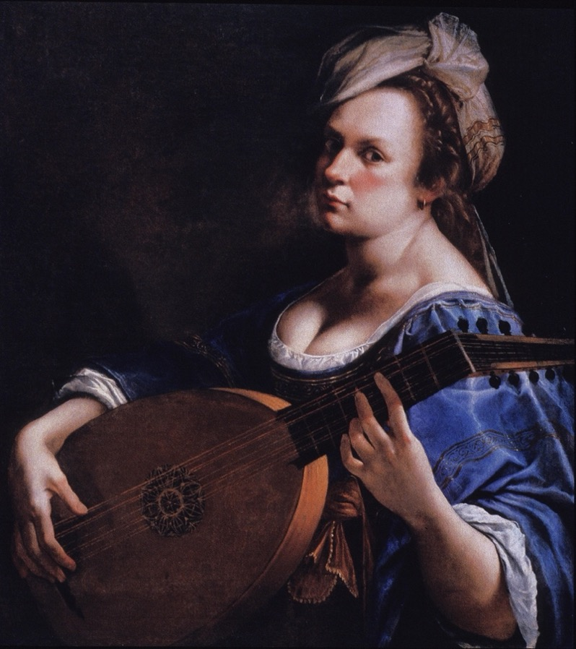

Figure 2: Artifact 2
Amalia Ulman, “The Cute Girl,” from Excellences & Perfections, 2014, Digital photography on Instagram

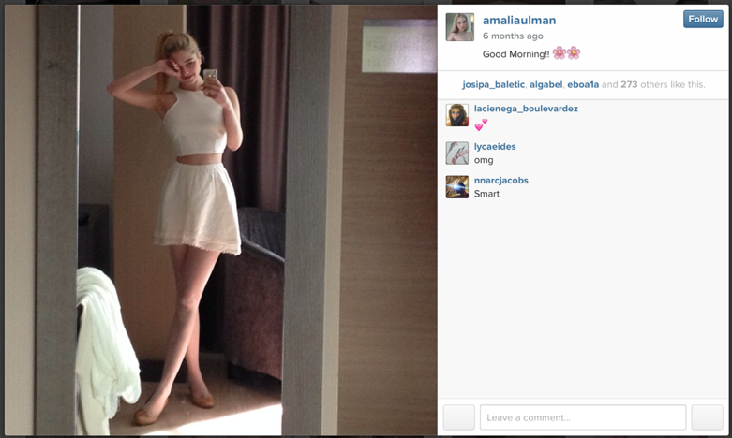

Figure 3: Artifact 3
Amalia Ulman “The Sugar Baby” from Excellences & Perfections, 2014, Digital photography on Instagram

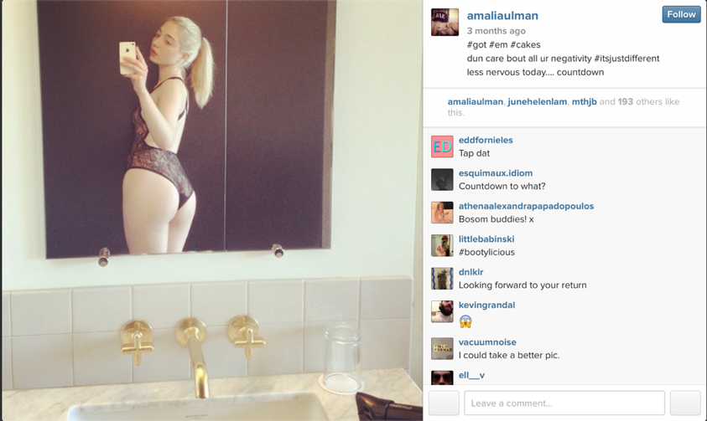

Figure 4: Artifact 4
Amalia Ulman, “The Life Goddess,” From Excellences & Perfections, 2014, Digital photography on Instagram

Figure 5
Caterina Van Hemessen, Self-Portrait, 1548, Oil on board, Kunstmuseum, Basel.

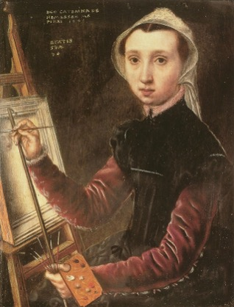

Figure 6
Sofonisba Anguissola, Self-Portrait at the Clavichord, 1561, Oil on canvas, Kunsthistorisches Museum, Vienna

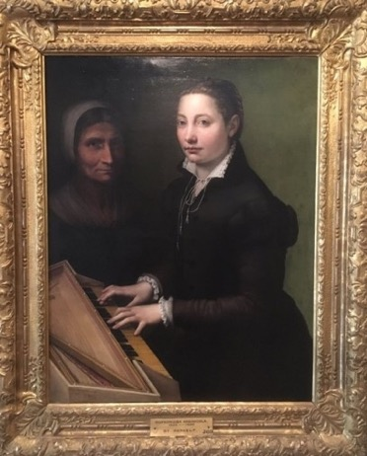

Figure 7
Lavinia Fontana, Self-Portrait at the Clavichord with Servant, 1577, Oil on canvas, Accademia di San Luca, Rome.

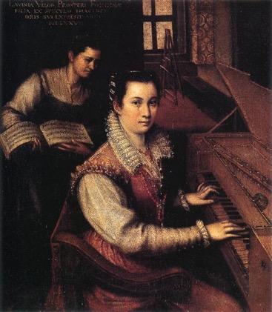

Figure 8
Michelangelo Merisi da Caravaggio, Deposition, c. 1603, Oil on canvas, Chiesa Nuova, Rome.

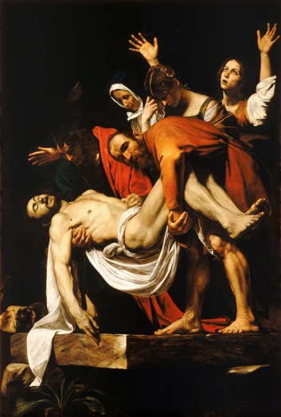

Figure 9
St. Teresa in Ecstasy, Gianlorenzo Bernini, c. 1650, White marble, Santa Maria della Vittoria, Rome.

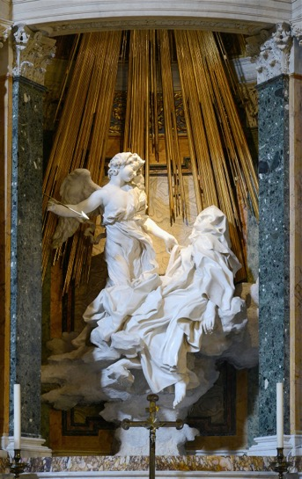

Figure 10
Andrea Pozzo, Triumph of Saint Ignatius ceiling fresco, 1691-1694, Church of St. Ignatius, Rome.

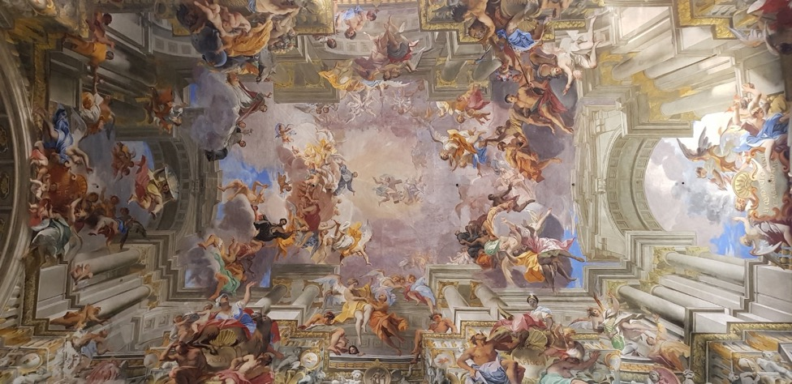

Figure 11
Michelangelo Merisi da Caravaggio, Death of the Virgin, 1606, Oil on canvas, the Louevre, Paris.

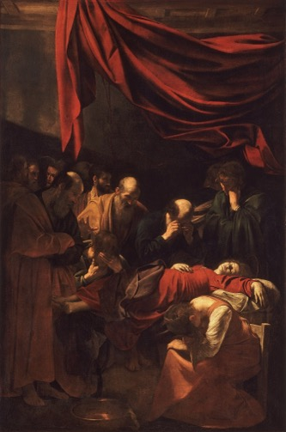

Figure 12
Michelangelo Merisi da Caravaggio, Conversion on the Way to Damascus, Santa Maria del Popolo, Rome.

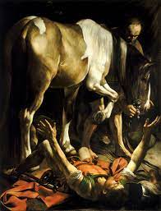

Figure 13
Cindy Sherman, Untitled Film Still #2, 1977, Silver gelatin photograph, Museum of Modern Art.

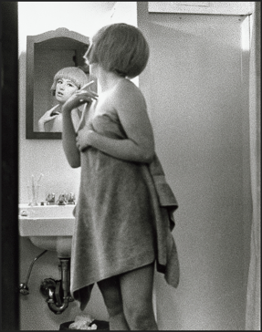

Figure 14
Frances Benjamin Johnston, Self-Portrait, Silver gelatin photograph, 1896, Library of Congress.

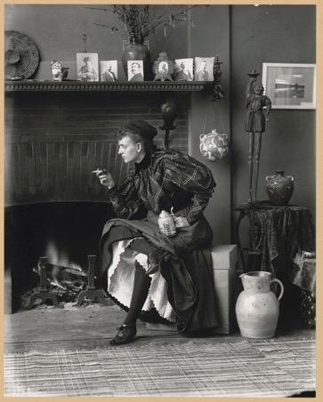

Figure 15
Claude Cahun, Self-Portrait, 1927, Silver gelatin photograph.

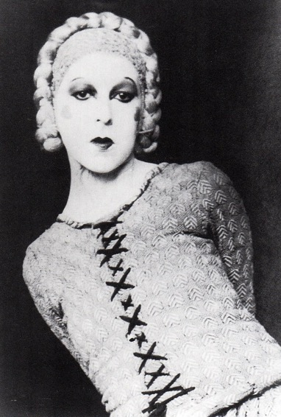

Figure 16
Claude Cahun, Self-Portrait, 1928, Silver gelatin photograph

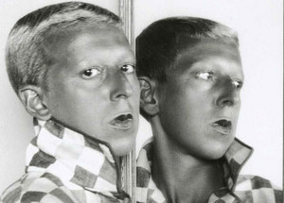

Figure 17
Frida Kahlo, Henry Ford Hospital, 1932, Oil on metal, Dolores Olmedo Museum, Xochimilco, Mexico City.

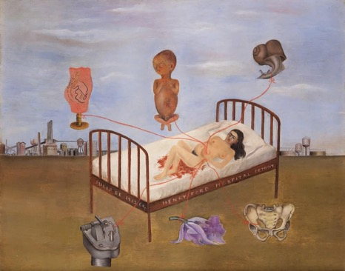

Figure 18
Frida Kahlo, My Birth, 1932, Oil on metal, Private Collection.

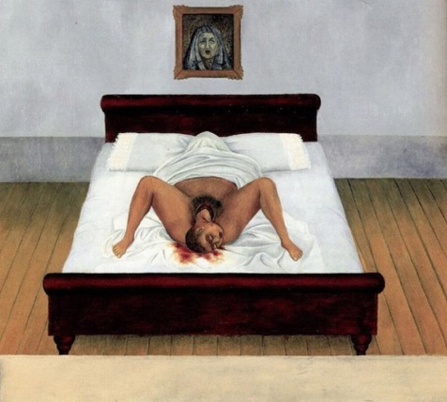

Figure 19
Louise Bourgeois, Self-Portrait, Kunsten Museum of Modern Art Aalborg

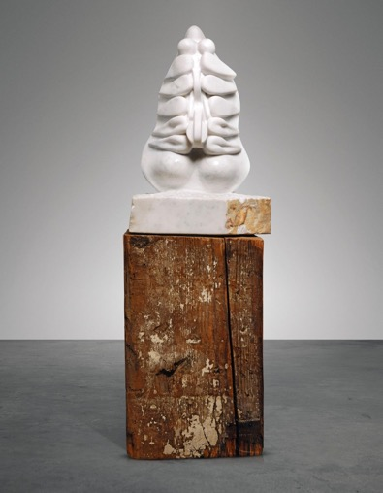

Figure 20
Alice Neel, Self-Portrait at Age Eighty, Oil on canvas, 1980, National Portrait Gallery

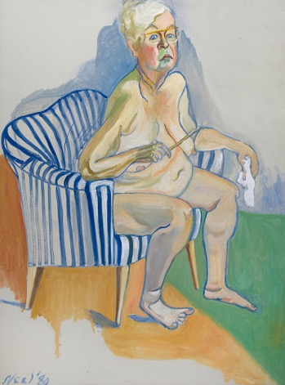

Figure 21
Example of “Korean girls whose Instagrams I check every morning”

Figure 22
Amanda Bynes, 2013

Figure 23
Image from Gwyneth Paltrow’s Goop’s Instagram feed

Figure 24
Image from Gwyneth Paltrow’s Goop’s Instagram feed

Figure 25
Image of Gisele Bündchen from her Instagram feed

Figure 26
Self-Portrait as a Lute Player and the St. Catherines side-by-side at the DIA

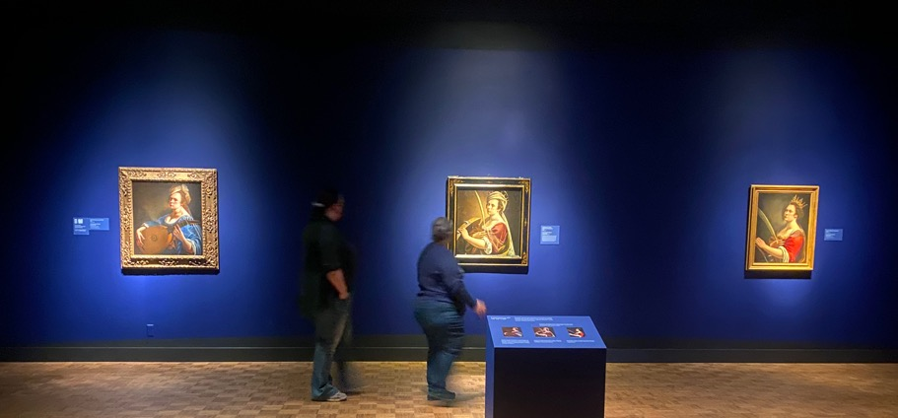

Figure 27
Self-Portrait as St. Catherine, Artemisia Gentileschi, c. 1614, Oil on canvas, Uffizi, Florence

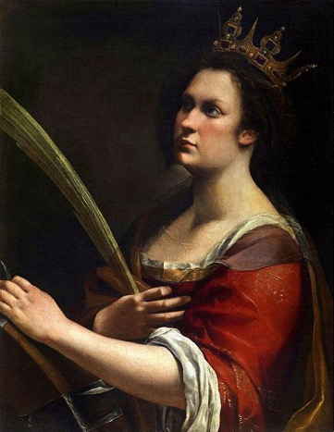

Figure 28
Self-Portrait as St. Catherine of Alexandria, Artemisia Gentileschi, c. 1614, Oil on canvas, National Gallery, London

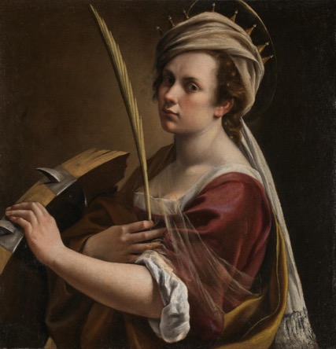

Figure 29
Instagram post by Wadsworth Atheneum Museum of Art

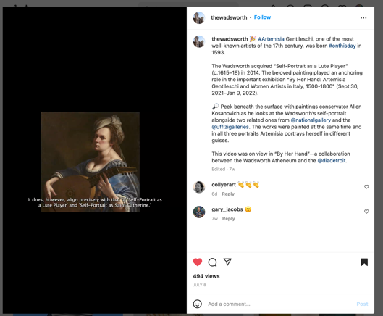

Figure 30
Instagram post by Detroit Institute of Art (DIA)

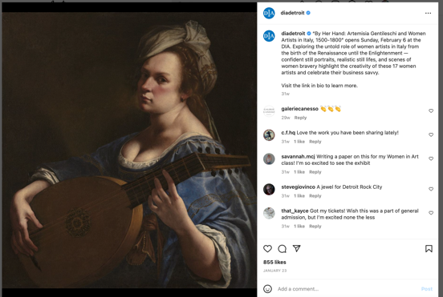

Figure 31
Instagram grid excerpt for Excellences and Perfections

Figure 32
DIA Gift shop, showing reproduced Artemisia Gentileschi paintings as reproduced prints, mugs, magnets, bookmarks, pins, playing cards, and note pads.

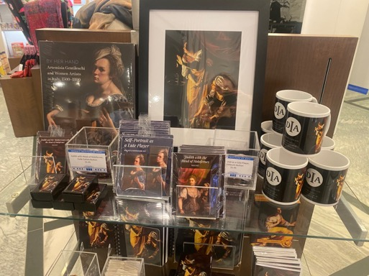

Figure 33
Jan Van Eyck, Arnolfini Portrait, 1434, Oil on panel, National Gallery London

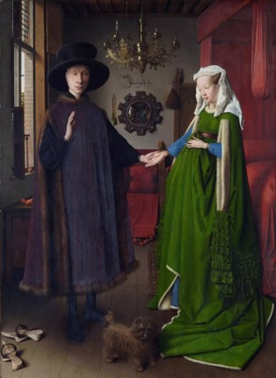

Figure 34
Johannes Gumpp, Self-Portrait, Oil on canvas, Uffizi, Florence

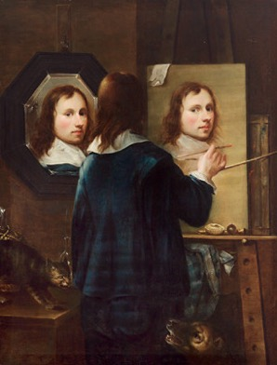

Bibliography

Australian Financial Review. “Has Amalia Ulman Created the First Instagram Masterpiece?,” January 20, 2016. https://www.afr.com/life-and-luxury/arts-and-culture/has-amalia-ulman-created-the-first-instagram-masterpiece-20160121-gmagq1.
Baldwin, Geoff. “Individual and Self in the Late Renaissance.” The Historical Journal 44, no. 2 (2001): 341–64.
Barker, Sheila. Artemisia Gentileschi. Los Angeles: Getty Publications, 2022.
Barker, Sheila. “The First Biography of Artemisia Gentileschi: Self-Fashioning and Proto-Feminist Art History in Cristofano Bronzini’s Notes on Women Artists.” Mitteilungen Des Kunsthistorischen Institutes in Florenz 60, no. 3 (2018): 404–35.
Barker, Sheila. Artemisia Gentileschi. (Los Angeles: Getty Publications, 2022).
Bissell, R. Ward. Artemisia Gentileschi and the Authority of Art: Critical Reading and Catalogue Raisonné. University Park, Pa: Pennsylvania State University Press, 1999.
Bjork, Daniel. “By Popular Demand.” Bon, Spring-Summer 2016. https://bone.se/magazine/bon-70/by-popular-demand/.
Boccaccio. Boccaccio Concerning Famous Women, 1362. http://archive.org/details/boccaccio-concerning-famous-women.
Bolter, Jay David, and Richard Grusin. Remediation: Understanding New Media. Cambridge: MIT Press, 1999.
Borzello, Frances. Seeing Ourselves: Women’s Self-Portraits. New York: Harry N. Abrams, Inc, 1998.
Bradley, Paige K. “Amalia Ulman.” Artforum.com, May 18, 2018. https://www.artforum.com/interviews/amalia-ulman-on-her-new-book-and-internet-performances-75471.
Bryson, Norman, ed. Visual Theory: Painting and Interpretation. Icon Editions. New York: Harper Collins, 1991.
Butkowski, Chelsea P, Travis L Dixon, Kristopher R Weeks, and Marisa A Smith. “Quantifying the Feminine Self(Ie): Gender Display and Social Media Feedback in Young Women’s Instagram Selfies.” New Media & Society 22, no. 5 (May 1, 2020): 817–37. https://doi.org/10.1177/1461444819871669.
Butler, Judith. Bodies that Matter: On the Discursive Limits of Sex. New York: Routledge, 1993.
Butler, Judith. “Critically Queer.” GLQ 1, no. 1 (November 1993): 17-32. https://doi.org/10.1215/10642684-1-1-17
Butler, Judith. Gender Trouble: Feminism and the Subversion of Identity. Thinking Gender. New York: Routledge, 1990.
Butler, Judith. “Performative Acts and Gender Constitution: An Essay in Phenomenology and Feminist Theory.” Theatre Journal 40, no. 4 (December 1988): 519–31.
Caleira, Sofia, Sander De Ridder, and Sofie Van Bauwel. “Exploring the Politics of Gender Representation on Instagram: Self-Representations of Femininity.” DeGeSt. Journal of Diversity and Gender Studies 5, no. 1 (2018): 23–42.
Chapman, H. Perry. A Companion to Renaissance and Baroque Art. Edited by James M. Saslow and Babette Bohn. Hoboken, UNITED STATES: John Wiley & Sons, Incorporated, 2013. http://ebookcentral.proquest.com/lib/ferrisstate/detail.action?docID=1120623.
Cheney, Liana De Girolami. “Lavinia Fontana: A Woman Collector of Antiquity,” n.d.
Christiansen, Keith, Judith Walker Mann, Artemisia Gentileschi, and Orazio Gentileschi. Orazio and Artemisia Gentileschi. New York: Metropolitan Museum of Art, 2001.
Collins, Jim. Architecture of Excess: Cultural Life in the Information Age. New York: Routledge, 1995.
Connor, Michael. “First Look: Amalia Ulman—Excellences & Perfections.” October 20, 2014. https://rhizome.org/editorial/2014/oct/20/first-look-amalia-ulmanexcellences-perfections.
Corbett, Rachel. “How Amalia Ulman Became an Instagram Celebrity.” Vulture. Accessed September 8, 2022. https://www.vulture.com/2014/12/how-amalia-ulman-became-an-instagram-celebrity.html.
Council of Trent. Canons and Decrees of the Council of Trent. Rockford, IL: TAN Book and Publishers, 1978.
Cover, Rob. “What is Facebook For?” In Identity Technologies: Constructing the Self Online, edited by Anna Poletti and Julie Rak. Madison, WI: University of Wisconsin Press, 2014.
Dallenbach, Lucien and Annette Tomarken. “Reflexivity in Reading.” New Literary History 11, no. 3, (Spring 1980): 435-449. http://www.jstor.org/stable/468937.
DeJean, Joan E. The Essence of Style: How the French Invented High Fashion, Fine Food, Chic Cafés, Style, Sophistication, and Glamour. New York: Free Press, 2005.
Derrida, Jacques. Truth in Painting. Chicago: University of Chicago Press, 1987.
Dickmann, Iddo. “Using Mise En Abyme to Differentiate Deleuze and Derrida.” Journal of the British Society for Phenomenology 48 (September 5, 2016): 1–18. https://doi.org/10.1080/00071773.2016.1217664.
Eco, Umberto. The Open Work. Translated by Anna Cancogni. Cambridge, MA: Harvard University Press, 1989.
Elam, Diane. Feminism and Deconstruction: Ms. Em Abyme. London: Taylor & Francis Group, 1994.
Farkas, Rózsa. “Foreword.” In Excellences & Perfections, by Amalia Ulman, 6-7. Munich: Prestel, 2018.
Focillon, Henri. The Life of Forms in Art. Translated by George Kubler. New York: Zone Books, 1992.
Foucault, Michel. “Ethics of Concern for Self as a Practice of Freedom.” In Foucault Live, 1961-1984, edited by Sylvére Lotringer. Translated by Lisa Hochroth and John Johnston. New York: Autonomedia, 1989.
Foucault, Michel. The Order of Things: An Archaeology of Human Sciences. Translated by Alan Sheridan. New York: Vintage Books, 1994.
Francioso, Monica. “Eco, Umberto.” In The Encyclopedia of Literary and Cultural Theory, edited by Michael Ryan. Hoboken, NJ: Wiley, 2011. https://search-credoreference-com.ferris.idm.oclc.org/content/entry/wileylitcul/eco_umberto/0
Galvin, Francesca. “Amalia Ulman.” Kaleidoscope Magazine Online. www.kaleidoscope.media/article/amalia-ulman.
Garrard, Mary D. Artemisia Gentileschi and Feminism in Early Modern Europe. Renaissance Lives. London: Reaktion Books, 2020.
Gide, André. Journal 1885-1939 (Bibliothèque de la Pléiade). Paris: Gallimard, 1948.
Gonzalez, Cesar A. and Katie Spencer. “Femininity.” In The International Encyclopedia of Human Sexuality, edited by Patricia Whelehan and Anne Bolin. Hoboken, NJ: John Wiley & Sons, Incorporated, 2015.
“Goop | A Modern Lifestyle Brand.” Accessed April 15, 2023. Goop.com.
Greenblatt, Stephen. Renaissance Self-Fashioning: From More to Shakespeare. Chicago: University of Chicago Press, 1980.
Gries, Laurie E. Still Life with Rhetoric: A New Materialist Approach for Visual Rhetorics. Logan: Utah State University Press, 2015.
Guignon, David. “The Mirror Stage: Jacques Lacan.” Theory and Philosophy Podcast. Produced by Podbean. April 20, 2022. https://theoretician.podbean.com/e/the-mirror-stage-jacques-lacan-keyword/
Hanssen, Beatrice. “Whatever Happened to Feminist Theory?” In Feminist Consequences: Theory for the New Century. Edited by E. Bronfen and M. Kavka. New York: Columbia University Press, 2001.
Heywood, Ian, and Barry Sandywell. The Handbook of Visual Culture. London: Berg, 2012.
Horning, Robert, and Amalia Ulman. “Perpetual Provisional Selves: A Conversation about Authenticity and Social Media.” Rhizome (blog), December 11, 2014. https://rhizome.org/editorial/2014/dec/11/rob-horning-and-amalia-ulman/.
Howard, Jean E. “The Cultural Construction of the Self in The Renaissance.” Edited by Stephen Greenblatt. Shakespeare Quarterly 34, no. 3 (1983): 378–81. https://doi.org/10.2307/2869917.
Higgie, Jennifer. The Mirror and the Palette. New York: Pegasus Books, 2021.
“Humanism | The Encyclopaedia of the Renaissance - Credo Reference.” Accessed February 22, 2023. https://search-credoreference-com.ferris.idm.oclc.org/content/entry/mheren/humanism/0.
“Iconoclasm | The Encyclopaedia of the Renaissance - Credo Reference.” Accessed February 22, 2023. https://search-credoreference-com.ferris.idm.oclc.org/content/entry/mheren/iconoclasm/0.
“In Between the Painting and the Mirror: Framing the Female Subject on JSTOR.” Accessed September 1, 2022. https://www.jstor.org/stable/44733694?seq=1#metadata_info_tab_contents.
Jones, Amelia. The Feminism and Visual Culture Reader. In Sight. London: Routledge, 2003.
Joslin, Isaac. “Society and Spectacle: The Sublimation of Reality in Baroque Aesthetics.” Journal of Comparative Literature and Aesthetics 43, no. 2 (2020): 42+.
Keith, Larry, Letizia Treves, Marta Melchiorre di Crescenzo, and Joanna Russel. “Artemisia Gentileschi’s ‘Self Portrait as Saint Catherine of Alexandria.’” National Gallery Technical Bulletin 40 (2019): 4–17. http://www.jstor.org/stable/45287035.
Lambert, Gregg. The Return of the Baroque in Modern Culture. London: New York: Continuum, 2004.
Maguire, Emma. “Constructing the ‘Instagirl,’ Deconstructing the Self-Brand: Amalia Ulman’s Instagram Hoax.” European Journal of Life Writing 8 (May 18, 2019): DM12–32. https://doi.org/10.21827/ejlw.8.35546.
Malabou, Catherine and Judith Butler. “You Be My Body for Me: Body, Shape, and Plasticity in Hegel’s Phenomenology of Spirit.” In A Companion to Hegel, edited by Stephen Houlgate and Michael Baur. Hoboken, NJ: John Wiley & Sons, Inc, 2011.
Marien, Mary Warner, “Self Portrait,” in 100 Ideas that Changed Photography European Journal of Life Writing, London: Laurence King, 2012. https://ferris.idm.oclc.org/login?url=https://search.credoreference.com/content/entry/lkingitcp/ self_portrait/0?institutionId=723
McIver, Katherine A. “Lavinia Fontana’s ‘Self-Portrait Making Music.’” Woman’s Art Journal 19, no. 1 (1998): 3–8. https://doi.org/10.2307/1358647.
Melchior-Bonnet, Sabine. The Mirror: A History. New York: Routledge, 2001.
Mercado, Mia. “I Can’t Shut Up About Sexy Babies.” The Cut. October 28, 2022. https://www.thecut.com/2022/10/what-does-taylor-swift-mean-with-that-sexy-baby-lyric.html
Merchant, Brian. The One Device: The Secret History of the iPhone. London etc.: Bantam press, 2017.
Mitchell, W. J. T. Picture Theory. Chicago: University of Chicago Press, 1994.
Ndalianis, Angela. Neo-Baroque Aesthetics and Contemporary Entertainment. Media in Transition. Cambridge, Mass: MIT Press, 2004.
Pliny, the Elder, K. Jex-Blake, and Heinrich Ludwig Urlichs. The Elder Pliny’s Chapters on the History of Art; London, New York, Macmillan and co., ltd., 1896. http://archive.org/details/cu31924031053550.
Pollock, Griselda. Differencing the Canon: Feminist Desire and the Writing of Art’s Histories. Re Visions. London ; New York: Routledge, 1999.
Roden, Frederick S. “Becoming Butlerian: On the Discursive Limits (and Potentials) of Gender Trouble.” In Butler Matters: Judith Butler’s Impact of Feminist and Queer Studies, edited by Margaret Sönser Breen and Warren J. Bluenfield. __-__. Florence: Taylor & Francis Group, 2005.
Roraback, Erik. “Interdisciplinarity And Gilles Deleuze’s Leibnizian-Monad Of The Fold: Leibniz And The Baroque,” n.d., 10.
Rose, Gillian. Visual Methodologies: An Introduction to Researching with Visual Materials. 4th edition. London: SAGE Publications Ltd, 2016.
Rhizome. “Do You Follow? Art in Circulation 3 (Transcript).” Accessed November 1, 2022. http://rhizome.org/editorial/2014/oct/28/transcript-do-you-follow-panel-three/.
Salazar, Manuela. “A Look into the Picture-Perfect Fake Life of Amalia Ulman’s Excellences and Perfections.” Excursions Journal 9, no. 1 (January 25, 2020): 76–88. https://doi.org/10.20919/exs.9.2019.242.
“Selfie,” Oxford English Dictionary, last modified March 2022, https://www.oed.com/viewdictionaryentry/Entry/390063;jsessionid=3AF0B4B17DE9DFC281E9459E2C2E8B1B#:~:text=A%20photograph%20that%20one%20has,and%20shared%20via%20social%20media.
Serano, Julia. The Whipping Girl: A Transsexual Woman on Sexism and the Scapegoating of Femininity. Emeryville, CA: Seal Press, 2007.
Showalter, Elaine. “Feminist Criticism in the Wilderness.” Critical Inquiry 8, no. 2 (1981): 179–205.
Sims, Josh. “Burlesque.” In 100 Ideas that Changed Street Style. London: Laurence King, 2014. https://search-credoreference-com.ferris.idm.oclc.org/content/entry/lkingitcss/burlesque/0?institutionId=723
Small, Rachel. “Amalia Ulman.” Interview Magazine Online, October 14, 2015. https://www.interviewmagazine.com/art/amalia-ulman.
Snow, Marcus. Into the Abyss. PhD diss., London Metropolitan University, 2016.
Solinas, Francesco. Lettere di Artemisia. Roma: Rispublica Literaria, 2011.
Sooke, Alastair, “Has Amalia Ulman Created the First Instagram Masterpiece?” The Financial Times, January 21, 2016.
Straussman-Pflanzer, Eve, Oliver Tostmann, Babette Bohn, Wadsworth Atheneum, and Detroit Institute of Arts, eds. By Her Hand: Artemisia Gentileschi and Women Artists in Italy, 1500-1800. First edition. Detroit, Michigan: Detroit Institute of Arts, 2021.
Sylvester, Sara. “The Theatre of the Selfie: Fictive Practices of the Instagram Artist.” Body, Space & Technology 18, no. 1 (March 12, 2019): 61. https://doi.org/10.16995/bst.315.
Szorenyi, Anna. “Judith Butler: Their Philosophy of Gender Explained.” The Conversation, October 19, 2022. http://theconversation.com/judith-butler-their-philosophy-of-gender-explained-192166.
The Influencers. “Amalia Ulman,” September 18, 2015. https://theinfluencers.org/en/amalia-ulman.
“The Theoretical Turn | 100 Ideas That Changed Photography - Credo Reference.” Accessed April 4, 2023. https://search-credoreference-com.ferris.idm.oclc.org/content/entry/lkingitcp/the_theoretical_turn/0.
“Thirst Trap.” Cambridge Advance Learner’s Dictionary & Thesaurus online. Cambridge: Cambridge University Press, 2023. https://dictionary.cambridge.org/us/dictionary/english/thirst-trap
Transpositions. “The Intimacy of Embodiment & the Art of Portrayal » Transpositions,” April 4, 2012. https://www.transpositions.co.uk/the-intimacy-of-embodiment-the-art-of-portrayal/.
Ulman, Amalia. Excellences & Perfections. 2014. Digital Photography. https://webenact.rhizome.org/excellences-and-perfections/20141014150552/http://instagram.com/amaliaulman. Accessed March 23, 2022.
Ulman, Amalia. Excellences & Perfections. Munich: Prestel, 2018.
Winant, Carmen. “Our Bodies, Online.” Aperture, no. 225 (2016): 138–43.

Berénger De la Tour, “Le Miroir,” in Poémes du XVI Siècle (Paris, France: Galimard [La Pléiad], 1953), 353. Quoted in The Mirror, Melchior-Bonnet, Sabine, (New York, NY: Routledge, 2001), 157.
Sabine Melchior-Bonnet, The Mirror, (New York, NY: Routledge, 2001), 157.
Stephen Greenblatt, Renaissance Self-Fashioning, (Chicago, IL, University of Chicago Press: 1980), 2.
Frances Borzello, Seeing Ourselves: Women’s Self-Portraits, (London, England, Thames and Hudson,Ltd., 1998), 26.
Jennifer Higgie, The Mirror and the Palette, (NY, NY, Pegasus Books, 2021), 18.
Melchior-Bonnet, 7.
Greenblatt, 1-2.
H. Perry Chapman, “Self-Portraiture 1400-1700,” in A Companion to Renaissance and Baroque Art, edited by James M. Saslow and Babette Bohn, (Hoboken, NJ: John Wiley & Sons, Incorporated, 2013.), http://ebookcentral.proquest.com/lib/ferrisstate/detail.action?docID=1120623, 191.
Chapman, 191.
I define the term “self-portraiture” as a genre which includes all artifacts that are meant as representations of a self.
The earliest extant evidence we have of female self-portraiture comes from Pliny the Elder, in his Chapters on the History of Art. He notes on page 171 that Iaya of Kyzikos “painted a portrait of herself, executed with the help of a mirror.” However, the practice of self-portraits did not become common and widespread until the technology developed for mass production of larger, clear-glass mirrors, between 1500 and 1700, in Italy and France.
Borzello, 39.
Borzello, 7.
Borzello, 39.
Borzello, 21.
Katherine A. McIver, “Renaissance Women Painting Themselves,” Art Herstory, June 8, 2019, https://artherstory.net/self-portraits-by-renaissance-women-artists/.
Borzello, 37.
Katherine A. McIver, “Lavinia Fontana’s ‘Self-Portrait Making Music,’” Woman's Art Journal, Vol. 19, No. 1 (Spring - Summer, 1998), Published by: Woman's Art Inc. Stable URL: https://www.jstor.org/stable/1358647, 4-6.
“selfie, n.”. Oxford English Dictionary Online. (Oxford, England, Oxford University Press , 2022). https://www.oed.com/viewdictionaryentry/Entry/390063 (accessed February 02, 2023).
Mary Warner Marien, “Self Portrait,” In 100 Ideas that Changed Photography, (London, England: Laurence King, 2012). https://ferris.idm.oclc.org/login?url=https://search.credoreference.com/content/entry/lkingitcp/ self_portrait/0?institutionId=723.
Keith Christiansen and Judith Walker Mann, Orazio Gentileschi, and Artemisia Gentileschi. Orazio and Artemisia Gentileschi. (New York, NY: Metropolitan Museum of Art, 2001), xix.
Rhizome, “Do You Follow? Art in Circulation 3” (transcript). Oct. 28, 2014 https://rhizome.org/editorial/2014/oct/28/transcript-do-you-follow-panel-three/.
Rhizome.
Rhizome.
Sooke, Alastair, “Has Amalia Ulman Created the First Instagram Masterpiece?” The Financial Times, January 21, 2016.
Rhizome, “Do You Follow?”
Judith Butler, Gender Trouble: Feminism and the Subversion of Identity, (New York, NY: Routledge, 1990), 11.
Butler, Gender Trouble, 21.
Self-Portrait as a Lute Player was rediscovered in 1998; not in time to be included in R. Ward Bissell, Artemisia Gentileschi and the Authority of Art: Critical Reading and Catalogue Raisonné (University Park, Pa: Pennsylvania State University Press, 1999). Two exhibition catalogues: Orazio and Artemisia Gentileschi (The Met, 2001) and By Her Hand (The Wadsworth Atheneum Museum of Art and the Detroit Institute of Art, 2021) include scholarly discussions of Self-Portrait as a Lute Player.
Daniel Bjork, “By Popular Demand,” Bon 70, Spring-Summer 2016, https://bon.se/magazine/bon-70/by-popular-demand/.
Maguire, Emma, “Constructing the ‘Instagirl,’ Deconstructing the Self-Brand: Amalia Ulman’s Instagram Hoax,” The European Journal of Life Writing, Vol. VIII (2019): 12, DM12-DM32.
Rhizome, “Do You Follow?”
Henri Focillon, The Life of Forms in Art, trans. George Kubler (New York, NY, 1992), 33.
Umberto Eco, The Open Work, (Cambridge, MA, Harvard University Press, 1989), 218.
Eco, 59.
Ndalianis, Neo-Baroque Aesthetics and Contemporary Entertainment, 5.
Ndalianis, 5.
Ndalianis, 7-8.
Bolter and Grusin, Remediation: Understanding New Media, quoted by Angela Ndalianis in Neo-Baroque Aesthetics and Contemporary Entertainment, 6.
Ndalianis, Neo-Baroque Aesthetics and Contemporary Entertainment, 6.
Ndalianis, Neo-Baroque Aesthetics and Contemporary Entertainment, 71-101.
Borzello, Seeing Ourselves: Women’s Self-Portraits, 18.
Butler, Gender Trouble, xxix.
Butler, 4 Butler, Judith. “Performative Acts and Gender Constitution: An Essay in Phenomenology and Feminist Theory.” Theatre Journal 40, no. 4 (December 1988): 519, 521.
Butler, Judith. “Performative Acts and Gender Constitution”: 521.
Greenblatt, Renaissance Self-Fashioning, 2.
Ulman gave a nearly identical talk on a panel at Art Basel Miami Beach on December 4, 2014.
Bjork, Daniel, “By Popular Demand.”
Butler, “Performative Acts and Gender Constitution.”
Rhizome, “Do You Follow?”
From the French, meaning “put in the abyss.” The term has evolved to generally be applied to things and situations with an infinite regress. I elaborate further over the course of the thesis.
Diane Elam, Feminism and Deconstruction: Ms. en Abyme, (London: Taylor & Francis Group, 1994), 28.
Elam, 27.
Elam, 30.
Elam, Feminism and Deconstruction, 59-60.
Elam, 66.
Butler, “Performance Acts and Gender Constitution,” 521.
Elam, Feminism and Deconstruction, 521.
Butler, Gender Trouble, 11.
Maguire, Emma. “Constructing the ‘Instagirl,’ Deconstructing the Self-Brand: Amalia Ulman’s Instagram Hoax.” European Journal of Life Writing 8 (May 18, 2019), 14, DM12. https://doi.org/10.21827/ejlw.8.35546.
Butler, Gender Trouble, 21.
Ward, Myah, “Blackburn to Jackson” Politico.com, March 22, 2022, https://www.politico.com/news/2022/03/22/blackburn-jackson-define-the-word-woman-00019543.
Mise-en-abyme is a French term that means “put in the abyss.” Thought to have originated with the medieval practice of portraying a miniature coat-of-arms inside the larger, the term has developed as a literary term to mean a story within a story, indicating an infinite regress. Visually, this infinite regress is classically portrayed as a hall of mirrors.
Butler, Gender Trouble, 21.
Rózsa Farkas, “Foreword,” in Excellences & Perfections, by Amalia Ulman and Rózsa Farkas, (Munich, Germany: Prestel, 2018), 6.
Rhizome is a digital archive associated with the New Museum.
Ndalianis, Neo-Baroque Aesthetics and Contemporary Entertainment, 5.
Council of Trent, Canons and Decrees of the Council of Trent (Rockford, IL: TAN Book and Publishers, 1978), 270-271.
Mary Garrard, Artemisia Gentileschi and Feminism in Early Modern Europe, (London, England: Reaktion Books, 2020), 105.
Sheila Barker, Artemisia Gentileschi, (Los Angeles: Getty Publications, 2022), 45.
Franceso Solinas, Lettere di Artemisia, (Roma: Rispublica Literaria, 2011), 23-24.
Sooke, “Has Amalia Ulman Created the First Instagram Masterpiece?”
Brian Merchant, The One Device: The Secret History of the Iphone. (London, England: Bantam Press, 2017), 133.
Bolter and Grusin, Remediation: Understanding New Media, quoted by Angela Ndalianis in Neo-Baroque Aesthetics and Contemporary Entertainment, 6.
Ndalianis, Neo-Baroque Aesthetics and Contemporary Entertainment, 6.
Jim Collins, Architectures of Excess: Cultural Life in the Information Age, (New York, NY: Routledge, 1995), 6.
Ndalianis, Neo-Baroque Aesthetics and Contemporary Entertainment, 79.
Monica Francioso, “Eco, Umberto.” In The Encyclopedia of Literary and Cultural Theory, edited by Michael Ryan. Wiley, 2011. https://ferris.idm.oclc.org/login?url=https://search.credoreference.com/content/entry/wileylitcul/ eco_umberto/0?institutionId=723.
Ndalianis, Neo-Baroque Aesthetics and Contemporary Entertainment, 26.
Ndalianis, 72.
Rhizome, “Do You Follow?”
Rhizome, “Do You Follow?”
Farkas, “Foreword,” 7.
Rhizome, “Do You Follow?”
Excellences & Perfections includes Hello Kitty imagery in its post from April 19, 2014. Hello Kitty is a multimedia business mogul created in 1974. Hello Kitty, in turn, was based on the character “Kitty,” in Lewis Carroll’s Through the Looking Glass.
Mia Mercado, “I Can’t Shut Up About Sexy Babies,” The Cut, October 28,2022, https://www.thecut.com/2022/10/what-does-taylor-swift-mean-with-that-sexy-baby-lyric.html Taylor Swift recently brought the virgin/whore trope to the fore with the lyrics of her 2022 song “Anti-hero.” She sings, “Sometimes I think that everybody is a sexy baby, and I’m a monster on the hill.” This article discussed the trope.
Rhizome, “Do You Follow?”
Josh Sims, “Burlesque.” In 100 Ideas that Changed Street Style, (London, England: Laurence King, 2014). https://ferris.idm.oclc.org/login?url=https://search.credoreference.com/content/entry/lkingitcss/burlesque/0?institutionId=723.
The Cambridge Dictionary defines a thirst trap as “a statement by or photograph of someone on social media that is intended to attract attention or make people who see it sexually interested in them, usually involving sexy selfies.” https://dictionary.cambridge.org/us/dictionary/english/thirst-trap Accessed Feb. 6, 2023.
Search results for “t-shirt,” Goop.com, last modified April 22, 2023, https://goop.com/search?q=t-shirt&country=USA&filterAndSort=%257B%2522filters%2522%253A%255B%257B%2522name%2522%253A%2522contentType%2522%252C%2522values%2522%253A%255B%2522Products%2522%255D%257D%255D%252C%2522sortBy%2522%253A%2522%2524_minPrice%2522%252C%2522sortDirection%2522%253A%2522ASCENDING%2522%257D.
Michael Connor, “First Look: Amalia Ulman—Excellences & Perfections,” on Rhizome.org, Oct 20, 2014, https://rhizome.org/editorial/2014/oct/20/first-look-amalia-ulmanexcellences-perfections/.
David Guignon, “The Mirror Stage: Jacque Lacan,” Theory and Philosophy Podcast, Produced by Podbean: April 20, 2022. 5:05-5:14. https://theoretician.podbean.com/e/the-mirror-stage-jacques-lacan-keyword/.
Bjork, “By Popular Demand.”
Maguire, “Constructing the Instagirl,” 15.
Sooke, Alastair. “Has Amalia Ulman Created the First Instagram Masterpiece?”
Since 2014, Ulman has had at least 16 solo exhibitions, she has been interviewed and her work reviewed countless times by major media outlets. See amaliaulman.eu. In 2022, she released El Planeta, which was screened at the Sundance Film Festival in 2021. See https://www.elplaneta.info.
Larry Keith and Letizia Treves, Marta Melchiorre Di Crescenzo, and Joanna Russell. “Artemisia Gentileschi’s ‘Self Portrait as Saint Catherine of Alexandria.’” National Gallery Technical Bulletin 40 (2019): 4–17. http://www.jstor.org/stable/45287035. I subsequently refer to Self-Portrait as St. Catherine of Alexandria and St. Catherine of Alexandria as the St. Catherines.
Keith, “Artemisia Gentileschi’s ‘Self Portrait as Saint Catherine of Alexandria,’” 8.
Ndalianis, Neo-Baroque Aesthetics in Contemporary Entertainment, 5.
Farkas, 6.
Butler, “Performative Acts and Gender Constitution,” 520.
Judith Butler, Bodies that Matter: On the Discursive Limits of Sex, (New York, NY: Routledge, 1993), 95.
Judith Butler “Critically Queer,”GLQ 1 November 1993; 1 (1): 17–32. https://doi.org/10.1215/10642684-1-1-17.
Butler, Gender Trouble, xxix.
Butler, xxix.
Frederick S. Roden, “Becoming Butlerian: On the Discursive Limits (and Potentials) of Gender Trouble,” in Butler Matters: Judith Butler's Impact on Feminist and Queer Studies, Warren J. Blumenfeld and Margaret Sönser Breen, eds., (Florence: Taylor & Francis Group, 2005), 29.
Butler, Gender Trouble, 174.
Szorenyi, Anna. “Judith Butler: Their Philosophy Of Gender Explained (Oct. 2022),” In The Conversation: An Independent Source of Analysis from Academic Researchers, edited by The Conversation, 2018. https://ferris.idm.oclc.org/login? url=https://search.credoreference.com/content/entry/conversqauq/judith_butler_their_philosophy_of_genderexplained/0?. institutionId=723
Julia Serano, The Whipping Girl: A Transsexual Woman on Sexism and the Scapegoating of Femininity, (Emeryville, CA: Seal Press, 2007), 118.
Catherine Malabou and Judith Butler, “You Be My Body for Me: Body, Shape, and Plasticity in Hegel’s Phenomenology of Spirit,” in A Companion to Hegel, edited by Stephen Houlgate and Michael Baur, (Hoboken, NJ: John Wiley & Sons, Incorporated, 2011), 31.
Malabou, 31.
Hanssen, Beatrice, “Whatever Happened to Feminist Theory,” in Feminist Consequences: Theory for the New Century, eds. E. Bronfen and M. Kavka, Columbia University Press, New York, p. 82.
Keith, “Artemisia Gentileschi’s ‘Self Portrait as Saint Catherine of Alexandria,’” 7.
McIver, “Lavinia Fontana’s ‘Self-Portrait Making Music,’” 4.
Cesar A. Gonzalez and Katie Spencer. “Femininity,” in The International Encyclopedia of Human Sexuality, eds. Patricia Whelehan and Anne Bolin. (Hoboken, NJ: John Wiley & Sons, Incorporated, 2015.) https://ferris.idm.oclc.org/login? url=https://search.credoreference.com/content/entry/wileyhs/femininity/0?institutionId=723.
Butler, “Performance Acts and Gender Constitution,” 531.
Michel Foucault, “Ethics of Concern for Self as a Practice of Freedom,” in Foucault Live, 1961-1984, (Lotringer, ed., New York, NY: Autonomedia, 1989), 441-442.
Borzello, Seeing Ourselves, 115.
Sooke, Alastair, “Has Amalia Ulman Created the First Instagram Masterpiece?”
Rhizome, “Do you follow?”
Rhizome, “Do you follow?”
Rhizome.
Maguire, “Constructing the Instagirl,” 13.
Cover, Rob. “What is Facebook For?,” in Identity Technologies: Constructing the Self Online, edited by Anna Poletti and Julie Rak, (Madison, WI: University of Wisconsin Press, 2014), 57-58.
Galvin, Francesca, “Amalia Ulman,” Kaleidoscope Magazine Online, www.kaleidoscope.media/article/amalia-ulman.
Butler, “Performance Acts and Gender Constitution,” 519.
Farkas, “Foreword,” 7.
Gonzalez, “Femininity.”
Mercado, “I Can’t Shut Up About Sexy Babies.”
Borzello, Seeing Ourselves, 20, 27.
Rhizome, “Do You Follow?”
Horning, “Perpetual Provisional Selves.”
Gonzalez, "Femininity."
These three accounts existed in 2014 and are still in operation as of February 7, 2023.
Michael Connor, “First Look.”
Ulman, Amalia, Excellences & Perfections, Post from Sept. 5, 2014.
Ulman, Amalia, Excellences & Perfections, Post from Sept. 14, 2014.
Garrard, Artemisia Gentileschi and Feminism in Early Modern Europe, 97.
Butler, Gender Trouble, 21.
Butler, Judith. Gender Trouble, 6.
Rhizome, “Do You Follow?”
Bjork, Daniel, “By Popular Demand.”
Butler, “Performance Acts and Gender Constitution,” 520.
Butler, “Performance Acts and Gender Constitution,” 519.
Butler, “Performance Acts and Gender Constitution,” 521.
Butler, Gender Trouble, 176.
Butler, “Performance Acts and Gender Constitution,” 522.
André Gide, Journal 1885 - 1939 Bibliothèque de la Pléiade, (Paris: Gallimard, 1948), 35.
Iddo Dickmann, The Little Crystalline Seed (Albany, NY: SUNY Press, 2019), 11.
Marcus Snow, “Into the Abyss,” (PhD diss., London Metropolitan University, 2016), 11.
Lucien Dällenbach and Annette Tomarken, “Reflexivity in Reading,” New Literary History, Vol. 11, No. 3, (Spring, 1980), pp. 435-449 Published by: The Johns Hopkins University Press Stable URL: https://www.jstor.org/stable/468937,” 445.
Derrida, Truth in Painting, (Chicago, IL: University of Chicago Press, 1987), 20.
Malabou, “You Be My Body for Me,” 31.
Derrida, The Truth in Painting, 23. The texts Derrida refers to in the quoted passage are Hegel’s Lectures on Aesthetics and Heidegger’s Origin of the Work of Art.
Derrida, The Truth in Painting, 23.
Foucault, The Order of Things: An Archaeology of Human Sciences, (New York, NY: Routledge, 1989), 5.
Mitchell, W. J. T., Picture Theory, (Chicago: University of Chicago Press, 1994), 58.
Mitchell, 58.
Van Eyck took artistic license with the mirror pictured; it is larger than was possible to make at the time.
Rhizome, “Do You Follow?”
Gavin, Francesca, “Amalia Ulman.”
Paige K. Bradley, “Amalia Ulman,” Art Forum Online, May 18, 2018, https://www.artforum.com/interviews/amalia-ulman-on-her-new-book-and-internet-performances-75471.
Elam, 28.
Butler, Gender Trouble, 21.
Elam, Feminism and Deconstruction, 27.
Gonzalez, “Feminism.”
Farkas, 7.
Ndalianis, Neo-Baroque Aesthetics and Contemporary Entertainment, 194.
Rhizome, “Do You Follow?”

